Gap Analysis between eLMIS in Tanzania & Zambia and OpenLMIS 3.x

Winter, 2016 - 2017

The global initiative to develop shared, open source solutions for managing medical commodity distribution in low and middle income countries. OpenLMIS: Configurable. Interoperable. Open Source.

www.openlmis.org // info@openlmis.org

Table of Contents
Introduction 1
Executive Summary 1
Background 1
Purpose 2
Tanzania 2
Matrix of all personas 2
Actor Diagram 4
Feature Gap 6
Zambia 6
Matrix of all personas 7
Actor Diagram 10
Feature Gap 12
Next Steps 13
Remaining Gap Analysis Work 13
Current Recommendations 13

Introduction

Executive Summary
Gap analysis activities thus far have included 4-days of interviews in both Tanzania & Zambia as well as approximately 2-weeks of documentation and analysis. So, while we have drawn some interim conclusions about the gap that exists between eLMIS in Tanzania and Zambia and the 3.x roadmap, these conclusions will evolve and become more concrete as the gap analysis progresses.
The feature gap between eLMIS Tanzania and OpenLMIS 3.x thus far seems relatively “low” complexity to re-create on the OpenLMIS roadmap. The gap primarily exists in the realm of reporting & dashboards, with a few other areas for additional investigation identified. However, the picture may change as we perform additional discovery. Please read the full Tanzanian feature gap section for more details.
The feature gap between eLMIS Zambia and OpenLMIS 3.x, on the other hand, appears to be quite large or of “high” complexity to re-create in OpenLMIS. The Zambia team has built out significant functionality to support their users and re-creating or creating alternate approaches for their use cases would be a significant undertaking. For more detail, please read the Zambia feature gap section. Likewise, as our discovery progresses, our understanding of the gap will evolve.
Based on current findings, we recommend the gap analysis proceed with only slight modifications. We anticipate needing 1 – 2 additional weeks of discovery in Tanzania – which may be undertaken by local business analysts if appropriate human resources are available. These activities will focus on interviewing the remaining personas we were not able to schedule time with during our initial visit, and better documentations of user and system processes, including reporting needs. In Zambia, we anticipate the need for an additional 2 – 4 weeks of exploration. This time will be spent performing additional interviews, understanding the use cases that resulted in such a diversity of features, and documenting user and system processes. These activities will be followed by analysis which is more fully documented in the current recommendations section.

Background
The original monolithic architecture of OpenLMIS and eLMIS does not easily support the re-use of features from country to country. At the OpenLMIS Stakeholder Conference in September 2015, the OpenLMIS community identified this barrier to “shared investment, shared benefit” as the greatest barrier to long term success and adoptability of OpenLMIS as an LMIS standard in LMICs. For this reason, the community undertook a re-architecture effort to re-create the system on an extensible, micro-services based architecture dubbed version 3.0. The initial 3.0 release is schedule for February 2017.
However, since Tanzania and Zambia are both on the older, monolithic version of OpenLMIS, they will not be able to take advantage of any features developed with the new architecture. To ameliorate this, the OpenLMIS Community has undertaken a “gap analysis” to identify the complexity of re-creating features from the existing Tanzania and Zambia implementations of eLMIS to the OpenLMIS 3.x code line.

Purpose
The purpose of the gap analysis is to identify the gaps between the current features (and roadmap) of eLMIS in Tanzania and Zambia and the feature roadmap for OpenLMIS 3.x. Based on the outcomes of this activity, an informed decision can be made on the need to add these “gap features” to the OpenLMIS roadmap and whether a migration path makes sense, and if so, the priority of such an undertaking.

Tanzania
The medical supply chain in Tanzania consists of 6 programs and approximately 800 products served by 9 zonal stores and over 5,700 health centers and dispensaries. Starting in 2011, with the support of the Ministry of Health and Social Welfare, the USAID | DELIVER PROJECT and SCMS began a major revamp of the public health supply chain management – including the introduction of eLMIS (the locally branded version of OpenLMIS) across all non-vaccine programs.
By July 2014, eLMIS was operational across the entire country and data from the roughly 5,700 service delivery was being fed into eLMIS at the district level. From the district level, R&Rs are created, authorized, and approved with the final approval taking place at a zonal store. Once approval at the zonal store has taken place, the R&R is converted to an order and fulfilled with the Epicor ERP system.
As part of our discovery in Tanzania, we were able to perform interviews both on the mainland and on Zanzibar. This distinction is important, because there are slight variations in process between the two.

Matrix of all personas
The following matrix describes the eLMIS Tanzania personas, their levels in the supply chain, their goals as a user, and their system roles. We identified these personas but were not able to interview individuals from each type during our 4-day visit. Personas without highlighting, may need follow-up during additional visits. Those highlighted in yellow were not interviewed and will need to be interviewed during follow-up activities.
User | Level | Goals | System Role
MSD User  (Customer Care) | Zonal / Central | - Get a print-out of approved R&Rs  - Convert to order | - Converts approved R&Rs to Order  - Print order
LMU User | Zonal / Central | - Approve or reject R&Rs for all districts that report to them  - Reach 100% reporting rate  - Increase data quality of reporting districts (to decrease her workload)  - Create monthly / quarterly reports for higher-ups  - (at Zonal) requisition & receive stock from central store | - View reports to perform some analysis into stock levels / trends at districts  - Perform final approval of R&Rs  - Data validation  - Ability to spot-check R&R cost against approximate facility budget  - Reject & provide feedback to facilities for incomplete / unacceptable R&Rs  - Provide feedback if rejected  - (at Zonal) Create R&R to central level  - Create monthly / quarterly reports for higher-ups, including monthly performance report
District Approver aka District Pharmacist | District | - Approve or reject R&Rs for all facilities that report to her  - Reach 100% reporting rate  - Increase data quality of reporting facilities (to decrease her workload)  - Requisition & receive stock from zonal store  - Ensure R&Rs are within budget | - Enter paper R&R into eLMIS on behalf of facility user  - Incorporate stock-out days into R&R  - Approve or reject all R&Rs for facilities in her district  - Perform data validation  - Ability to spot-check R&R cost against approximate facility budget  - Provide feedback to facilities for rejection (if rejected)  - View non-reporting facilities  - Perform physical inventory  - Create district R&R  - Correct rejected district R&R
Facility R&R Creator* | Facility
Facility Authorizer | Facility
Administrator✝ | Zonal / Central
Decision-maker  (Report consumer) | Central
* In Zanzibar we spoke with a district level facility, Kivunge Cottage Hospital, that dispensed stock to patients as well as supplying stock to neighboring facilities. However, we have not spoken to a “true” health facility level user.
✝ We were able to speak with administrators while in country, but not about their interactions with the system. Additional conversations regarding the administrator as an actor are required.

Actor Diagram
The following actor diagram shows eLMIS system actors and the interactions they have with the eLMIS (on the right) and interactions they have with other systems (on the left). Question marks denote additional interviews are needed, while yellow highlighted actions (in the eLMIS column) denote a gap in functionality. Interactions with other systems have been shown as potential areas where new OpenLMIS features can add value to our user personas.
Please note, that while certain actions can be assumed – such as that an eLMIS administrator logs in – we have not documented these activities unless we observed users performing them or users described them to us. As such, this actor diagram can be considered fairly conservative. This diagram is a living document and will be updated as additional discovery is undertaken.
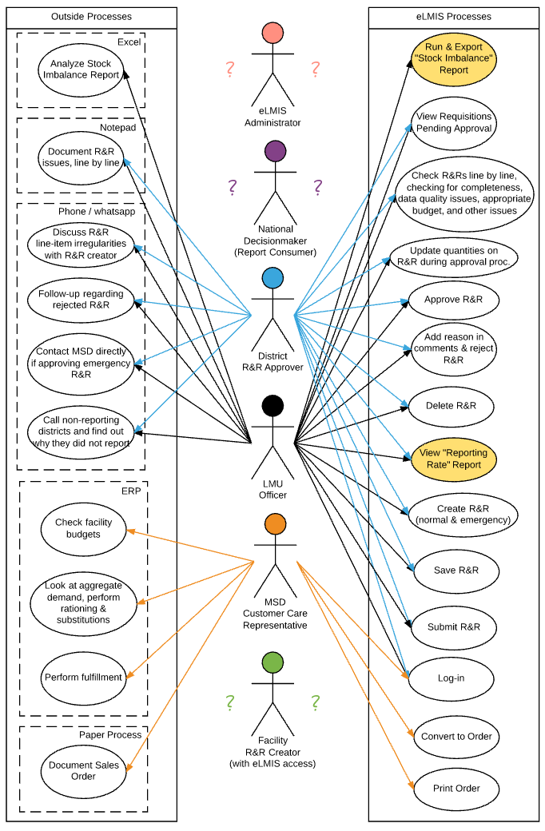

Feature Gap
Though gap analysis in Tanzania remains incomplete, what we have discovered thus far shows a limited gap between eLMIS and the OpenLMIS 3.x roadmap. Interviews with facility level eLMIS users (in Dar Es Salaam), eLMIS administrators, and National Decisionmakers are required to complete this gap analysis.
The largest gaps in functionality we’ve discovered are around reporting. eLMIS has a vast array of reports and report filters that are not on the OpenLMIS roadmap. However, interviews thus far have shown that users only interact with a very limited number of these reports – amongst the 3 user personas we interviewed, they only used 2 reports in total – so this gap could be quite small. Recreating these two reports would likely be low effort. However, this gap may grow larger upon future investigation with decision-makers, whom we assume, are the primary consumer of many eLMIS reports.
Another gap area is dashboards. None of the personas we interviewed claimed to use the eLMIS dashboards, however this may change as we perform additional interviews.
We identified a small gap area regarding the automatic calculations on the R&R form. While these calculations are not on the roadmap, extension points for customized calculations are, so we believe this to be a small gap as well.
Lastly, we were unable to get any information on lab equipment during our visit. While equipment will likely be on the OpenLMIS roadmap as part of the vaccines module slated for 2017, exploration of both eLMIS lab equipment and vaccines must be performed to better understand if a gap exists and to what extent.
At this point in discovery, the gap between the features present in eLMIS in Tanzania and those on the OpenLMIS 3.x roadmap seem relatively small or low complexity.

Zambia
eLMIS in Zambia was developed as part of USAID | DELIVER PROJECT, with initial pilots at the facility level beginning in 2014. The approach used in Zambia is markedly different than that used in Tanzania with a primary focus on the “Facility” and “Central” editions of the software.
The Central edition of the software operates similarly to eLMIS in Tanzania, with a web based interface for approving R&Rs from facilities and converting them to orders which are then pushed to a MACS ERP system. The Central edition allows R&Rs to be synced from the Facility edition or for users to manually enter paper forms from facilities that do not have access to the Facility edition.
The Facility edition is currently deployed at 251 hospitals which are operated by the Ministry of Health or Ministry of Defense. The Facility edition allows hospitals to perform inventory management at multiple nodes (i.e. labs, ARV dispensary, etc.) within the hospital via an off-line local network which can be synced with the Central edition when internet access is present.
Additionally, there is a Hub edition that operates in Lusaka similarly to the Facility edition. However, rather than delivering to different service delivery points on the hospital grounds, this “mini-warehouse” delivers to different facilities in the Lusaka area.

Matrix of all personas
The following matrix describes the eLMIS Zambia personas, their levels in the supply chain, their goals as a user, and their system roles. We identified these personas but were not able to interview individuals from each type during our 4-day visit. Personas without highlighting, may need follow-up during additional visits. Those highlighted in yellow were not interviewed and will need to be interviewed during follow-up activities.
User | Level | Goals | System Role
LMU (MSL) Officer | Central | - To achieve visibility into stock levels throughout the country  - To communicate with lower levels regarding delivery delays, changes to orders, rationing, etc.  - To provide necessary order information to warehouse for order fulfillment | - View approved R&Rs from district  - Review & approve R&Rs  - Convert R&Rs to order  - Generate reports for district program officers:  - Non-reporting facilities  - Stock balance  - Consumption
Store Manager | Facility | - To manage their storeroom  - To ensure timely ordering  - To eliminate/minimize stock outs  - To complete physical count and periodic reporting on time with complete and accurate data  - To ensure all dispensaries/other nodes within their facility complete physical counts as well | - To record stock issues  - To record stock adjustments  - To record stock receipt  - View stock on hand for all commodities in store room  - To record physical stock count  - To generate monthly R&R to central edition  - To sync with central edition database
Dispensary Clerk | Facility | - To fill patient prescriptions  - To ensure sufficient stock in the dispensary to fill prescriptions  - To eliminate / minimize stock outs | - To record stock dispensing  - To record stock adjustments  - To request stock from main storeroom  - To record physical stock count  - To view electronic stock cards for all products at SDP
Lab Store Manager | Facility | - To manage lab store  - To ensure lab equipment is working properly  - To manage kits  - To perform testing of samples, sample management  - To ensure all lab supplies are in stock  - To complete emergency orders as needed | - To consume lab stock supplies for intended use (not dispensary, but consumption of products)  - To record stock adjustments  - To record receipt of stock  - View stock on hand for lap supplies  - To record physical stock count  - Request stock from main storeroom  - View electronic stock card
System Admin | Central | - To manage ongoing system operations  - To assist users in system use  - To provide ongoing system maintenance  - To provide updates and enhancements | - To administrate the system, including management of:  - Users  - Facilities  - Products  - Approval / reporting hierarchies  - Data collection (types of information, calculations)  - System integrations (SmartCare, MACS, Facility → Central edition)
Decision-maker  (Report Consumer) | Central
Warehouse manager | Central
District Approver | District
District Store Manager (Approver)  aka Pharmacist | District
Hub Approver | Hub

Actor Diagram
For the same reasons outlined in the Tanzania section, this actor diagram can be considered conservative. Please also note the significantly increased number of actors and larger gap in supported actions. This diagram is a living document and will be updated as additional discovery takes place.
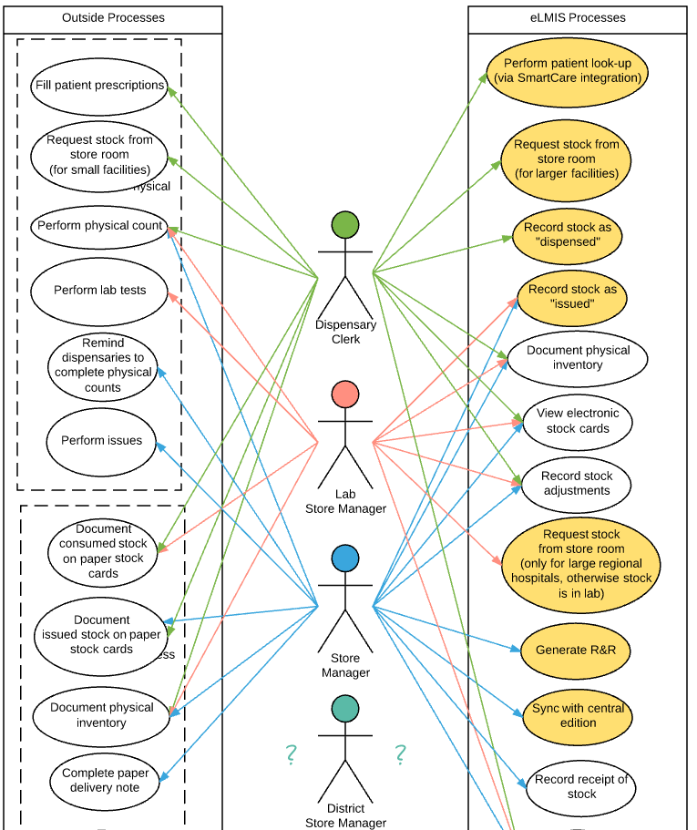

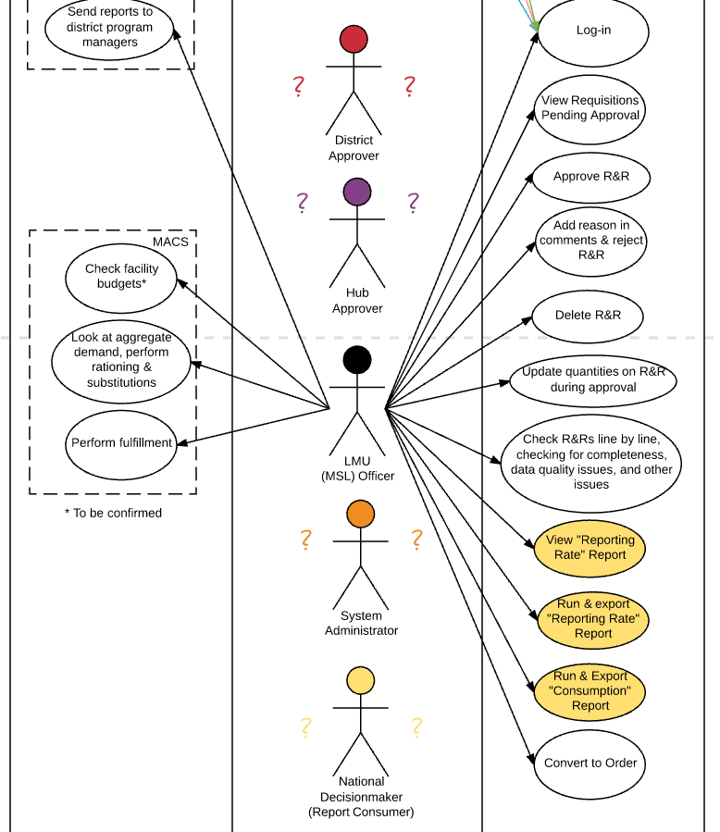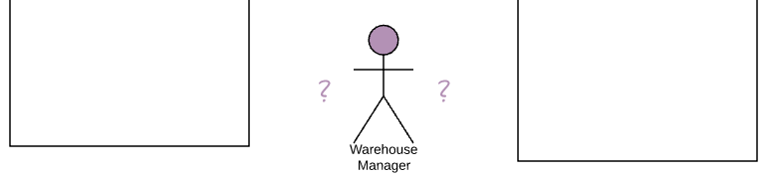

Feature Gap
The feature gap between eLMIS Zambia and OpenLMIS 3.x appears to be quite large or of “high” complexity to re-create in OpenLMIS. The following table represents the currently identified features that are not on the OpenLMIS roadmap. Additionally, there are several features that the OpenLMIS community has defined as outside of the OpenLMIS domain such as dispensing and integration with an EMR system. While the new architecture supports building these features as contributed rather than community modules, these features contributions to shared benefit would be minimal.
Complexity of Gap* | Feature Set
High | Dispensing
High | Integration with an EMR system
Medium | Multi-level stock management support within a health facility
Medium | Facility Edition optimized for use with touch screens
Medium | Aggregate requisitions
Low | Automatically generated requisitions
Low | Physical count validation
Low | Facility edition offline capability

There is an additional grey area regarding these gaps in that some of this functionality may be met by alternative functionality that is on the OpenLMIS roadmap. For example, while there is no intention to develop a facility edition based around a local area network that allows off-line functionality, there is a tablet front-end that utilizes the mobile network to communicate data that likely fills many of the same use cases as the facility edition. Likewise, this tablet based approach could supersede the need for a facility edition optimized for use with touch screen monitors. Investigating these grey areas is an important portion of the continuing gap analysis effort and will be reported on at project end.
At this point in discovery, the gap between the features present in eLMIS in Zambia is large and would take considerable effort to recreate in OpenLMIS 3.x. This picture will become clearer with additional discovery.

Next Steps

Remaining Gap Analysis Work
The following activities must be completed to provide a clear picture of the gaps between the current features (and roadmap) of eLMIS in Tanzania and Zambia and the feature roadmap for OpenLMIS 3.x.
- Complete documentation of eLMIS personas and interactions within the system through interviews and field visits
- Analyze eLMIS roadmap and incorporate into gap analysis
- Match non-gap features into OpenLMIS releases (i.e. 3.0, 3.1, etc.)
- Identify complete list of gap features
  - Explore use cases for gap features and analyze whether features on the existing OpenLMIS roadmap may fulfill those use cases
- Report back on met and unmet eLMIS features by OpenLMIS releases including a rough level of effort (by business analysts, not developers) required to re-create the feature(s)
Based on the outcomes of these activities, an informed decision can be made on the need to add these “gap features” to the OpenLMIS roadmap and whether a migration path makes sense, and if so, the priority of such an undertaking.

Current Recommendations
Based on current findings, we recommend the gap analysis proceed with only slight modifications.
Tanzania
We recommend an additional 1 – 2 weeks of discovery focusing on:
- Interviewing and documenting interactions of the remaining personas
- Continued documentations of user and system processes (including reporting needs)
- Exploration of lab equipment
- Document roadmap and on-going focal points for parallel development
Zambia
We recommend an additional 2 – 4 weeks of discovery focusing on:
- Interviewing and documenting interactions of the remaining personas
- Understanding the underlying use cases that resulted in FE design choices
- Continued documentations of user and system processes
- Document roadmap and on-going focal points for parallel development
The results of the field validation will then be documented and reviewed by business analysts and the OpenLMIS product owner over the course of 4 weeks. The resulting product will be a categorization of system actions as part of an OpenLMIS release (including release tag) or as a gap. The team will then report these findings to the OpenLMIS Community.

