OpenLMIS Version 3 – A Global Achievement
Written by: Tenly Snow, OpenLMIS Community Manager
Tenly.snow@openlmis.org
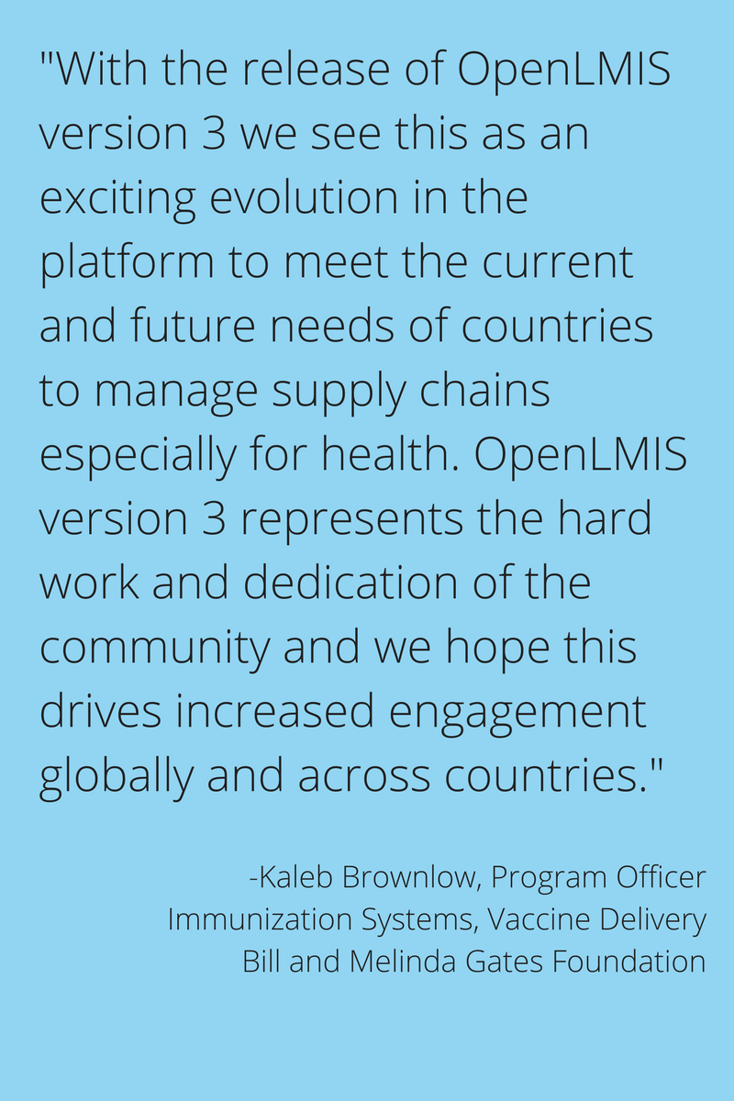
Selection of photos to accompany blog at the end of the document (not required – use as necessary)
The release of OpenLMIS version 3 on March 1, 2017 is truly something to be celebrated – it is the result of an extraordinary global effort that could not have been accomplished without the support of organizations and individuals around the world.
Teams from multiple countries contributed technical requirements, defined business processes, and wrote countless hours of code for the latest iteration of OpenLMIS, a powerful, enterprise class logistics management information system (LMIS). Since 2012, OpenLMIS has provided high-quality logistics management to improve health commodity distribution in low- and middle-income countries, and with version 3, the software is more forward-looking and collaborative than ever.
Over the last year, software development firms SolDevelo in Poland and VillageReach in the United States have contributed to a complete redesign of the core software architecture of OpenLMIS, moving away from a monolithic structure that encouraged “forking” the code, to using a micro service based approach to create a more flexible and extensible architecture. A core set of services is now accessible and grants users a high degree of customization without changing the core code. Users can choose which features they want to “turn on” – and have the ability to further refine those features to meet their needs. As new modules are developed for particular country implementations, these modules will be available to other users, further emphasizing the key vision of the OpenLMIS Community - shared benefit, shared investment. Now, rather than creating separate, parallel code structures, OpenLMIS version 3 allows continuous improvement of the core through shared country experiences, increasing the return on funders’ investments and benefitting the global health community as a whole by further encouraging collaboration between countries.
At SolDevelo, we are proud to have been part of the journey to OpenLMIS version 3 and having played a key role in establishing the new micro-service architecture. We are excited to see OpenLMIS version 3 released and ready to be deployed in the field to improve the work conditions of logistics and healthcare workers. We look forward to further serving the community through work on future releases and further improvement of OpenLMIS. – Pawel Gesek,Technical Project Manager, SolDevelo
The OpenLMIS Community has been highly active throughout the entire re-architecture process, and the release of OpenLMIS version 3 has made it stronger than ever before. From contributing to initial design considerations, prioritizing features and functionality, and assisting with user acceptance testing (UAT), the re-architecture could not have been completed without the invaluable participation and support of the Community. The OpenLMIS Initiative depends on its partners for guidance and assistance and they continue to immeasurably strengthen the Initiative.
Having deployed the OpenLMIS platform in three countries, JSI has experienced first-hand how dynamic the environment is. A more modular version with plug and play features will provide much needed flexibility to meet the evolving demands of tomorrow's health supply chains.
– Chris Wright, Practice Lead, Data Visibility & Use, JSI

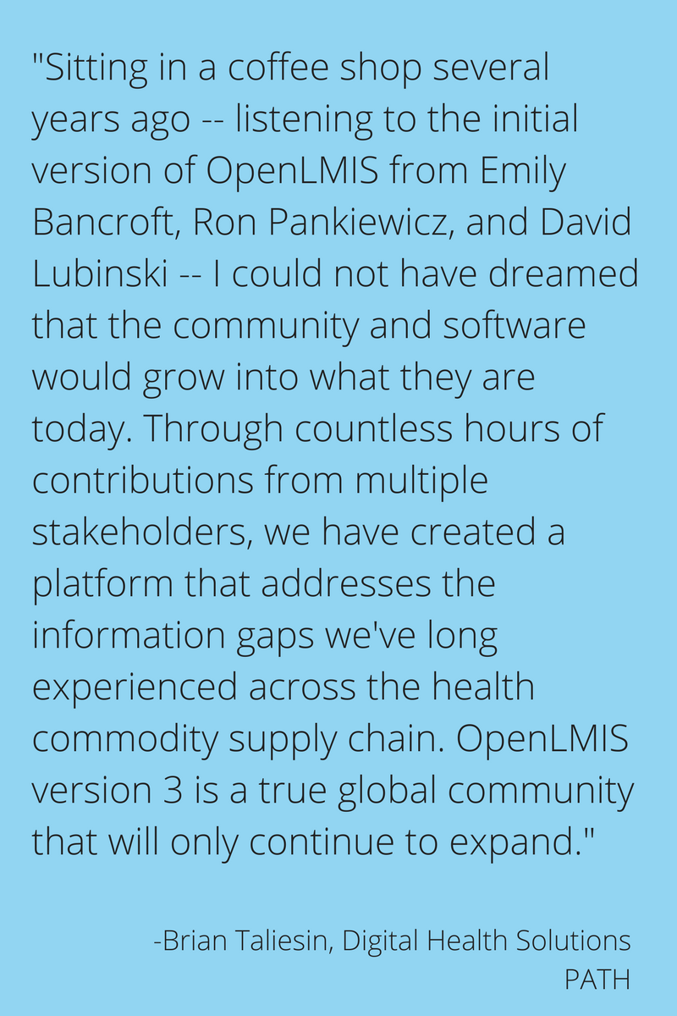
To reflect the growing capacity of the OpenLMIS software and the expanding diversity of the OpenLMIS Community, the launch of version 3 is coupled with a renewed focus on community building. Streamlined community processes, transparent development and documentation, and information sharing between partners are the hallmarks of the OpenLMIS Initiative in 2017. An updated logo, refreshed website, and a new communications strategy will focus on expanding global awareness of OpenLMIS to increase opportunities for implementation.
From the earliest requirements gathering workshop conducted in 2008, to the launch of the OpenLMIS initiative in 2011, the first release of OpenLMIS in 2012, and the formation of the OpenLMIS Community in 2015, the OpenLMIS Initiative has continue to grow in participation and magnitude. With the support of major global health stakeholders like PATH, CHAI, and JSI, and new partners like BAO Systems and Chemonics, OpenLMIS has become a key player in the global health landscape. The Bill & Melinda Gates Foundation and USAID have been the primary funders of the OpenLMIS Initiative since the beginning, and the Gates Foundation continues to assist OpenLMIS with supplemental funding in 2017 to complete additional activities beyond the version 3 release, including adding vaccine-specific functionality. OpenLMIS would not be where it is today without their support, and we are incredibly grateful for their continued guidance and participation in this growing initiative.
OpenLMIS version 3 is the result of a bold undertaking by the Community to re-architect the way the software adapts to varying country contexts and needs. I'm excited to see its impact moving forward in future implementations, particularly in how a country can extend the system to fit their needs without sacrificing their ability to upgrade easily to future versions of the software. – Chris George, Principal Consultant, ThoughtWorks
The real success of the version 3 launch is the success of the Community. The Initiative remains dedicated to its mission to make high-quality, powerful LMIS software available in low-resource environments – and maximizing the benefit of the software through profound collaboration between partners and countries. This release would not have been possible without contributors around the globe and a growing network of dedicated individuals and organizations, combining their expertise and skills to create a lasting, sustainable legacy.
See the OpenLMIS 3.0 Release Notes for the full details of the release, and visit Features and Benefits on the newly updated openlmis.org for a full feature list. Please contact info@openlmis.org to see a demo of OpenLMIS version 3.
Interested in learning more about OpenLMIS? Visit openlmis.org or write to info@openlmis.org

A) OpenLMIS manages vaccines in a majority of provinces in Mozambique

B) Members of the OpenLMIS Community at the September, 2015 all-community meeting
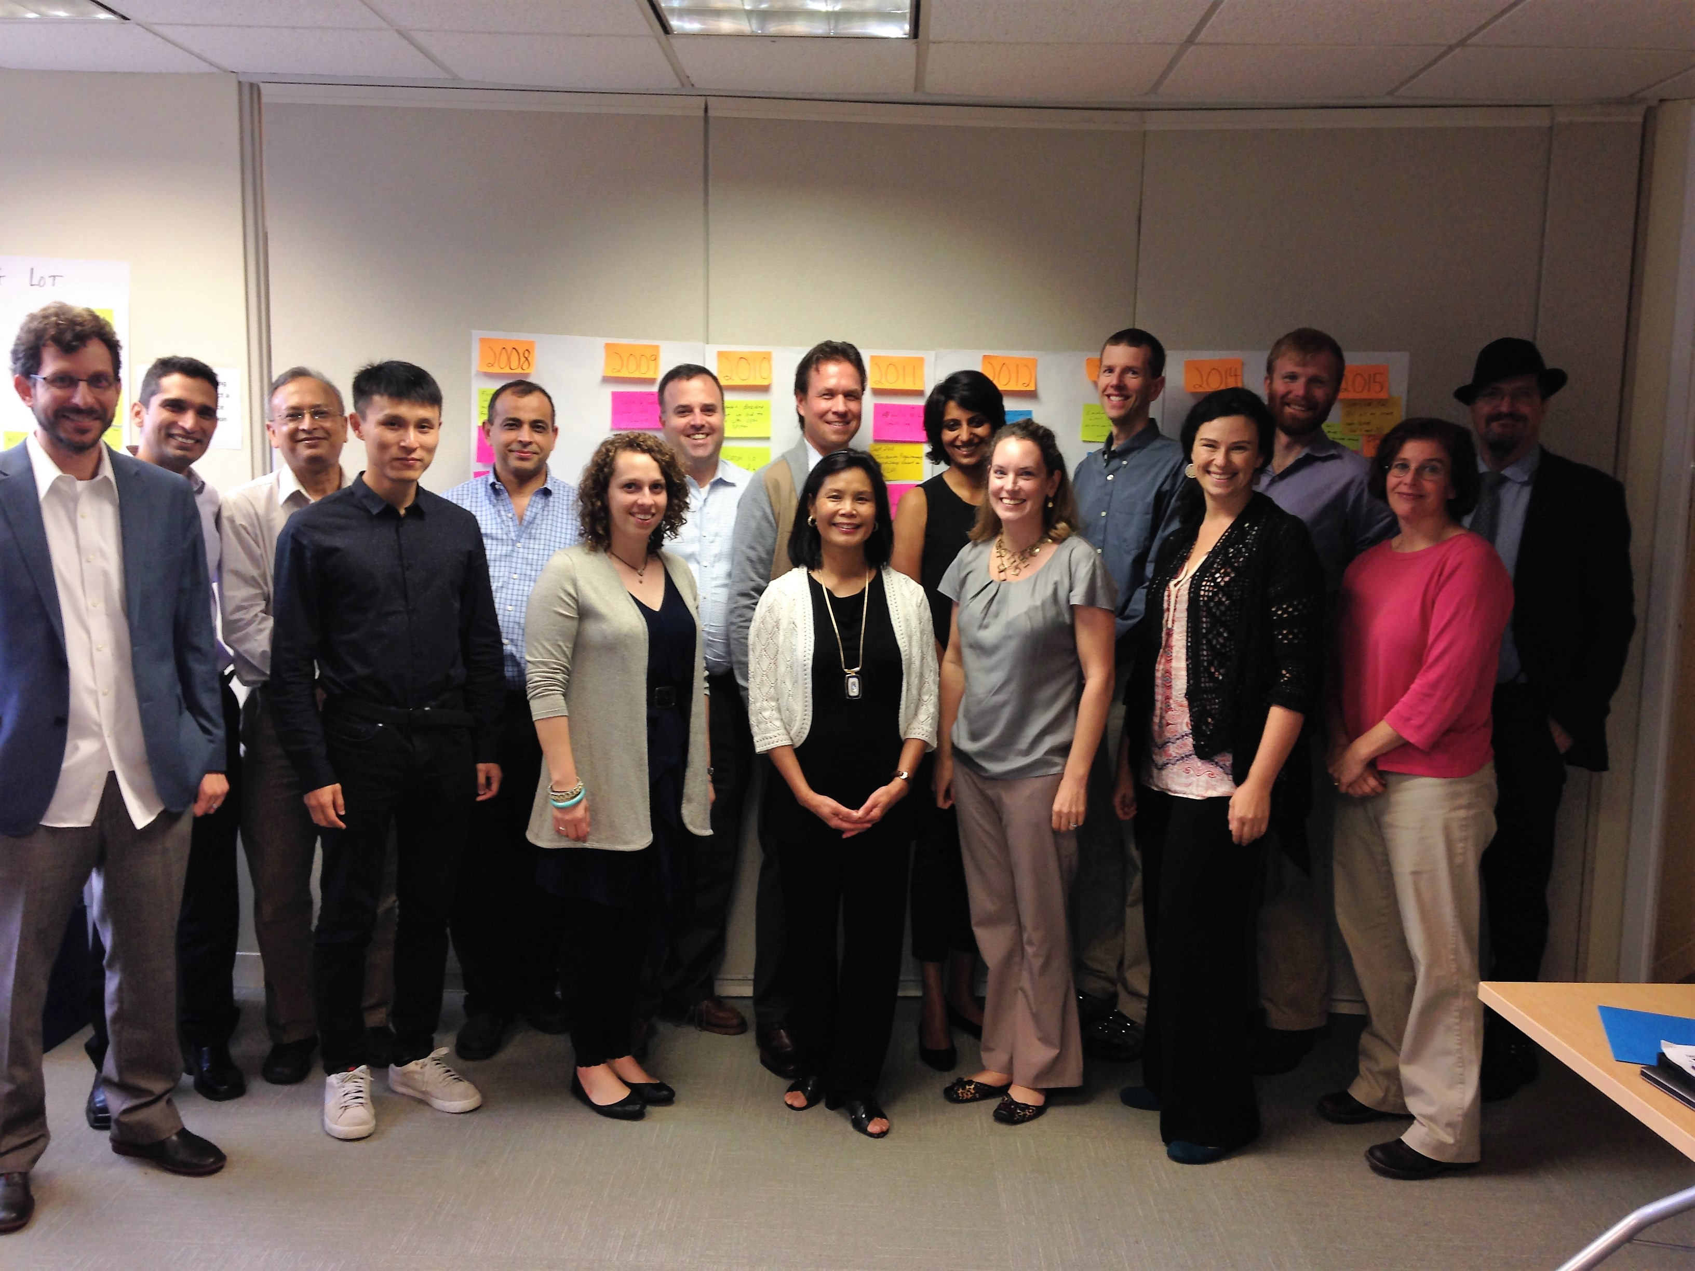

C) Training users on OpenLMIS in Mozambique

