Stock On Hand report

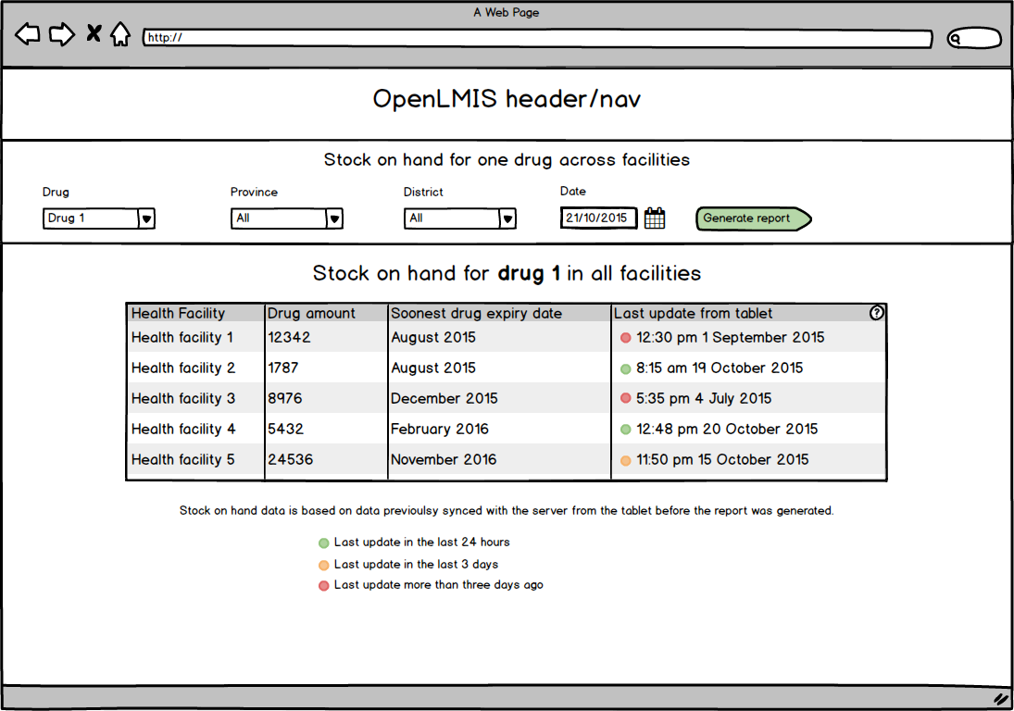

The report page is made up of two elements. A control bar that is used to generate the report and the report.

Control Bar
In the control bar there are 5 elements.
- A province selection combo box
- A district selection combo box
- A facility selection combo box
- A date picker
- A ‘Generate report’ button

- Province combo box
  - Users can select a province
  - Selecting a province constrains the districts available in the district combo box
  - Users can search for a province
  - Combo box selection and search behaviour
- District selection combo box
  - Users can select a district
  - Selecting a district populates the province combo box with the appropriate province
  - Selecting a district constrains the districts available in the facility combo box
  - Users can search for a district
- Facility selection combo box​​
  - Users can select a facility
  - Selecting a facility populates the province and district combo boxes with the appropriate province and district
  - Users can search for a facility
- Date picker
  - User can select a date
  - Default selection is the current date
- ‘Generate report’ button
  - The generate report button will generate a report based on the parameters in the combo boxes
  - If a combo box isn’t populated and the generate report button is clicked validation feedback will be displayed below the relevant combo box in red e.g ‘Please select a facility’.
  - When a user changes their selections within the combo boxes they will need to click the generate report button again to rerun the report with the new parameters

Report
In the generated report pane a table is visible with the columns below as well as a header with the text “Stock on hand for all drugs at {Facility name}”
- Drug name
- Drug amount
- Drug expiry date
- Movement sync information

- Drug name
  - Column contains the name of the drug
- Drug amount
  - Column contains the stock on hand of the drug at the relevant facility
  - Stock on hand will be a number formatted with a comma every three digits (100,000)
  - If there is no stock on hand at the facility this field should be red (#AB433F)
  - Low stock
  - Overstock
  - This column should be right aligned (unlike the mockup)
- Drug expiry date
  - Expiry date of stock on hand at facility
  - Only the soonest expiry date shown
  - Expiry date of the drug formatted with month and year (August 2016).
- Movement sync information

General
- ​Combo box selection and search behaviour
  - ​​When a user clicks on the combo box a list of options appears below the combo box
  - Users are able to type within the combo box and search for the option they require
  - When searching in the combo box the search will filter the dropdown list below on each character entered
  - As the results are filtered the string in the options below that matches the search string is highlighted
  - NB! Example of required combo box behaviour
    - ​http://brianreavis.github.io/selectize.js/​
    - Scroll to ‘Country Selector’
- Loading
  - While the report is being generated a loading spinner should be visible and the text ‘Your report is being generated’ should be visible in the report area.

Stock out report

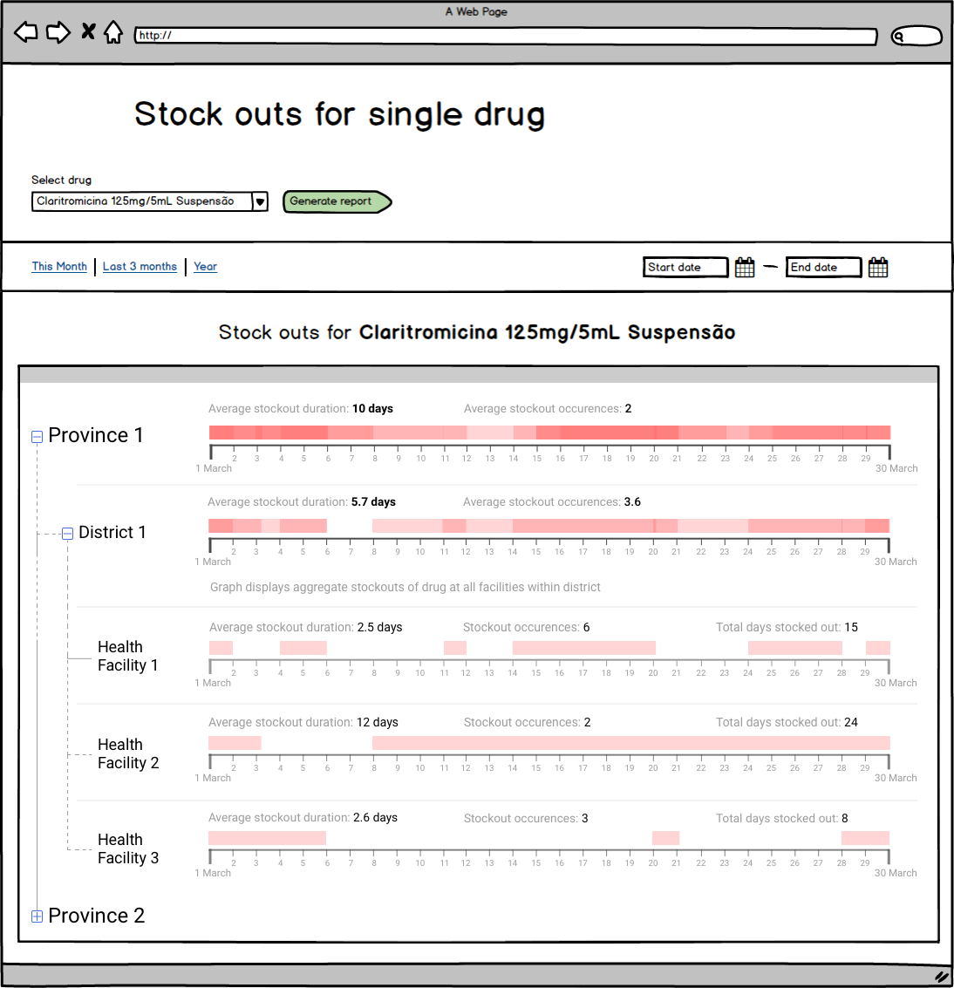

Drug selection:
Only one drug should be selected by user per time, as the name of the report suggests.

Stock out definition:
When soh of a drug goes down to 0 from a positive number, that date is the start of a stock out event.
When soh of a drug goes to a positive number from 0, that date is the end of a stock out event.
Days in between those two dates is the duration of the stock out.
If the soh of a drug is still 0 on the current day, that is a on-going stock out event, its duration should be the days between the start date and the current day.
If one drug initiate its soh is 0 at beginning, then when its soh become positive number, we won’t regard this as duration of the stock out.

Date range selection:
User should be able to select a date range, in the format of start - end (as the mock up shows).
Any stock out event whose duration overlaps with this selected period should be displayed.

Tree view:
The tree view should have 3 levels: province, district, facility.
Each level should have its own graph, which will be described below.
All the facilities that were carrying the selected drug during the user selected date range will be included in the tree view, so in turn the district and province that the
facilities belongs to will also be included.
Definition of the term "carrying a drug":
If a facility has created stock card for the selected drug before or during the user selected date range, then we define that as "carrying a drug".
Deactivation, reactivation and archived drug:
We suggest to keep this out of scope, since the openlmis system does not have traceability of these information.
To be more detailed, if a facility was carrying the selected drug during the selected date range, but the drug has been archived or deactivated during that date range, the graph
will show it as stock out, since the soh is 0.
Ideally, deactivated or archived drugs should not be shown as stock out, but since the openlmis system does not record exact dates of deactivation and archive, this can not be achieved at
the moment.

Graph for facility:
The graph for one facility should be shown as the mock up. That is, the part of stock out duration that overlaps with the selected date range will be marked as red.

Graph for district and province:
The graph for district and province should be aggregated results of the facilities under it.
To be more detailed, in the selected date range, on any certain day, the graph should be filled with red color representing there were stock out events that day.
If there were no stock out events on a certain day, the graph should not be filled with any color.

Height of the filled area:
The height should be determined by percentage of facilities had stock out on that day. The following is the formula:
Percentage = (number of facilities stocked out) / (total number of facilities under the district or province)
(
number of facilities stocked out: number of facilities under that district or province that is carrying the drug that had 0 soh on that day
total number of facilities under the district or province: total number of facilities under the district or province on that day that is carrying the drug
)

Definition of the term "facilities under that district or province on that day":
If a facility goes live before or on a certain day, we define that facility as being under its district or province on that day.

Switching district/province of a facility:
We suggest to keep this out of scope as well, since the system does not have full traceability of this information either.

Pop up messages:
When user points mouse cursor at the graph, there should be a pop up box that shows:
“…”
The message box will disappear automatically when user moves the mouse cursor away.

Tracer drug report

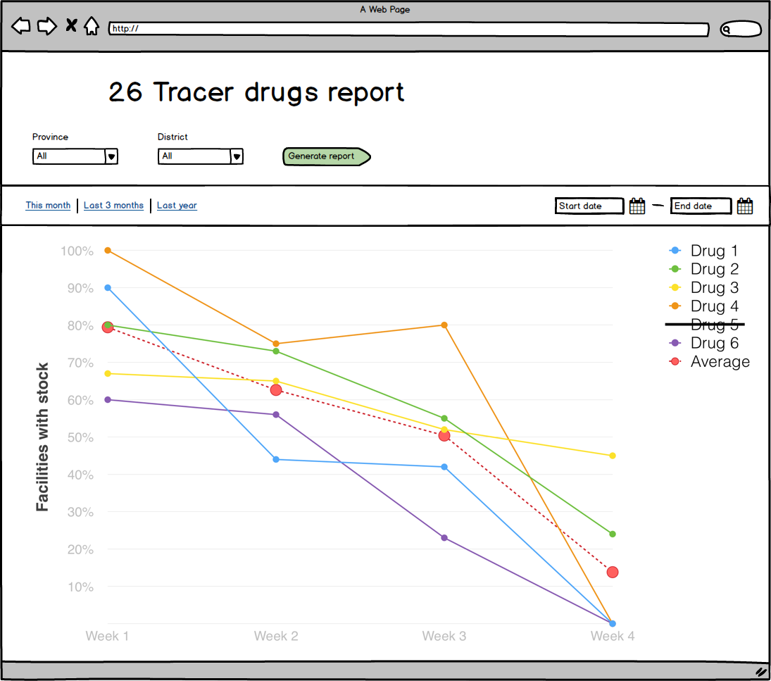
Understanding:
Calculation logic is as below:
For example, if there are 10 health facilities in total while only 5 of them have these tracer drugs then the percentage is 50%.

Average is the average percentage of all tracer drugs, calculation logic is below
 | % of facilities with stock
Drug | W1 | W2 | W3 | W4 | W5 | W6 | W7 | W8 | W9 | W10
Drug A | 60% | 55% | 50% | 30% | 85% | 80% | 70% | 55% | 90% | 90%
Drug B | 60% | 50% | 49% | 23% | 70% | 66% | 60% | 50% | 91% | 90%
Drug C | 60% | 60% | 30% | 25% | 85% | 62% | 55% | 23% | 75% | 60%
Drug D | 40% | 40% | 23% | 20% | 95% | 94% | 80% | 55% | 75% | 62%
Drug E | 40% | 35% | 33% | 10% | 88% | 80% | 55% | 30% | 80% | 23%
Average | 52% | 48% | 37% | 22% | 85% | 76% | 64% | 43% | 82% | 65%

- Default view is all tracer products are selected across all province and districts in this month.
- When I choose a specific province/district and click the generate button, it will generate the tracer report for my chosen location
- When I click the export button, it will export all raw data relate to this report
- When I choose a specific date range, the tracer report will only be generated within the data for that given period.
- When I unselect a product, this product’s line will disappear on the chart.
- When I point to one dot on the chart, it shows which week, what health facilities have positive SOH of this tracer product.
- Average trend line will remain the same no matter whether user selects/deselects a tracer drug.

Consumption report

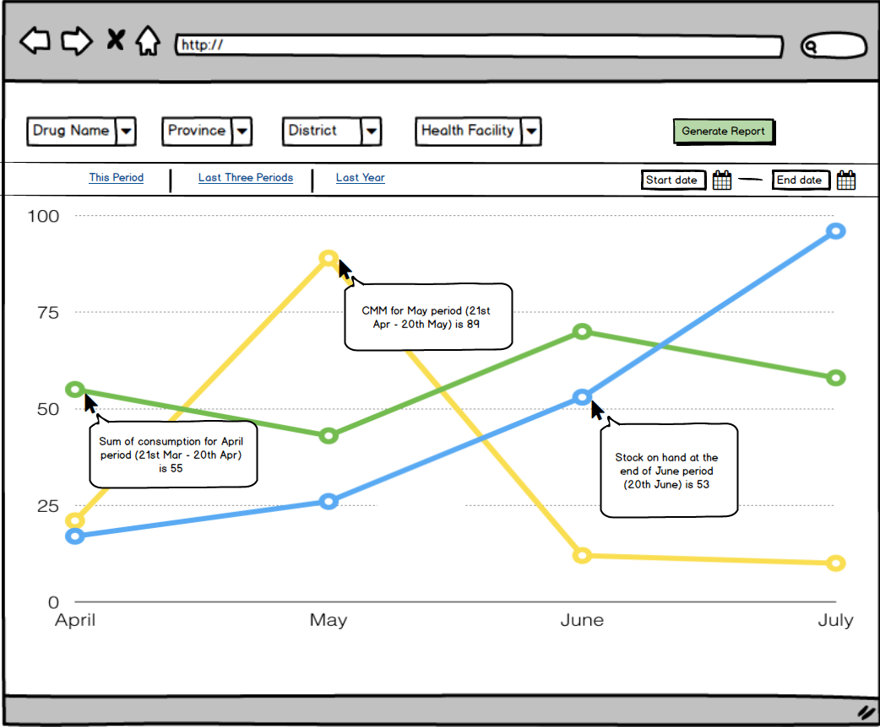

- X-axis: period, each dot represents one period (21st - 20th )
- Y-axis: the amount of the chosen drug
- Consumption line is the summary of consumption for each period
- stock on hand line is the stock on hand amount at the end of each period
- CMM line is the CMM value for each period, if CMM is does not exist then we will not draw the CMM line
- Drug name is mandatory field and it allows user to search by drug name keywords or FNM number
- Province is mandatory field and it allows user to choose from a drop-down list
- District is optional, default value is ‘all’ which means the select all for the given province
- Health Facility is optional, default value is ‘all’ which means the select all for the given district
- Start date is mandatory and it only allows user to choose month/year for current or past periods
- End date is mandatory and it only allows user to choose month/year for current or past periods and it must be larger than start date
- we also provide the quick timeline link for users to choose, ‘this period’、‘last three periods’、’last year’

Adjustment occurrences report

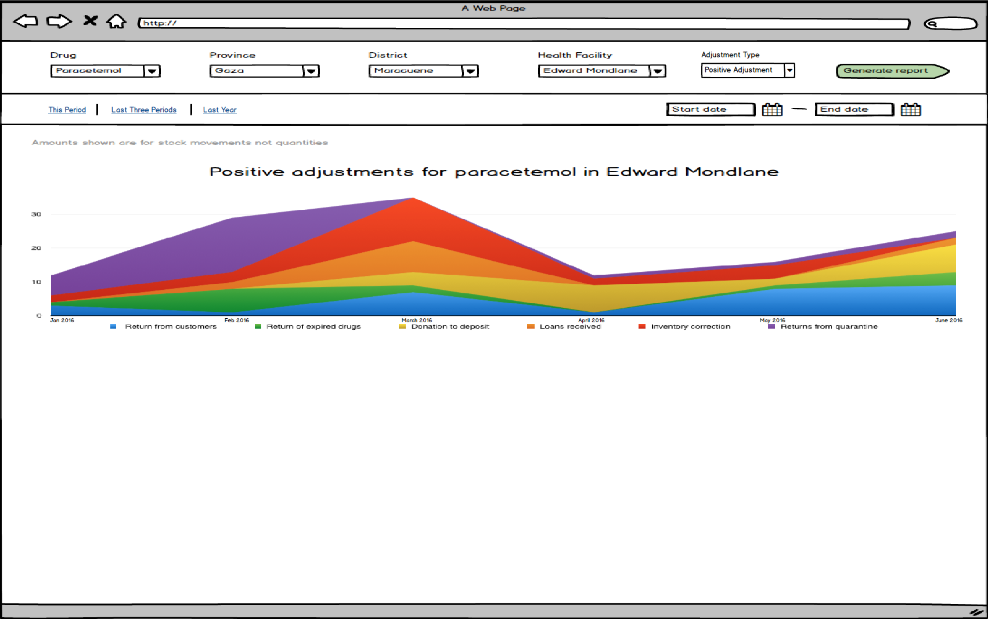

- date picker only allows users to choose month/year and one month means one period (21st - 20th )
- search drug name/FNM number, drug field is mandatory for generating the report (mandatory field)
- choose province/district/health facility
- province is mandatory field
- district/health facility are optional field and the default value is ‘all’
- adjustment type: positive/negative, default is negative
- colour code adjustment reasons
- Default view is empty
- Y-axis is the sum of occurrences for each reason
- X-axis is the period, one dot represent one period (21st - 20th), e.g. Jan 21st – Feb 20th will be displayed as “Jan – Feb 2016”

- Given I am at the web portal homepage when I click the adjustment report menu option then I will see the adjustment occurrences summary report page.
- Given I am at the adjustment report page when I choose a drug, a location (Province/District/HF), a time period (from the date picker), adjustment type (default value is negative) and click the generate report button then I will see the sum of all negative adjustments happened during for this specific drug at that given time period.
- Given I am at the adjustment report page when I miss those mandatory fields then I will see an error message informing me that I miss the mandatory field.
- Given I am at the adjustment report page when I click the drug drop-down box then I can search for a drug within the keywords of drug name or the FNM number.
- Given I am at the adjustment report page when I click the start/end date field then I will see a date picker pop up and only allows me to choose the current and past months. The end date must be larger than the start date.

