Key User Scenario Template
Description | Example
Background/Objective  Why are we doing what we are doing? What important background information is needed for the stories and may describe the pre-conditions or triggers?  Ideally including a statement describing what this functionality seeks to achieve. If possible, the objective would provide criteria guidance of how success would be measured or tested. | Background/Objective  See https://openlmis.atlassian.net/wiki/display/OP/Receiving+stock  1. Scope  The steps taken to accept shipped stock, via a proof of delivery within OpenLMIS, into the facility's inventory. The main additional feature is the ability to reject shipments.  2. Background  The process by which facilities using +OpenLMIS for stock management+ accept shipped stock into their inventory. The shipped stock must come from either a shipment file (from an ERP with OpenLMIS integration) or a fulfillment facility using OpenLMIS. If stock is shipped to the facility with only with a paper POD (perhaps from a 3rd party or donation), that stock will be entered via an adjustment.  Receive verified quantity and quality of goods into store and determine need for remedial action when necessary.
Personas  Who are the users that will be interacting with this functionality? What are their challenges, responsibilities, and level of connectivity?  These personas are intended to be representative archetypes of the key stakeholders who will participate in theses workflows/scenarios. | Personas  See https://openlmis.atlassian.net/wiki/display/OP/User+Personas  User Goals Pain Points Context, Characteristics, Comments, Quotes  Title: Storeroom Manager/Clerk - To manage my storeroom stock levels. - Ensure timely ordering/issuing of the right commodities in the right quantity. - I want my facility to have the right stock at the right time. I want to ensure the right stock is being ordered. I want to minimize stock outs. - Stock out, over stocks - Plays multiple roles Tech aptitude: Low technical skills - Has limited / poor internet connectivity - examples, could be pharmacy assistant or medical assistant, nurses for HIV, Health Surveillance supervisor
Business Process Diagram  Describes the tasks and the personas who perform those activities. The diagram provides the context for the user stories and serves as a focal point for achieving clarity and agreement among stakeholders. Looks like a standard flow chart. | Business Process Diagram  See http://www.path.org/publications/detail.php?i=1865  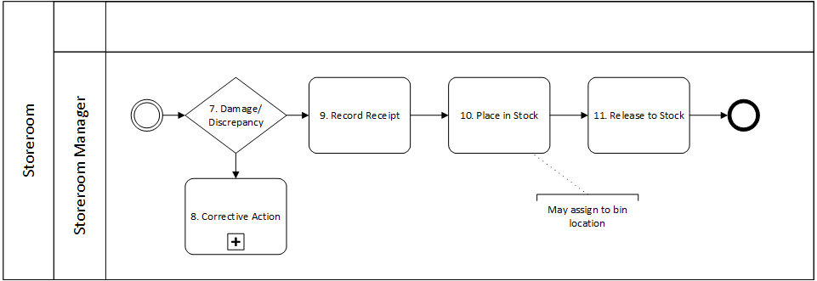
User Stories  Short, simple description of a feature told from the perspective of the person who desires the new capability, usually a user or customer of the system. | User stories  See https://openlmis.atlassian.net/browse/OLMIS-892  Task Description Link  7 View POD with approved requisition quantities As a storeroom manager receiving stock into my inventory I want to be able to electronically view and fill out a proof of delivery that shows what I requisitioned, what was fulfilled, and what I actually receive so that I have proof within OpenLMIS of stock movements and visibility into my current SoH. OLMIS-892  8 Reject shipment outright As a storeroom manager at any level I want to be able to wholly reject a shipment if it is unacceptable for whatever reason so that I am not held responsible for defective products and can follow the SOP OLMIS-686  8 Partially reject shipment As a store room manager I want to be able to partially reject a shipment by receiving the actual quantities of stock that I are delivered to me in good working order so that my stock levels are accurate and I can follow the SOP OLMIS-685  9 Provide e-signature to POD As a store manager at any level I want to account for shipments I've received that are going to be quickly sent out/picked up by another facility so that my stock balances aren't artificially high while waiting to send this package onward OLMIS-237
Dependencies  Identify initial dependencies that are on the critical path for this functionality and may affect the delivery time and serving of business goals. | Dependencies  See https://openlmis.atlassian.net/wiki/display/OP/Local+Fulfillment  Description Link  Electronic version of a stock card Used to mirror the physical cards that sit in storeroom bins and serve as a log of all past ins and outs for each commodity in the storeroom. Each stock card should contains all transactions for each batch of the commodity. OLMIS-623
Outstanding Questions  Initial communication between stakeholders and the development team to help understand scope and estimates. | Outstanding Questions  See https://openlmis.atlassian.net/wiki/display/OP/Local+Fulfillment  Question Outcome Status  Is there a need for order generation to be configurable? Right now, it is a manual step. Open  Do we want to increase the configuration of order templates? Open  How should the rejected or returned stock be handled at the warehouse? Open

