ColdTrace Integration Interface Requirements, June 2015
VillageReach and Nexleaf

- Project Overview
The purpose of the ColdTrace Integration project is to create an interface between the Nexleaf cold chain monitoring system and SELV in Mozambique so cold chain-monitoring data is available to users through the SELV system, and the more detailed information in Nexleaf can be accessed quickly and simply from SELV, via one login.

Nexleaf will handle the creation of the API that can be queried from SELV to populate: (1) a new cold chain status summary page in SELV and (2) a new status column on an existing page. VillageReach will contract an additional development team to handle the UI/infrastructure additions and changes to SELV.

- User Stories
A user story captures a description of a software feature from an end-user perspective. It describes the type of user, what they want, and why, thereby creating a simplified description of a requirement.

As a Field Coordinator in the DLS system
I want to know the status of fridge function at a health center before I leave on a vaccine distribution run to health center
So that I can better plan which health centers to visit and which health centers have malfunctioning CCE that need further follow-up.

As a CC technician
I want to see power and temperature profiles for fridges in the system
So that I can monitor CC performance I can understand underlying issues when a fridge is dead or malfunctioning

As an EPI logistics official
I want to log into a system to access information on both CCE and vaccine distributions
So that I have real-time insight when needed on vaccine supply chain logistics issues and fridge inventory and performance.

- Interface Requirements [from Nexleaf]

  - Interface definition

The interface will be implemented as a RESTful API. The specific API definition is to be provided by Nexleaf. The API call or calls need to be able to retrieve the information in table 3.2 below.

The API calls for status and associated URL will be queried in real-time based on users accessing the dashboard (see section 3).

Nexleaf will provide the full proposed API definition to VillageReach.

  - Data Elements

Data Element | Data Type | Values | Definition
FridgeID | Text string |  | Nexleaf Fridge ID
Status | Enumerated value | 1 – Failed  2 – Follow-Up  3 - Working  4 - No Data | See section 2.3
HighAlarmCount | Integer |  | Count of high temp SMS alerts above 8C in the past 7 days
LowAlarmCount | Integer |  | Count of low temp SMS alerts below 2C in the past 7 days
MinutesInRange | Integer |  | Minutes temperature was in range 2-8 degrees in the past 7 days
MinutesLow | Integer |  | Minutes temperature was below 2 degrees in the past 7 days
MinutesHigh | Integer |  | Minutes temperature was above 8 degrees in the past 7 days
MinutesNoData | Integer |  | Minutes where no temp data is available in the past 7 days
URL | Text string |  | Permanent URL linking to refrigerator power and temperature chart of the current month (based on the date of the query)

  - Health Indicator Definitions

The CCE’s health status indicators described below are preliminary thresholds. Note: in all the scenarios below, “week” is defined as preceding 7 days from date of the API call request, inclusive of the current date. For example, if a query is made on June 8th, the status will cover the period from June 2nd through June 8th.

    - Failed (Red)

Health indicator is Failed if:
Fridge is below -0.5°C for more than 48 cumulative hours in the past 7 days AND/OR above 10°C for more than 120 cumulative hours in the past 7 days.

    - Follow-Up (Yellow)

Health indicator is Follow-Up if:
Fridge is below -0.5°C for more than 1 cumulative hour in the past 7 days AND/OR above 10°C for more than 10 cumulative hours in the past 7 days

    - Working (Green)

Health indicator is Working if:
Health Status is NOT Follow-Up or No Data for the past 7 days

    - No Data (Black)

Health indicator is No Data if:
Less than 70% of data is available in the past 7 days

  - Maintaining Fridge ID Mappings

The Fridge ID to Fridge Name mapping will be handled in the Nexleaf System. Maintaining this list and cross-referencing with existing SELV CCE inventory and DPS inventory will be VillageReach HSG staff responsibility. This mapping will be verified every six months (January and July) and Nexleaf will be informed of any discrepancies for further corrections.

  - Authentication

Authentication will be provided by the standard cookie/session-key method. A POST with the username and password will be issued to a specified URL and the server will return a cookie with the session key to be included for all subsequent communication. Timeouts can be decided during implementation.

- Temperature & Power 30 Day Visualization [from Nexleaf]

In SELV, there will be two screens which will have clickable options that, when used, will take the user to the CT temperature and power 30-day data dashboard, which is provided as a mock-up below:

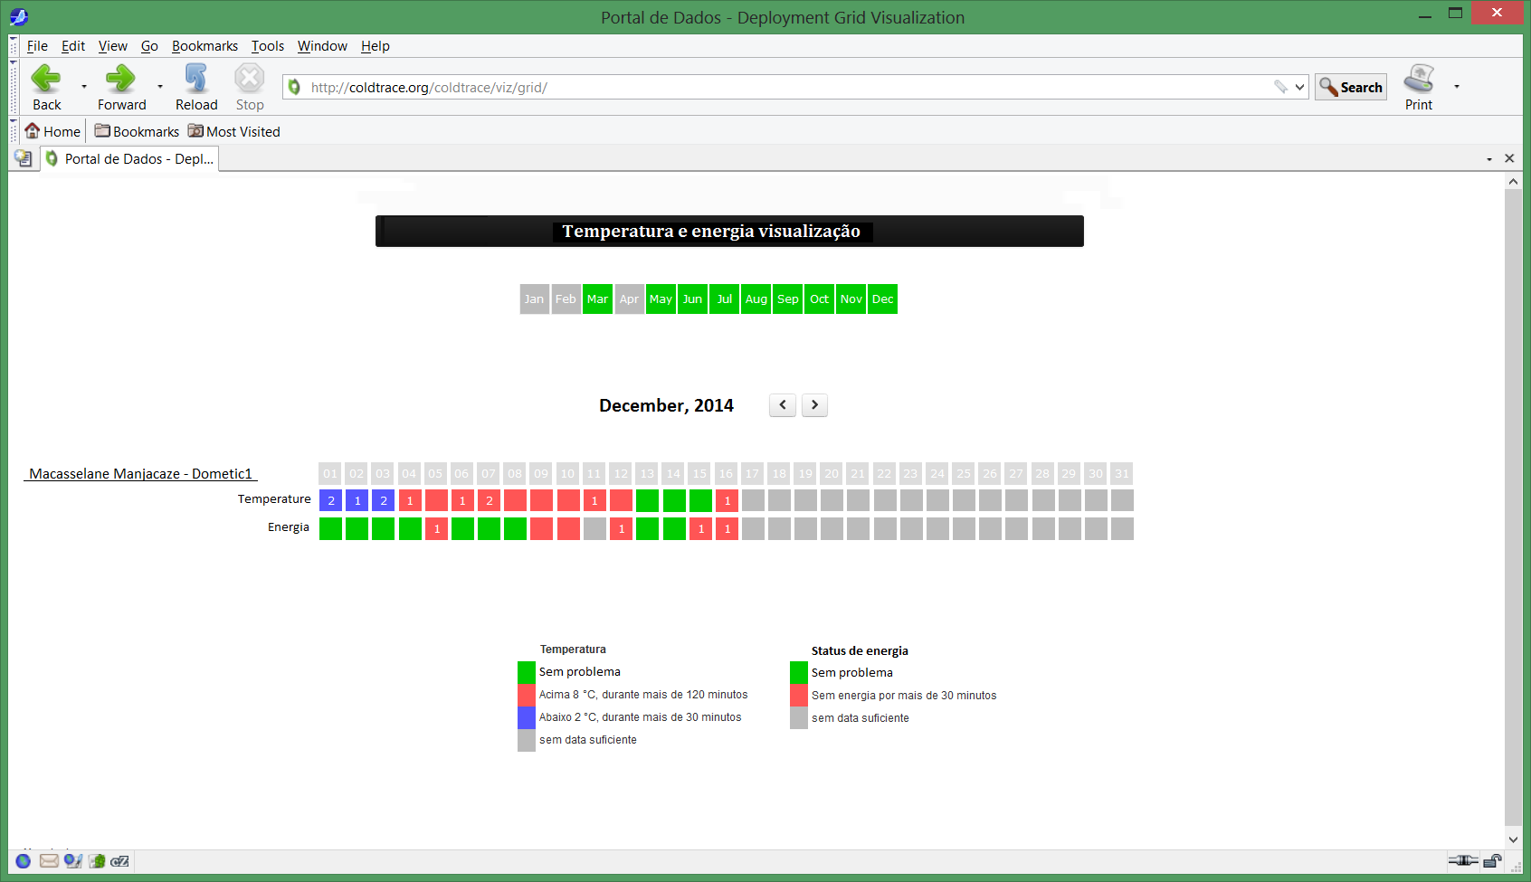

This data dashboard must be available in Portuguese and English.

Authentication: This needs further discussion since the API/feed can use the cookie/session-key method, however this interaction will happen via a users web browser. Suggestion: API provides a token that is used with basic http authentication.

- Changes to SELV UI/Infrastructure [VillageReach Contractor deliverable]

The following changes needed to be implemented in the SELV U/I. All new strings must be localized in English and Portuguese.

  - Distributions>Manage Landing Page
Add a new button, [View Cold Chain Status] to the Manage Distribution page in SELV, next to the [View Load Amounts] and [Initiate a Distribution] buttons (see mock up below). The button will only display if all the following criteria are met:
- A Delivery Zone is selected
- The selected Delivery Zone is in one of the following provinces:
  - Gaza
  - Tete
  - Niassa
- A Program is selected
- A Month is selected
If the criteria are not met, the button will not display on the screen. Additionally, the button must be localized in English and Portuguese so it displays in Portuguese if the Portuguese translation option is selected. The new button will display the Cold Chain Status Summary screen (see section 5.3)
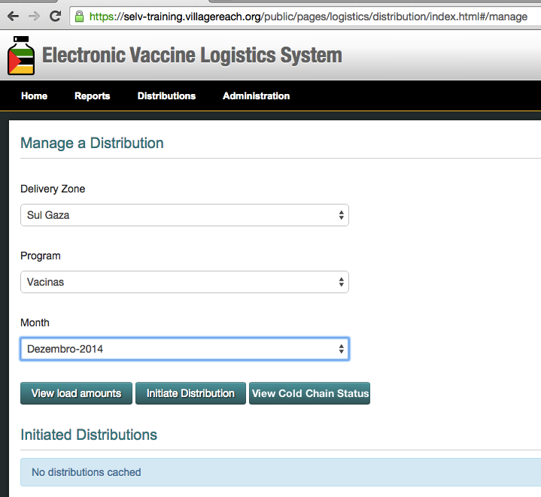

  - New page – “Cold Chain Status Summary”

When the [View Cold Chain Status] button on the Manage Distributions page is clicked, the user is taken to a new page, the Cold Chain Status Summary page (see mock up below).

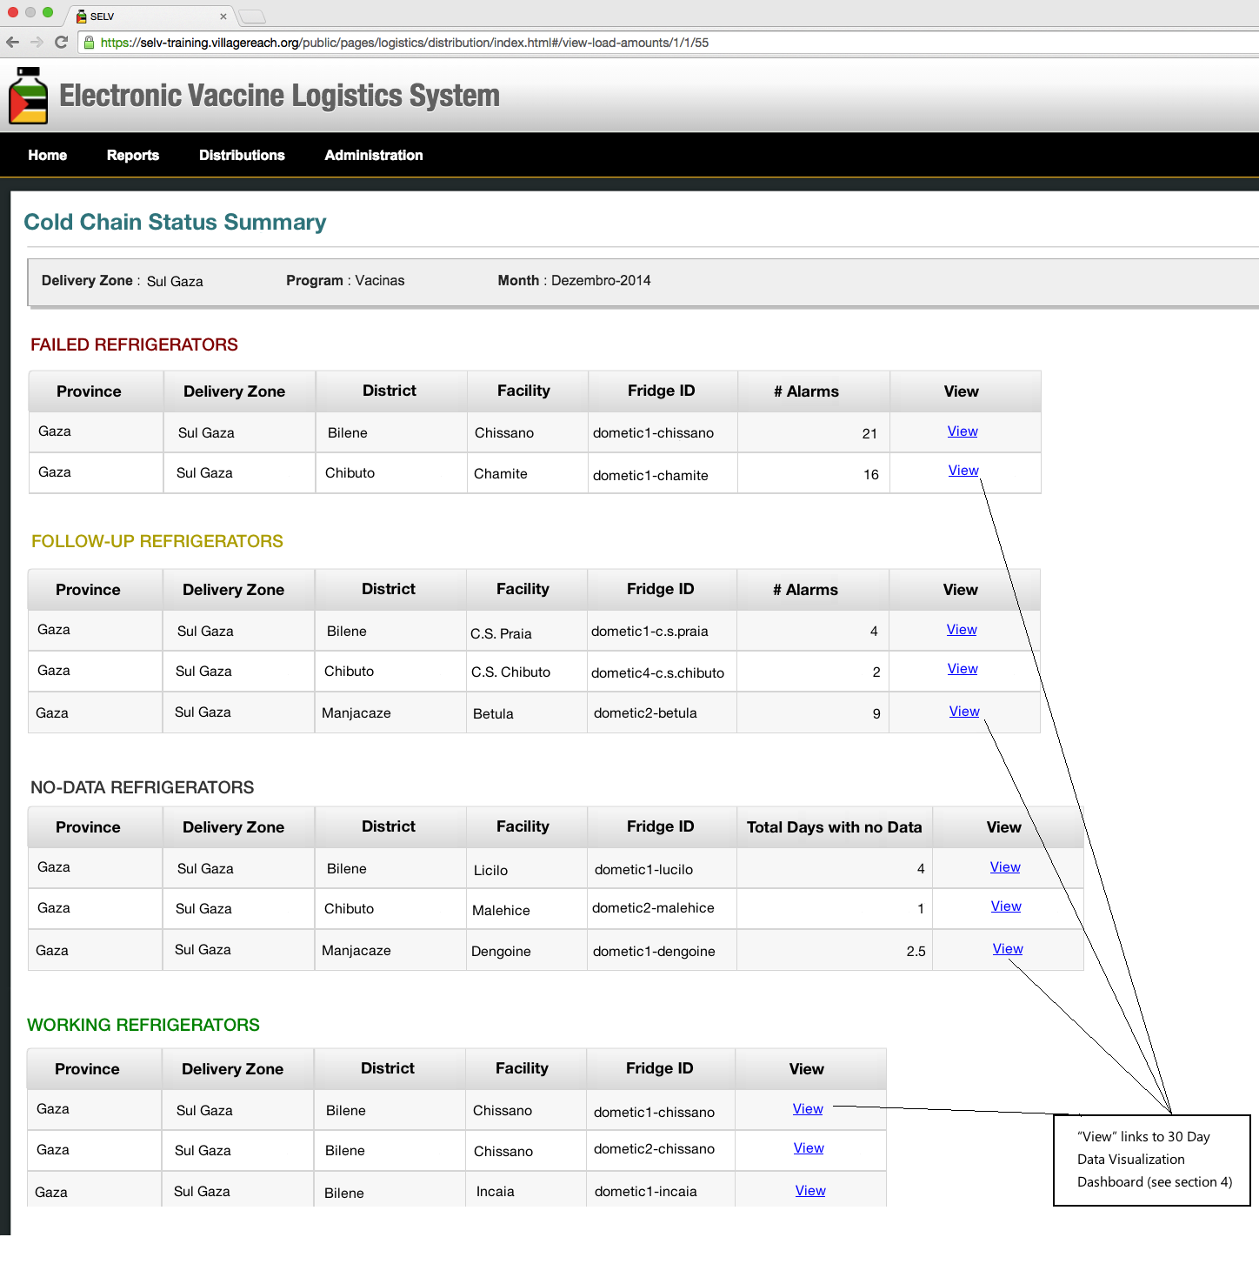
    - Section Descriptions

- Failed Refrigerators
Failed Refrigerators displays data for all fridge IDs associated to a facility within the selected delivery zone and program with status “Failed” (enumerated value 1) from the Nexleaf interface (see section 3.2). The section and section title only display if there are refrigerators with “Failed” status.

- Follow-Up Refrigerators
Follow-Up Refrigerators displays data for all fridge IDs associated to a facility within the selected delivery zone and program with status “Follow-Up” (enumerated value 2) from the Nexleaf interface (see section 3.2). The section and section title only display if there are refrigerators with “Follow-Up” status.
- No-Data Refrigerators
No-Data Refrigerators displays data for all fridge IDs associated to a facility within the selected delivery zone and program with status “No data” (enumerated value 4) from the Nexleaf interface (see section 3.2). The section and section title only display if there are refrigerators with “No Data” status.
- Working Refrigerators
Working Refrigerators displays data for all fridge IDs associated to a facility within the selected delivery zone and program with status “Working” (enumerated value 3) from the Nexleaf interface (see section 3.2). The section and section title only display if there are refrigerators with “Working” status.

5.2.2 Data Elements

Column/  Data Element | Data Type | Description | Source | Display Criteria
Province | Text | Displays the name of the province of the delivery zone selected on the Manage a Distribution page | SELV configuration reference data | Always displays for all fridges in all sections
Delivery Zone | Text | Displays the name of the delivery zone selected on the Manage a Distribution page | SELV configuration reference data | Always displays for all fridges in all sections
District | Text | Displays the name of the district where the facility of the fridge is located | SELV configuration reference data for facility associated to specific fridge | Always displays for all fridges in all sections
Facility | Text | Displays the name of the facility in which the fridge is located | SELV configuration reference data associated to specific fridge name | Always displays for all fridges in all sections
Fridge ID | Text | Displays Nexleaf fridge ID | Fridge ID from Nexleaf interface (see section 3.2) | Always displays for all fridges in all sections
# Alarms | Integer | Displays the number of alarms the fridge has experienced | Sum of HighAlarmCount and LowAlarmCount from Nexleaf interface (see section 3.2) | Displays for all “Failed” and “Follow-Up” status fridges (in Follow-Up Refrigerator section)
Total Days with no Data | Integer | Displays the total time, in days, a fridge has been at “No Data” status | MinutesNoData from Nexleaf interface (see section 3.2) divided by 1440 for number of days. Non-whole number values will be rounded up to the nearest half day. | Displays for all “No Data” status fridges (in No Data Refrigerator section)
View | Hyperlink | Link to 30 day data visualization for the specific fridge ID | URL from Nexleaf interface (see section 3.2) | Always displays for all fridges in all sections

    - No Data Message

If the Nexleaf API returns no data or only undefined data, a message will display on the Cold Chain Status Summary Screen (see mock up below) stating: “No cold chain status information available.” This message should be localized in both English and Portuguese, displaying depending on the language option selected by user.

  - View Load Amounts Page

When the user clicks on [View Load Amounts] from the Manage a Distribution page, when, the existing page will load with the following changes (see mock up below):
- The addition of the color status-indicator icons for facilities shown in column 2 of the facility tables (not included the district summary, the first table)
- The color icons key shown in the top right corner of the page
- Clicking a color status-indicator icon opens a new browser window showing the ColdTrace Temperature & Power Visualization (see section 4) for the fridge associated to the specific facility. The hyperlink for the latest Temperature & Power Visualization is included in the Nexleaf interface for each fridge.
- The column, color indicator, and color indicator key will only display if the selected Delivery Zone is in one of the following provinces:
  - Gaza
  - Tete
  - Niassa

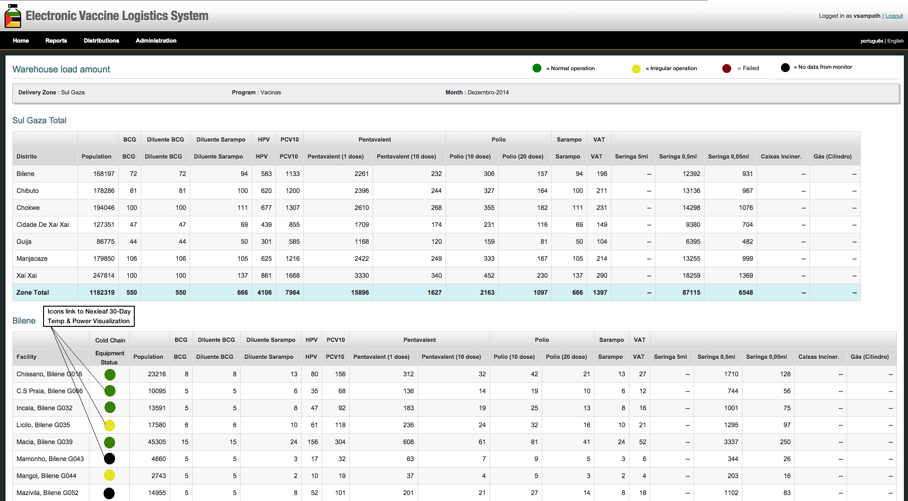

  - Determining the Color Icon

The color icon on the Manage Distributions page, and the refrigerator categorization on the Cold Chain Status Summary Screen, are determined by the current status of the refrigerator as reported by the Nexleaf API.

5.5 Performance

The View Load Amounts screen (including the color indicators) and the Cold Status Summary page should load within 3 seconds

6. Reporting

6.1 Cold Chain Reports

Two reporting requirements are needed as part of this work:

- VillageReach will provide Nexleaf the requirements for a monthly customized report which will be emailed by Nexleaf at the end of each month. [Timeline/due dates to be finalized along with requirements]
- An API will be defined and implemented to obtain data from Nexleaf for future reporting for the specified month (see table below for data definitions).

FridgeID | Text string |  | Nexleaf Fridge ID
HighAlarmCount | Integer |  | Count of high temp SMS alerts above 8C in the specified month
LowAlarmCount | Integer |  | Count of low temp SMS alerts below 2C in the specified month
MinutesInRange | Integer |  | Minutes temperature was in range 2-8 degrees in the specified month
MinutesLow | Integer |  | Minutes temperature was <2 degrees in the specified month
MinutesHigh | Integer |  | Minutes temperature was > 8 degrees the specified month
MinutesNoData | Integer |  | Minutes where no temp data is available in the specified month

