Stock Management Demo script
7/27/17

Intro
Screen setup:
Show OpenLMIS presentation intro image with “Stock Management” on the slide

Hello, my name is Tenly, and today I will be walking you through a demonstration of the Stock Management functionality in OpenLMIS version 3.1. This video is part of a series of demonstration videos of the functionality available in the version 3 series of OpenLMIS. OpenLMIS is an open source, enterprise class, electronic logistics management information system purpose built to manage commodity supply chains in low and middle income countries.

Stock Management explanation
Screen setup:
Show slide with “What is Stock Management?”
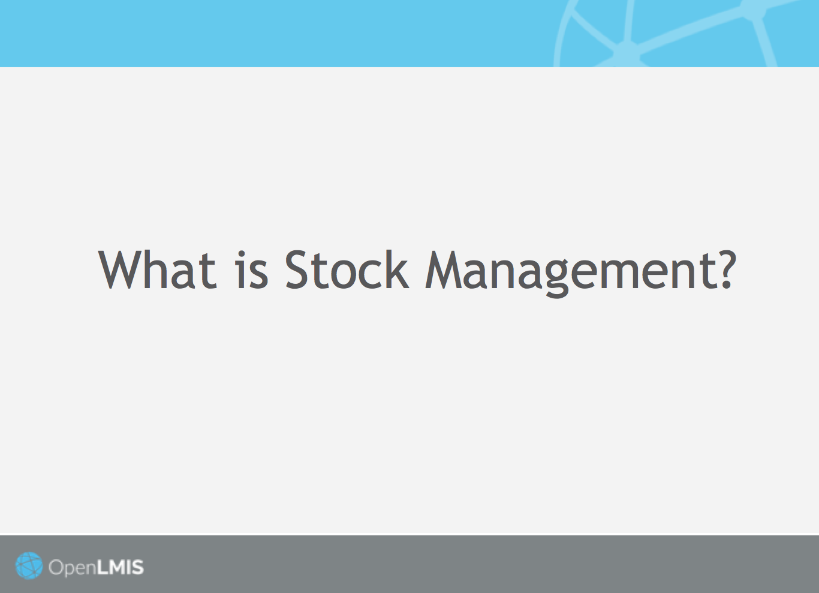

Stock Management is the process of managing a stock of commodities at various types of locations, for example a regional drug depot or a small storeroom, by a Storeroom Manager. A Storeroom Manager manages stock at their storeroom and records stock movements, for example issues, receipts, and adjustments, on a schedule (either once a month or when an audit is being performed by the Program). The Storeroom Manager can also view and verify the Stock On Hand (SOH) at the facility, and can perform an audit of the physical inventory.

Process Flow for Stock Management
Screen setup:
Show Stock Management Workflow slide
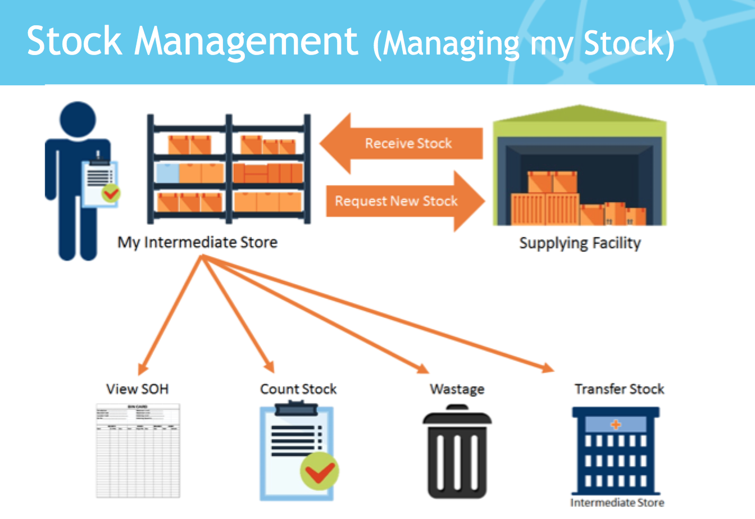

Within OpenLMIS, there is no prescribed workflow for stock management. A Storeroom Manager can approach the process flow for managing stock however they wish, in line with the actions available in the system as shown in this image.

For this video, however, I will demonstrate one possible process flow, acting as a Storeroom Manager who begins by logging in to the system and viewing the Stock on Hand at their facility (click animation to highlight SOH).

Upon viewing the SOH, as the Storeroom Manager I will then make an adjustment to a product in my storeroom (click animation to highlight wastage). An adjustment is a predefined type of stock movement that is configured with reasons for a user to select and associate with the movement. Typically this would involve logging loss or wastage of product.

I will then log the receipt and issue of stock in and out of my storeroom (click animation to highlight receipt/issue). The Receive and Issue stock movement types record two standard movements that adjust stock levels. The Receive type occurs when a facility has received stock that wasn't requested through the regular requisition workflow. The Issue type occurs when a facility needs to issue stock that wasn't requested through the regular requisition workflow.

Once all issues, receipts, and adjustments have been completed, I will view my SOH again, and then perform a physical inventory (click animation to show phy. Inventory), thereby ensuring that the stock information in OpenLMIS matches the physical inventory available in my storeroom.

A Storeroom Manager can do these actions in any order. Whatever your workflow, OpenLMIS is designed to support real-world processes with a user-friendly digital record that helps track and manage stock.

Ok, let’s get started!

Screen setup:
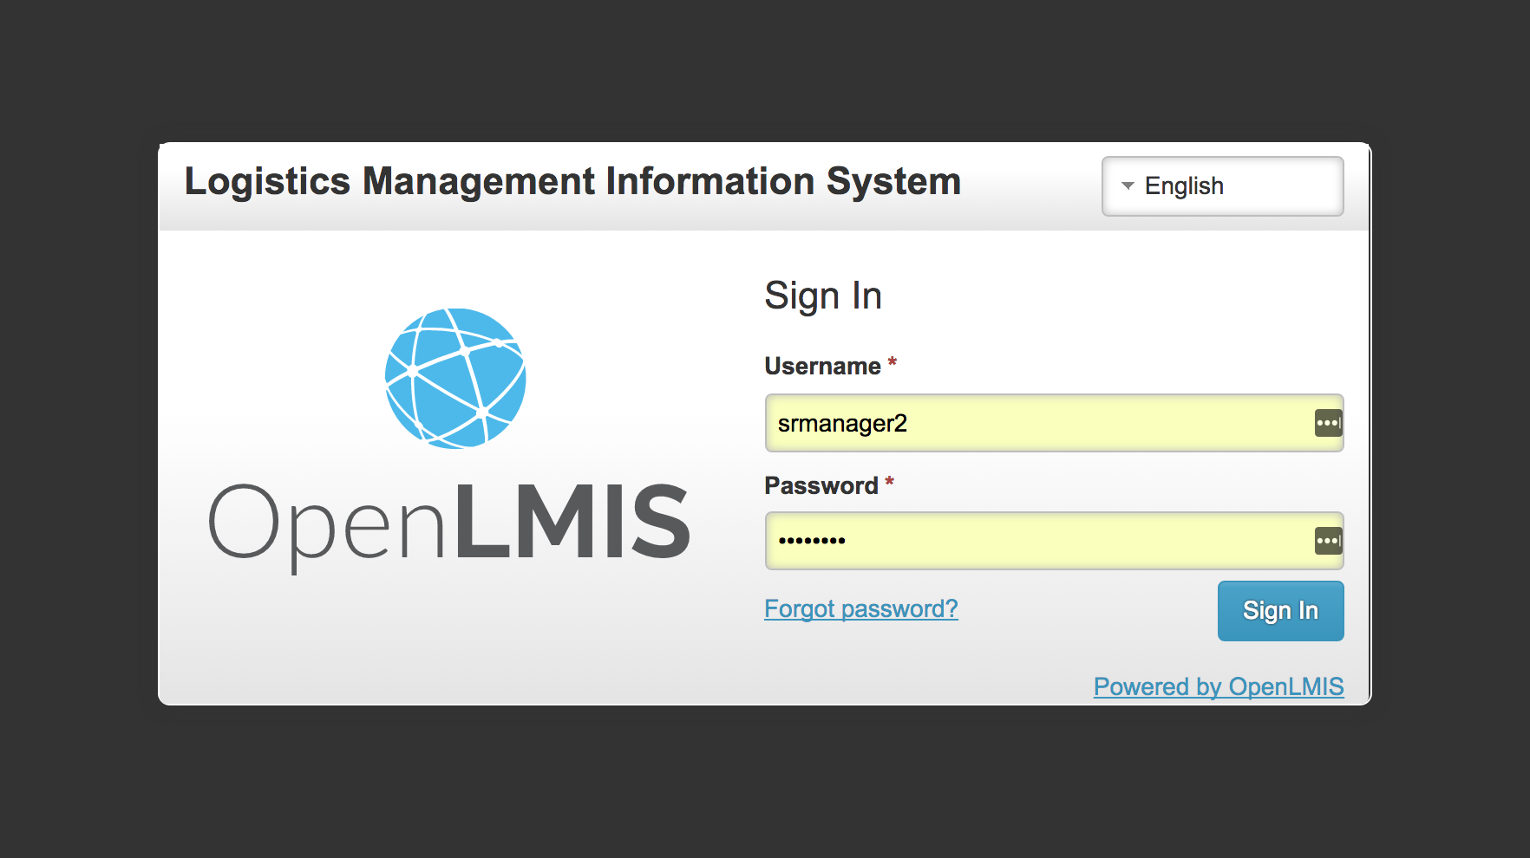

On the screen you can see the login page for OpenLMIS. For this demonstration, I will be logging in as the Storeroom Manager user. OpenLMIS includes role-based access and permissions, meaning that different users have different permissions within the system, depending on their role and responsibility within the supply chain. In this example, all the available actions within the Stock Management functionality have been granted to this user, the Storeroom Manager, who manages stock within a storeroom for their facility. Log in

My first action after logging in will be to navigate to the Stock Management menu at the top of the screen and view my SOH. When viewing SOH, the user would be comparing the SOH in the electronic system to the SOH listed on their physical inventory card.

Here, I will start by viewing the SOH for the Family Planning program at the Comfort Health Clinic. The electronic SOH seen here is populated from previous entries of stock received into the storeroom, and should match the products currently being managed in the storeroom. You can see here (point arrow to Levora product name) that there can be multiple product entries for a single product category, with all quantities totaled here (point to Levora total). When entering product, a user may enter a Lot number, or leave the Lot undefined.

By selecting View for a product, I can view the electronic bin card for that product, including the history of all physical inventory and adjustments performed for that product, and who made the changes. Here, for example, you can see that several adjustments were made to this product, including listing expiration, issues, and receipts. By selecting Print, the user can print out the stock card report for that product, including the history of all adjustments and physical inventories.

At this time, I have several options for how I can continue. In this example, I chose to view my Stock on Hand as a preliminary, informative step before completing actions within the system. Now, as the Storeroom Manager I know that I have some activities I need to complete to update my stock levels in my system, for example, entering an adjustment to an existing product in my storeroom.

In this example, I will make an adjustment to my stock of Ortho-Novum. I will navigate to the top level menu and select Adjustments from the drop down menu. I am making an adjustment to products within the Family Planning program, and will select Ortho-Novum from the drop down menu of products available within my system. Here, I will note that 200 units of Ortho-Novum were lost, and will add the reason, “Lost due to storeroom reorganization.” I will get a notification that the adjustment was submitted successfully here in the upper right hand corner.

The system then returns me to the SOH screen, where you can now see that the total SOH for Ortho-Novum has been reduced by 200 units.

At this point, I will now demonstrate the process of entering the receipt of a product into my storeroom.

From here, I will return to the top-level menu and select Receive from the drop down menu. Again, for the Family Planning program, I will then select Make Receive, to enter a receipt into the system.

On this page, I can see a list of available products to choose from in the system, or could choose to perform a search to find the product I want. These products are pre-populated from a defined master list that is managed by the system administrator. One unique aspect of OpenLMIS’s stock management functionality is the ability of a system administrator to define Lots and to align with GS1 (global standards one) global practices. In this demonstration example, some products have defined lots and others do not. Lots also have assigned expiration dates, which help manage expiry dates and align with FEFO (first expired, first out) standards.

In this example, I will select Implanon from the drop down menu and will not define the lot associated with it. I will hit Add, which then brings up the product information.

In this product information, I can view the current SOH in my storeroom (1000 units), and can select from where I am receiving new stock, in this example, from an NGO that is donating stock to the country. I can only select one reason in this example, “Transfer In,” and can add a comment here, for example, “Received delivery from Doctors Without Borders.” I will then enter the quantity being received, 2000 units, and hit the Submit button in the bottom right hand corner to add this receipt into my storeroom. I will receive confirmation that the receipt has been successfully entered here in the top right hand corner of the screen.

You can now see that my SOH for Implanon has been updated to reflect the latest receipt of stock – SOH is now 2,070 units. By selecting View I can see the comment associated with the last transfer.

At this point, I will now go through the process of issuing stock from my storeroom by navigating to the top level menu and selecting Issue from the drop down.

I will stay with the Family Planning program here and will select, “Make Issue.” I will make an issue in the system from my stock of Levora, and you can see that the system automatically allows me to select which stock of Levora I can issue from – either the stock without a defined lot, or from a specific lot number. In this example, I will issue from this defined lot.

The system will automatically generate a list of available locations to issue to, based on a list that is uploaded at the time of system configuration. In this example, I will issue to Balaka District Hospital, and only have one reason for the Issue, which is “Transfer Out.” I will add the comment, “Quarterly stock replenishment,” and will issue 50 units. I will select the Submit button in the bottom right hand corner, and again will see a confirmation in the upper right hand corner of the screen.

Pause to revisit stock management flow
Screen setup:

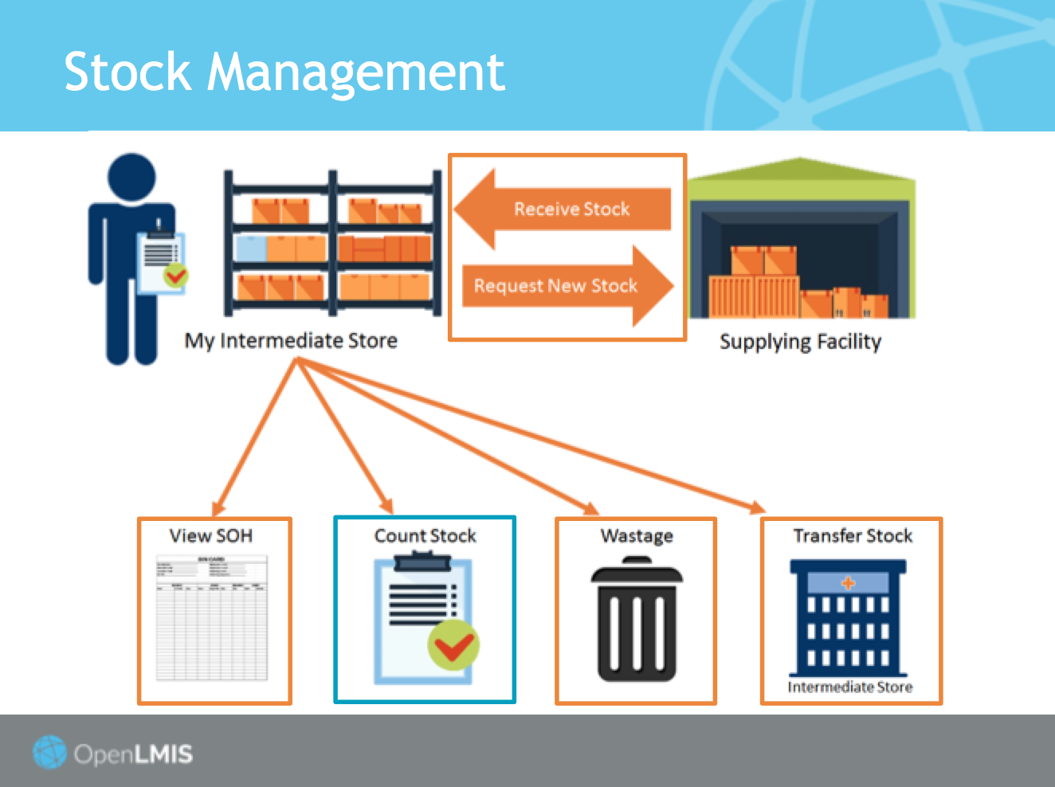

At this point, I have completed the following actions:
- I have viewed my stock on hand
- I have completed an adjustment to an existing product in my storeroom
- I have entered receipt of a new shipment into my storeroom
- I have issued stock out of my storeroom to an external facility

I have now completed all necessary actions in the system to make changes to my stock levels and am now ready to perform a physical inventory of my stock. By completing a physical inventory, I am comparing the actual physical counts of stock in my storeroom to my electronic stock card in OpenLMIS, ensuring that there are no discrepancies, or noting where there are differences.

Screen setup:
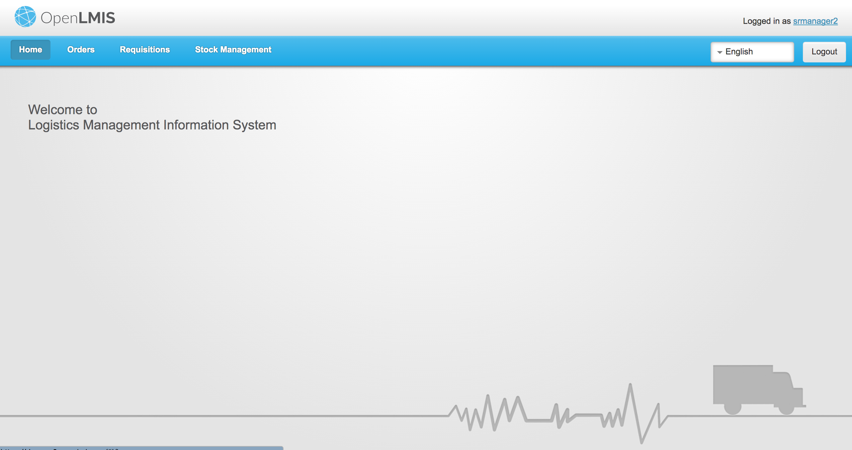

Returning to the home screen of OpenLMIS, I will navigate to the top level menu and select Physical Inventory from the drop down menu, continuing to manage stock for the family planning program.

On the screen you can see all products for the family planning program that are currently entered in the system, including their lot code (if defined), expiration date (if defined), and their current stock on hand.

At this point, it is also possible for me to add an additional product, in case there is a product physically on hand that I have not yet entered into my stock count in the system. The drop down will only populate with a list of family planning products in the system that are not yet counted in my electronic stock card, for example, Male Condoms. Here, I can add the product and enter the current SOH I have in my storeroom – I’ll enter 1000 units.

You can see here that because this is the first time I am adding Levonorgestrel to the system, there is no existing SOH. Once I complete my physical inventory, the current SOH for this product will be entered into the system and will appear on the Stock on Hand and Physical Inventory pages.

Entering the current inventory numbers for each of the products advances the progress of my physical inventory, so I can visually see how far along I am in my process. This feature is helpful for situations where a storeroom manager may have dozens, or even hundreds, of products to manage. An additional option to help storeroom managers is the ability to save a draft of an existing physical inventory to complete at a later time.

Additionally, if I have recently been re-stocked with an existing product in the system, here for example Levora with an expiration date of 1/30/2020, I can enter the physical SOH here and the additional quantity of this product will be added into the system once I complete my physical inventory.

Upon completing the inventory, I will hit submit here in the bottom right hand corner, and a popup will confirm the date of submission and require a signature. The date entered must either be in the past or today’s date. It cannot be a future date. The system will then automatically take me to the Stock on Hand page, where I can now view the updated amounts in my SOH, based on the physical inventory I just completed.

Fade and return to Home Screen

This concludes the demonstration of the Stock Management functionality in OpenLMIS version 3. We hope you’ve enjoyed this demonstration video, and we’d love to hear your feedback and questions! Please write to us at info@openlmis.org, or visit openlmis.org for further information on the software, community, and how to get started with OpenLMIS. We look forward to hearing from you soon!

####################################

Notes
Steps to manage stock:

- As a storeroom manager it is close to the scheduled physical inventory date or I am supporting an audit, and I need to update my stock count. The user can log into the system and print their Stock on Hand to use in the physical count, or they can do step 2.
- I’ve completed a physical count and now I need to record stock movements to update my stock on hand. Log into the system to View my Stock on Hand and compare the counts.
- When comparing counts I’ve identified a discrepancy that needs to be entered to adjust the product quantity.
- As a storeroom manager I go to Stock Management/Adjustments to enter in the adjustment for the product and submit. I continue this for a few products that must be adjusted.
- As a storeroom manager I have received stock that I didn’t request, and need to record this also. I go to Stock Management/Receive, and enter in the product that I have received and who I received the stock from. This will also update my stock on hand once I submit.
- If I have issued any stock to a facility, I can select Stock Management/Issue and record who I issued to and the amounts to update my stock on hand once I submit.
- Now that I’ve completed all my adjustments, I can verify by viewing my Stock on Hand.
- Now as the administrator (or store manager) I am ready to start my audit of physical inventory and go to Stock Management/Physical Inventory.
- As the administrator I enter the current stock amounts for each of the products, and save as I’m completing.
  - There is functionality to save the physical inventory draft to return to later, and there is also the option to delete a physical inventory draft if they want to start over.
  - There is also the functionality to Add a Product from the approved products list as the user is completing physical inventory. This happens when a product does not have a stock card but needs to be included in the physical inventory count. The user would select Add Product at the top of the table on the Physical Inventory page. This would create a current stock amount, but does not have an amount for Stock on Hand, and still updates the Physical Inventory.
- Now I am ready to submit my physical inventory. I click submit and select a date, the date must be today, or in the past, but cannot be a future date, then click confirm. Once I’ve clicked confirm, I have completed my physical inventory for my scheduled period, and can print the stock summary.

Storeroom managers need to record the reason for each stock event, for example an adjustment, receipt, or issue of stock. OpenLMIS provides a page for the system administrator to configure the reason list. There are two reason categories ('Transfer' and 'Adjustment') and two reason types ('Debit' and 'Credit'). The transfer category is for receive/issue stock event while the adjustment category is for adjustment stock event.
- An Adjustment is a predefined type of stock movement that is configured with reasons for a user to select and associate with the movement.
- The Receive and Issue stock movement types record two standard movements that adjust stock levels. The Receive type occurs when a facility has received stock that wasn't requested through the regular requisition workflow. The Issue type occurs when a facility needs to issue stock that wasn't requested through the regular requisition workflow.
- Credit or Debit is used to assist in the calculations for Stock on Hand. When creating different adjustment types, you must select whether the adjustment is a credit (addition or positive) to the stock on hand, or a debit (subtraction or negative) to the stock on hand.

User Personas:
- Storeroom Manager manages stock at their stockroom and records stock movements, enters in issues, receipts, and adjustments on a schedule (either once a month or when an audit is being performed by the Program).
- Store Manager views the Stock on Hand (SOH), audits stock count, and monitors stock outs at their facility. (In the UAT environment the Administrator is set up with the role and similar rights of the store manager, with some additional rights.)

Assumptions:
- Stock Cards are configured by the Implementer, therefore most if not all products should already have a stock card. If a product does not have a stock card this happens when the facility receives stock from an outside source (that wasn’t requested through the normal requisition process).
- Low stock and stock out notifications are not part of this release.
- Adjustment Reasons have already been configured by the Implementer, and these are used to explain why the stock has been adjusted, and make debit or credit adjustments based on the configuration of these reasons.

