**Potential Global Requirements from Benin SIIL Update**

# Calendar Display Language

1. The current java calendar control is not multi-lingual. Benin logisticians have requested that the calendar control be responsive to the language selected by the user. Currently, the calendar is only available in English (Figure 1). All labels on the calendar should be shown in in the language selected by the user, as shown in Figure 2
2. When the user selects the French language, Monday should be the first day of the week, to match typical calendars used in French-speaking countries, as shown in Figure 2.

**Figure 1. Current Calendar, in French display**

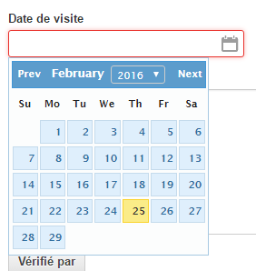

**Figure 2. To-be calendar, in French display**

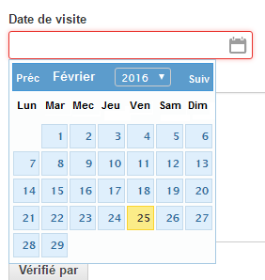

# Product display order

In order to allow the user to define the display order of products on the EPI Use screen through uploads, the “product group” csv used to upload the product group information will include a “display order” column. The display order column will define the display order of products on the EPI Use Screen. Currently, the display order on this screen is alphabetical by product group code, so in the example in Figure X, the products would display in order they are listed. The “program products” csv includes a display order column, and the display order on the products csv should have the same characteristics.

Product groups are used by OpenLMIS to define the entries on the EPI use screen for "push" based programs, where a user will record inventory and usage data regarding the number of doses of each antigen that is available in the program. OpenLMIS also uses these grouping to compute product wastage rates for "push" programs, in particular to group together all products that provide the exact same medical treatment to a patient. In the case of a vaccination program, 10-dose and 20-dose vials of Polio vaccine would be assigned to the same product group, "Polio" for example. OpenLMIS then knows to use the total number of doses available from 10-dose vials plus 20-dose vials to compare with the total number of doses administered to patients and thereby arrive at the total wastage rate for the Polio vaccine. Typical groups might include BCG, Measles, PCV10, and Polio. There is no limit as to the number of product groups you can define in the system.

Currently, the product group csv includes only columns for the product group code and the product group name, as shown in Figure X.

**Figure X. Current Product Group CSV**



A column will be added to allow the user to define the display order of the product groups on the EPI Screen via upload, as shown in Figure X.

**Figure X. To-be Product Group CSV**



# Data Edit Tool

Administrative users in SIIL need the ability to review and edit data after it has been collected and synchronized by the field coordinators. The most direct method for data management would be to add the feature directly into SELV, so administrators can review data that has been entered from the browser, and make edits if necessary.

**I. User Rights**

* User rights under the Admin Role type:
  + Admin – View Synchronized Data
    - Allows users to access the Review Data Screen
    - Allows users to access synchronized distributions in read-only mode (through the view link)
    - Allows users to view, download, or print the Edit History from the review data screen
  + Admin – Edit Synchronized Data
    - Allows users to access the Review Data Screen
    - Allows users to access synchronized distributions in read-only mode (through the edit link)
    - Allows users to access to Edit and Sync features (through the edit link)
    - Allows users to view, download, or print the Edit History from the review data screen

**Figure 1. Admin Role Additions**

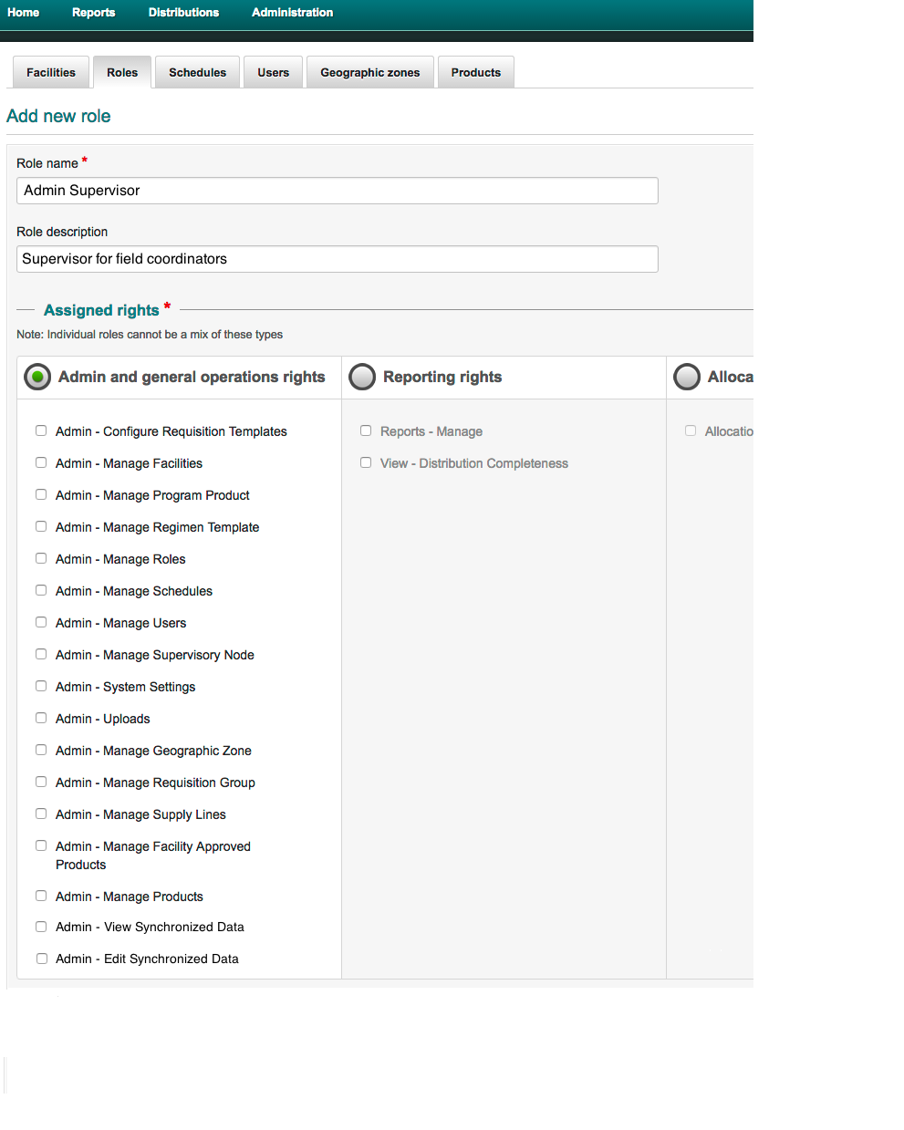

**II. Review Data Screen**

* Distributions sub menu item: “Review Data”
  + Available if user has either or both admin rights

**Figure 2. Distributions Sub-menu Items**

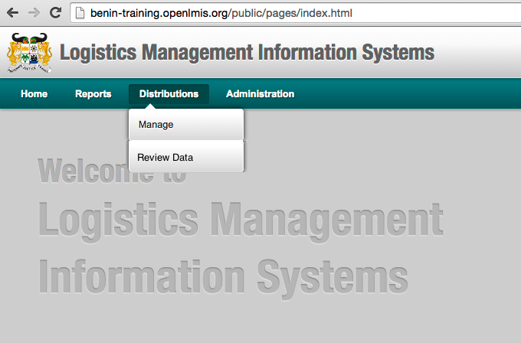

* + Review data screen offers several filters users can set to populate the “Synchronized Distributions List” and information
    - The Review Data screen and sub menu item are available only to users with Admin – View Synchronized Data and/or Admin – Edit Synchronized Data rights
    - Available filters:
      * Program
      * Province
      * Delivery Zone
      * Distribution Period
* Available distribution periods are those with 100% of data synchronized
* Available distribution periods are those synchronized with in the past 12 months
  + - Data included on Synchronized Distributions List:
      * Province
      * Delivery Zone
      * Period
      * Date of initiation
      * Date of synchronization
      * Last viewed date (most recent date that a user viewed the data, if applicable – blank if not viewed)
      * Last edited date (most recent date that a user edited any data, if applicable – blank if not edited)
      * User that last edited the distribution data (if applicable – blank if not edited)
      * View data link or Edit data link (if user has edit rights)
      * Edit history download and view/print link (see additional detail in section
* Print link - report opens as a PDF
* Report can be printed from the PDF report
* Download csv – downloads csv file with info
  + - Users can sort by information in any column by clicking on the sort arrows on the right side of the column heading (except view/edit link and edit history)
      * 1 click sorts descending/alphabetical/most recent - least recent
      * 2 clicks sorts ascending/reverse alphabetical/least recent – most recent
    - Default sort by sync date (descending)

**Figure 3. Review Data Screen with View & Edit Rights**

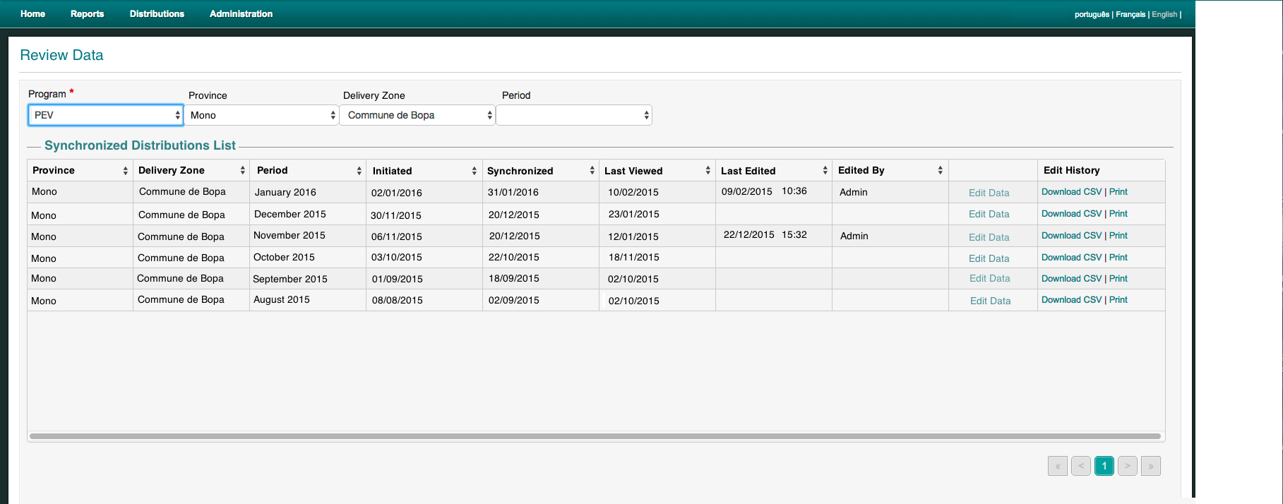

**Figure 4. Review Data Screen with View Only Rights**

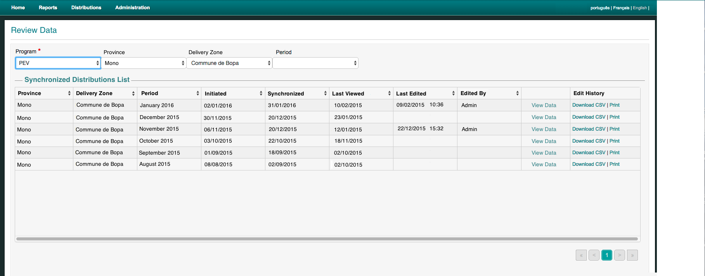

* + When a user selects the “View Data” or “Edit Data” link, the synchronized data from the distribution will be cached locally (as it is when distributions are initiated) to enable the user to view or edit data offline.
  + Edits made to the data will be automatically saved locally and synced with the server using the “Save” button when the user has access to an internet connection.
  + If a distribution has been cached by a user for editing (through the Edit Data link) and a second user attempts to edit the distribution a dialogue box will display (see Figure 5) stating: “Editing for this distribution has already been initiated by [username] at [date/time stamp]. Do you still want to continue?”

**Figure 5. Distribution Edit in Progress Dialogue Box**

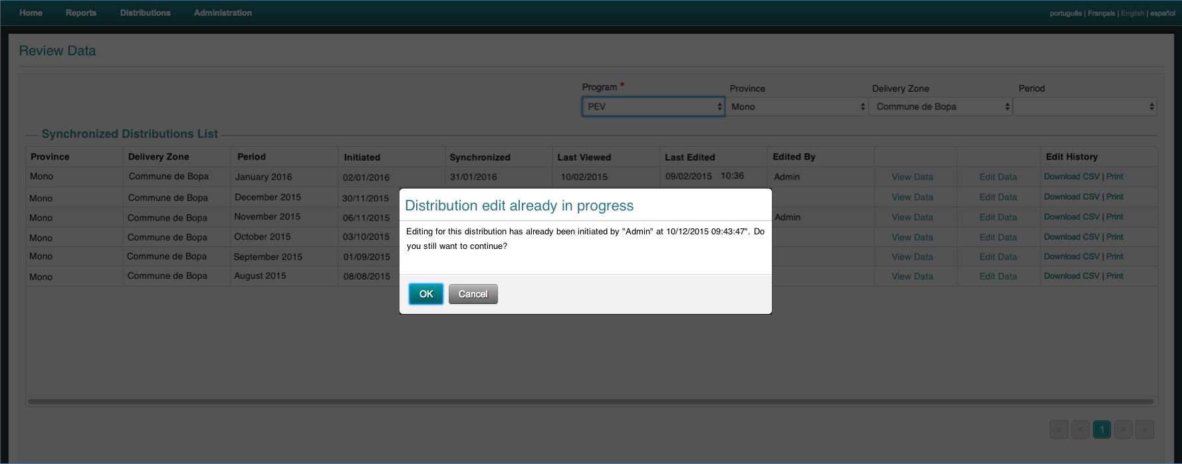

1. **View/Edit Data Screens:**

* When a user selects to view or edit a distribution, the data is cached locally on their device, so they can continue to review or edit data offline. The screens will appear as they do in the record data screens populated with the data.
* Status color indicators will all be blue (synced)
* All fields display as read-only

**Figure 6. Visit Info/Observations Screen – View Only Rights**

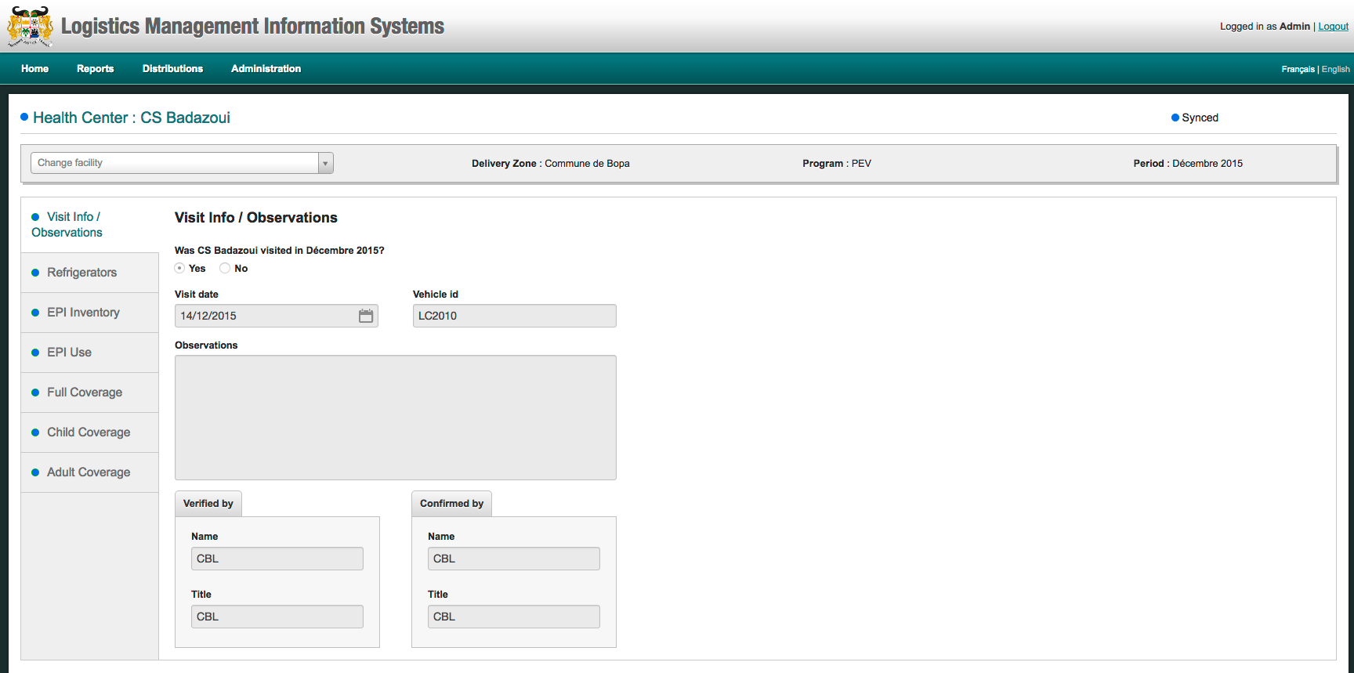

* For users with edit rights, additional features will be available to allow the user to each screen:
  + Edit button added to each screen (Visit Info, Refrigerators, EPI Inventory, EPI Use, Full Coverage, Child Coverage, Adult Coverage)
  + When the “Edit” button is selected, the fields on that screen change from read only to editable fields

**Figure 7. EPI Inventory - Edit Data Screen (Read Only Mode)**

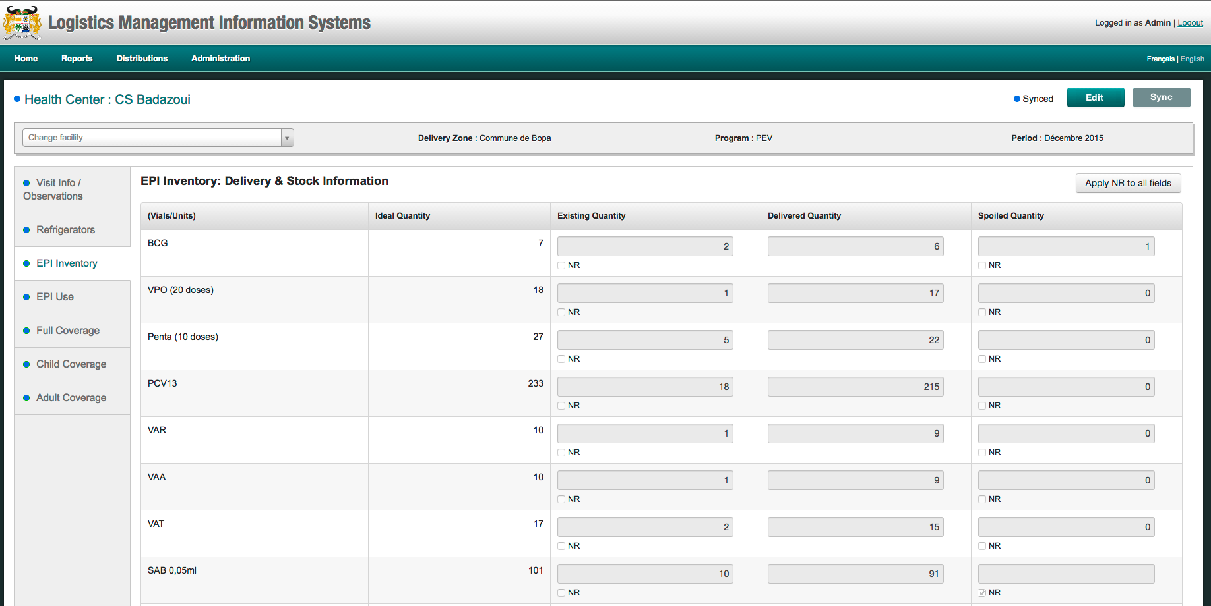

**Figure 8. EPI Inventory - Edit Data Screen (Edit Mode)**

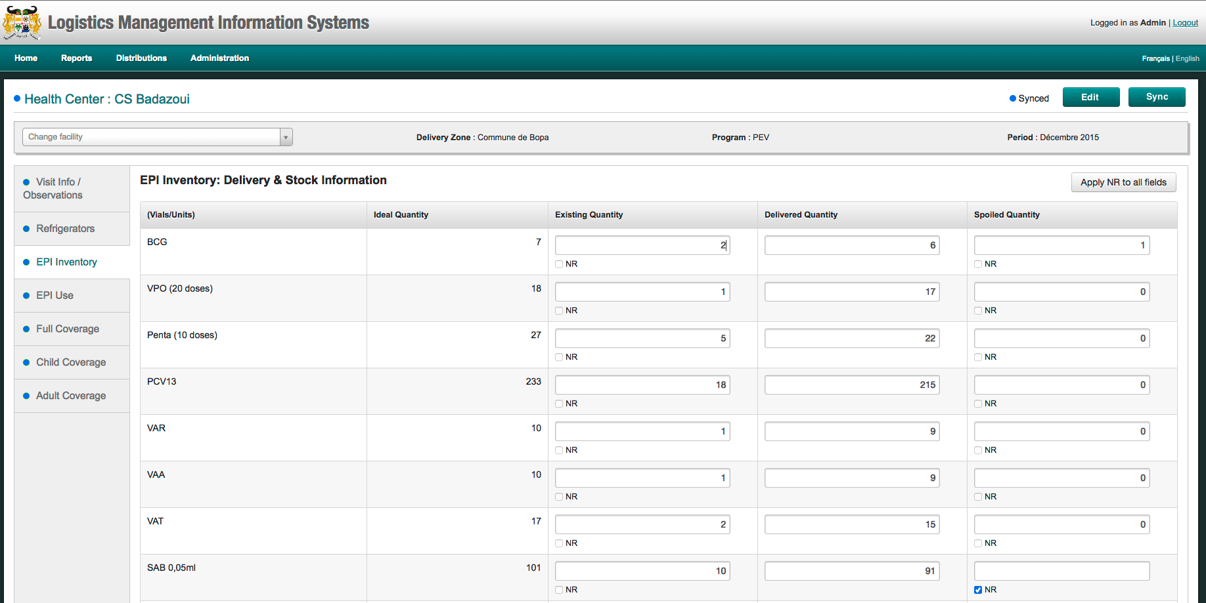

* + Edited data is automatically saved locally
  + If data that factors into an automatic calculation (such as coverage rate or opened vials wastage rate) is edited, the system will automatically update the calculated values
  + A Sync button is added the screen to save edited data to the database (for users with edit rights)
    - The button is only available in online mode, while in offline mode it is low-lit
    - When sync button is clicked, a confirmation dialogue box appears stating: “Syncing will overwrite the existing values in the database. Do you still want to continue?”
  + When changes to data are synced, only the edited values are updated in the database

**Figure 9. Save Edited Data Confirmation:**

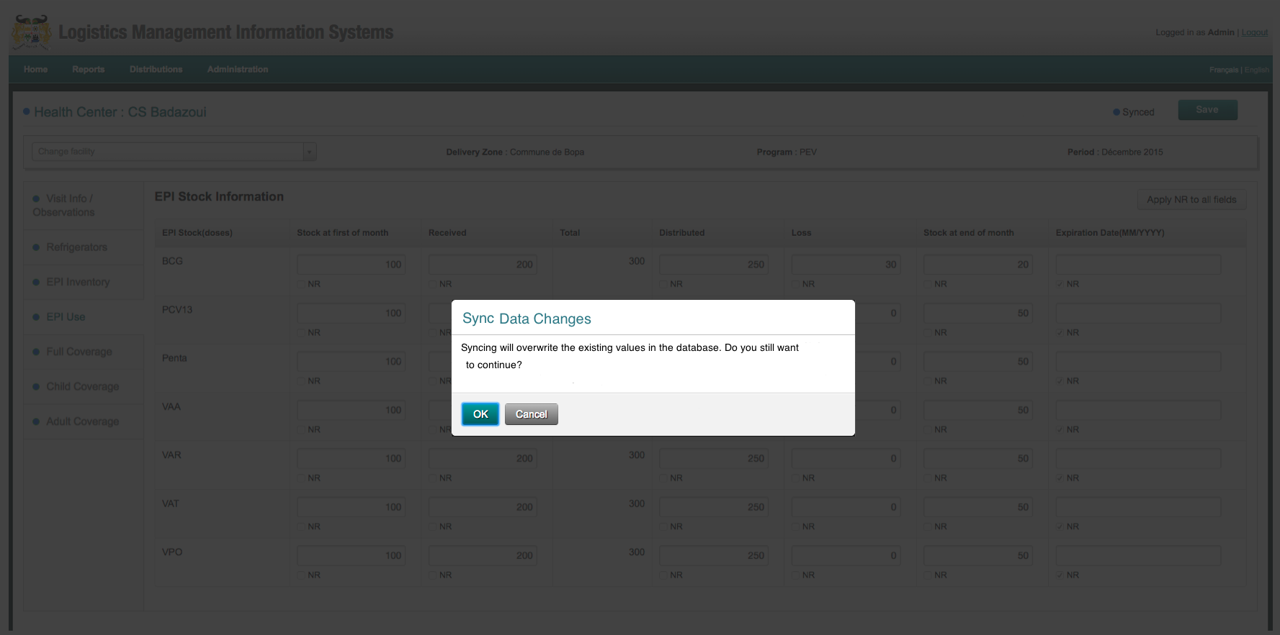

1. **Data Edit History**

* A log of the edit history for each distribution in the Synchronized Distribution List on the Review Data Screen will be available (through the Edit History download/print links) with following information for the distribution (see Figure 10):
* District
* Health Facility
* Data Screen (visit info, Refrigerators, EPI Inventory, etc.)
* Edited data item
* Old value
* New value
* Date/time edited
* User who performed the edit
* Edit History Links
  + Download CSV – automatically downloads the history in CSV format
  + Print – Opens a new window with a PDF version of the history that the user can review, save, or print from the browser.

**Figure 10. Data Edit History (PDF)**

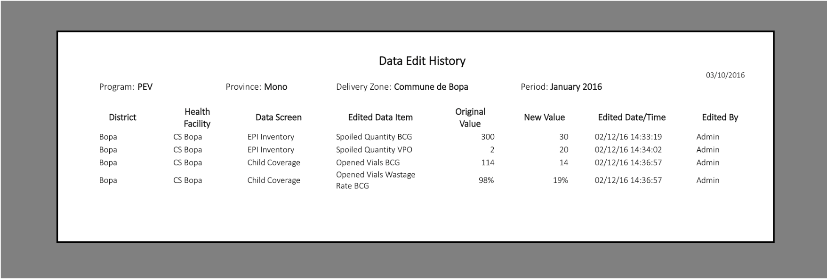

# Vial to dose conversion on the Inventory Screen

Currently, the fields on this screen are quantified in vials (Figure X). They should be changed to be quantified in doses. For some of the rows, the product is in a vial that only contains one dose, so these rows will not have to have changed.

**Figure X. Current EPI Inventory**

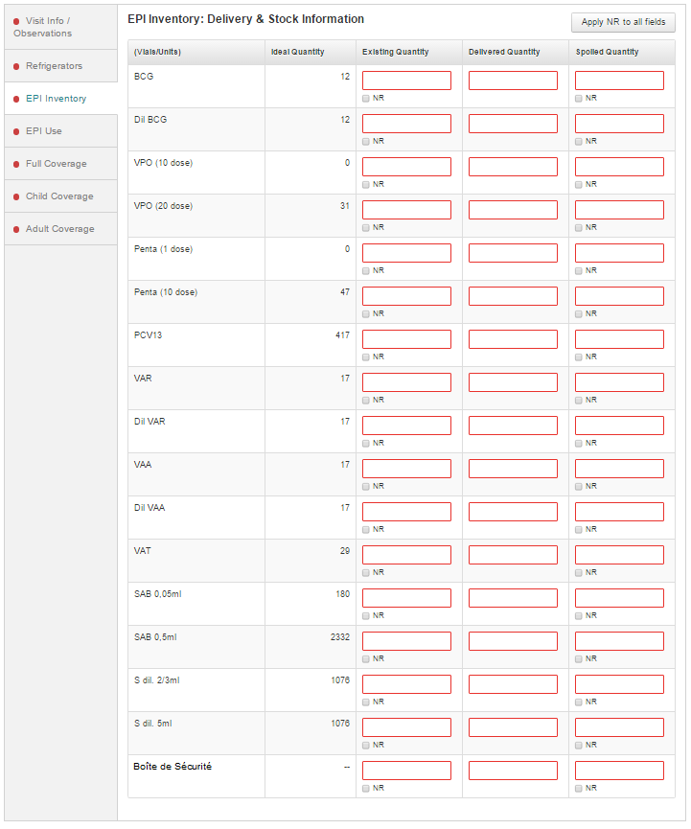

1. The Ideal Quantity, which currently displays in vials, should display in doses. In addition, the users should enter the Existing Quantity, Delivered Quantity and Spoiled Quantity of each product in doses, rather than in vials as they do currently. The Ideal Quantity is calculated by the Program Product ISA formulas, which are configurable by the user, and are viewable under through the menu Administration 🡪 Configure 🡪 Program Product ISA. They are currently configured in doses, not vials.

Other screens that display quantities in vials should not be changed.

1. Add data validation to each field:
   1. Entered value is greater than or equal to pack size
   2. Entered value is a multiple of pack size (is evenly divisible by pack size)
   3. Examples BCG:
      1. Acceptable entry: 100 (100 / 20 = 5)
      2. Unacceptable entry: 105 (105 / 20 = 5.25)
      3. Unacceptable entry: 12 (12 < 20)
   4. If an entered value does not satisfy the validation criteria, an error message displays (see figure x.) stating: “Value must be greater than [pack size] or a multiple of [pack size].”

Figure X. Data Validation Error Message

