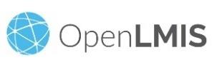
OpenLMIS Study Tour Trip Report
Cameroon delegation to visit VillageReach Malawi
December 2-5th, 2019

Instructions: this trip report is to be completed by the Cameroon delegation, led by CHAI, and submitted to the OpenLMIS Community Manager

Background for this trip-
List of Cameroon Delegation (visitors):
Dr. Jessica Bombah | Deputy Director of the Directorate of Pharmacy, Medicine & Laboratory (DPML) | Cameroon MoH, DPML
Marius Vouking | Head of Logistics & Supply Chain Unit at Expanded Program on Immunization (EPI) | Cameroon MoH, EPI
Tetang Fouelefack Xavier Lancelot | eLMIS Focal Point, DPML | Cameroon MoH, DPML
Nobel Cubahiro | CHAI Cameroon | CHAI Cameroon
Akinsola Fadeyi | CHAI Global | CHAI Global

List of VillageReach Malawi team (hosts):
Matthew Kumbuyo | Technical Advisor, OpenLMIS | VillageReach Malawi
Matthew Ziba | Supply Chain Senior Manager | VillageReach Malawi
Alinafe Kasiya, PhD | Country Director | VillageReach Malawi

Trip learning objectives identified by the Cameroon delegation:
- Receive technical overview of the OpenLMIS v3 system capabilities to frame how the system could potentially benefit Cameroon; technical deep dives on topics of particular interest
- Gain strong understanding of the Malawi implementation experience (activities, timelines, tools, lessons learned, challenges, key considerations, resource requirements, critical success factors, etc.)
- Listen to perspectives of other stakeholders regarding their use of the system (MoH, other partners, users)

Day 1 Summary Notes:
My most useful conversation:
Background of OpenLMIS implementation in Malawi
The support system put in place for OpenLMIS implementation in Malawi
Pre-requisites for deploying OpenLMIS
Two things I learned are:
Putting in place a support team is indispensable for ensuring OpenLMIS rollout success
Pre-requisites in terms of supply chain processes and necessary infrastructures are to be assessed before implementation
My most important takeaway from today’s meetings is:
OpenLMIS is a system that is highly configurable to respond to any supply chain needs
Cameroon needs to define its supply chain processes and conduct an infrastructure availability assessment

Day 2 Summary Notes:
My most useful conversation today was:
Different stages of OpenLMIS implementation in general and in particular in Malawi (requirements validation, configuration and deployment)
Deployment methodology (pilot and scale-up): what need to be taken into consideration
Sustainability aspect of OpenLMIS in Malawi: Contracting with a local firm and localizing data from Amazon to a local server in the MOH
Two things I learned today are:
The country requirements definition and validation is the most important stage that requires much technical efforts
Pilot and scale-up plans depends on available funding, infrastructures and how much efforts necessary and available for change management
My most important takeaway from today’s meetings is:
The selection of OpenLMIS modules and pilot sites in the pilot phase depends on the availability of infrastructures and funding.
It is important to think and plan on how OpenLMIS implementation will be sustained when funding will not be available.

Day 3 Summary Notes:
My most useful conversation today was:
Financial and time requirement for developing a national interoperability layer
Advantages and disadvantages of developing and using an interoperability layer vs hard (?)
How the stock management and cold chain management features are built and function
Two things I learned today are:
Building an interoperability layer is costly, requires at least 1-2 years for development and technical expertise
Hard (??) can be used as link between OpenLMIS and DHIS II and is less expensive than an interoperability layer
My most important takeaway from today’s meetings is:
Cameroon doesn’t need to reinvent the wheel, but will build on experience of other countries that have developed and implemented OpenLMIS

Key learnings/takeaways from this trip:
1) OpenLMIS is a system that is highly configurable to respond to any supply chain needs
2) Pilot and scale-up plans depends on available funding, infrastructures and how much efforts necessary and available for change management
3) It is important to think and plan on how OpenLMIS implementation will be sustained when funding will not be available.
4) Developing an interoperability layer is costly, requires at least 1-2 years and technical expertise. However, there is other alternatives.
5) Cameroon doesn’t need to reinvent the wheel, but will build on experience of other countries that have developed and implemented OpenLMIS
Remaining questions: [Are there still any outstanding questions that will require any additional follow up in order for Cameroon to decide whether they will move forward with OpenLMIS ? If so, please list them below]
1) How to integrate the private sector supply chain in the OpenLMIS (Angola experience)
2) Demo of Mozambique Vaccines cold chain management features
N.B. These questions are learning gaps for Cameroon team but don’t influence the decision related to OpenLMIS implementation in Cameroon.

Follow up plans/next steps [What are your intended next steps as a result of this visit? Please describe any planned meetings, stakeholder engagement, fundraising activities, etc. related to ]
Activities | Responsible | Deadline (Period)
OpenLMIS study tour debrief call | CHAI and Village Reach | December 13, 2019
Finalize the study tour report and share with Village Reach | CHAI and Cameroon MOH (DPML and EPI) | December 20, 2019
Deliver a presentation on the OpenLMIS study tour during the eLMIS Technical Working Group meeting | CHAI and Cameroon MOH (DPML and EPI) | February 28, 2020
Deliver a presentation on the OpenLMIS study tour during the Technical and Financial Partners meeting | CHAI and Cameroon MOH (DPML and EPI) | March 31, 2020
Organize a restitution meeting with the MOH General Secretary | CHAI and Cameroon MOH (DPML and EPI) | April 30, 2020
Requirements gathering for OpenLMIS | CHAI and Cameroon MOH (DPML and EPI) | January to June 2020
OpenLMIS project kick off | CHAI and Cameroon MOH (DPML and EPI) | July 2020

Photos-
Day 1.
Visit at NTCHEU District Hospital
Group Photo at NTCHEU DH
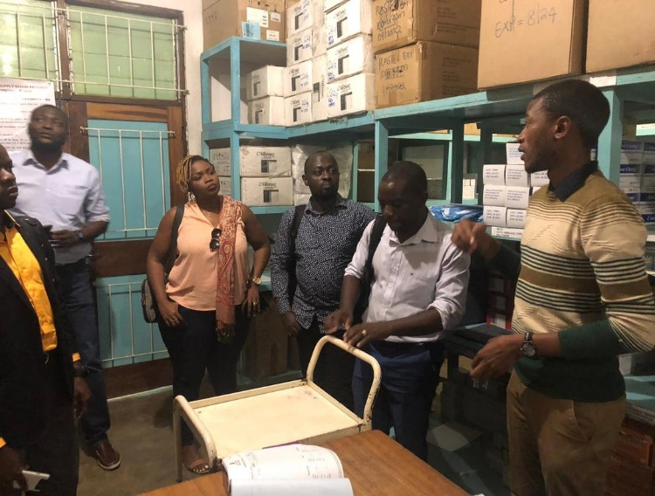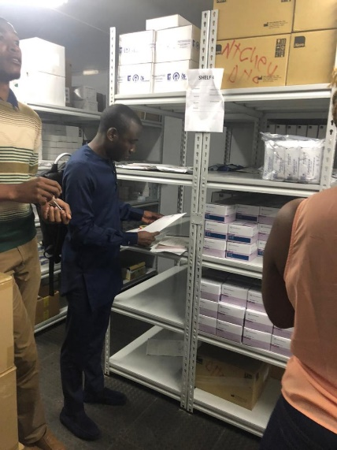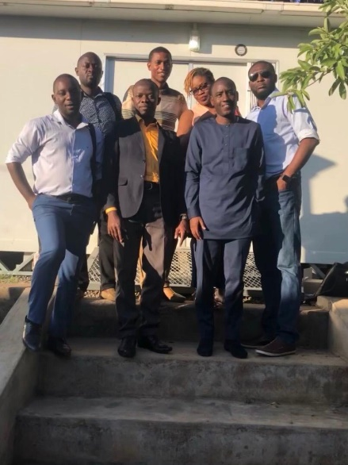
Pharmacist Technician of the NTCHEU DH explaining supply chain processes and tools used
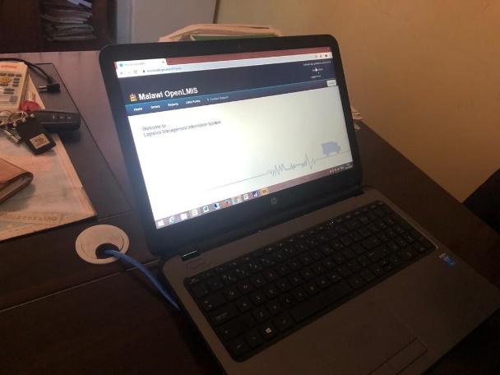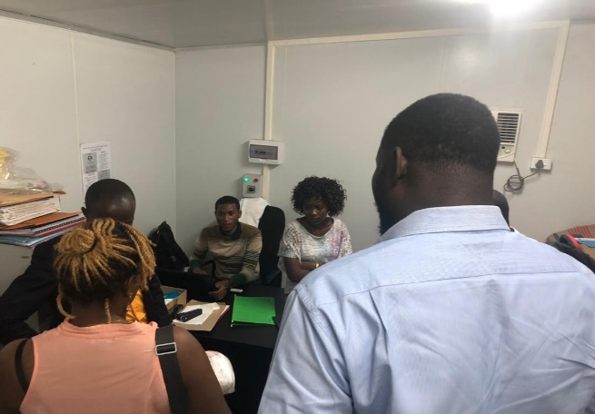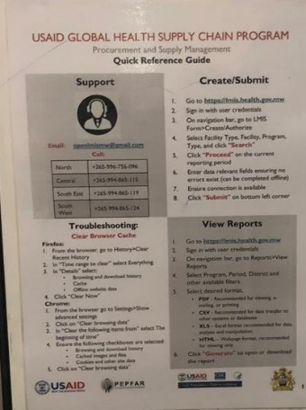
DH Medical officer and Pharmacist Technician of the NTCHEU DH explaining how OpenLMIS functions at DH

Day 2.
Session 1. Meeting with MOH and Chemonics staff
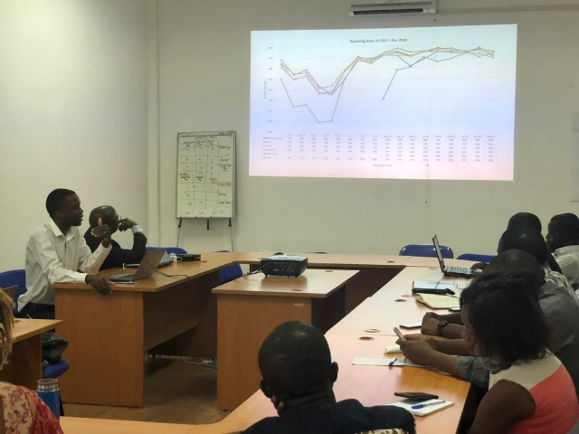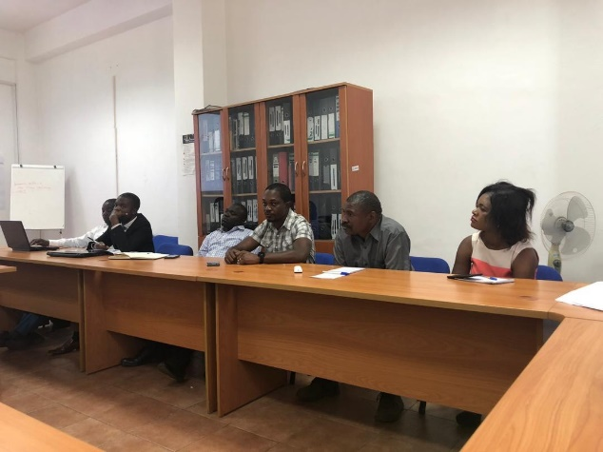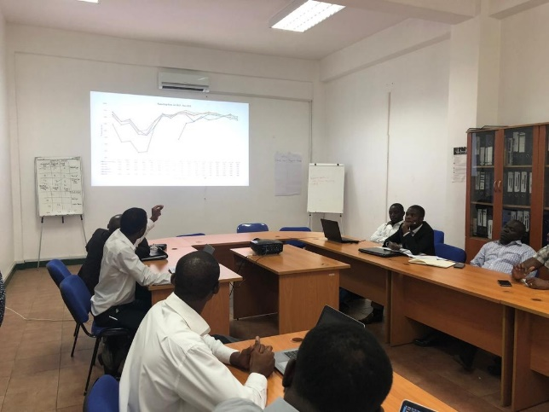
Chemonics OpenLMIS Manager presenting how OpenLMIS was implemented and its impact in increasing the visibility and availability of stocks

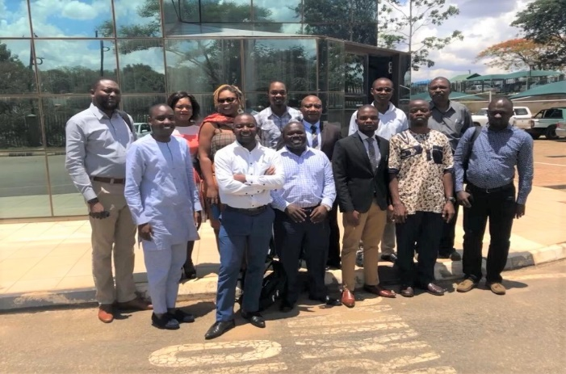
Group Photo
Session 2. Visit at Central Medical Stores (CMS)
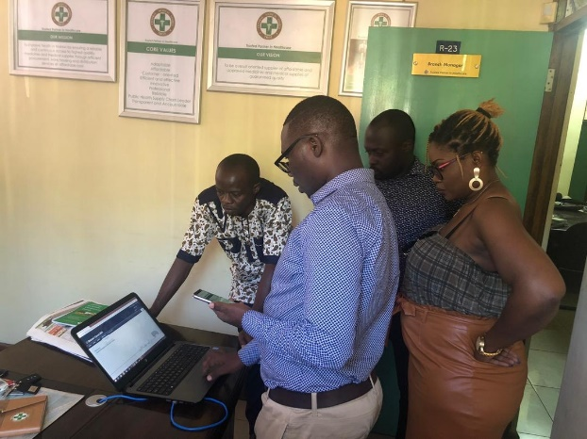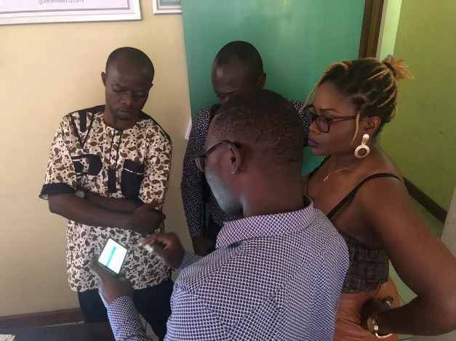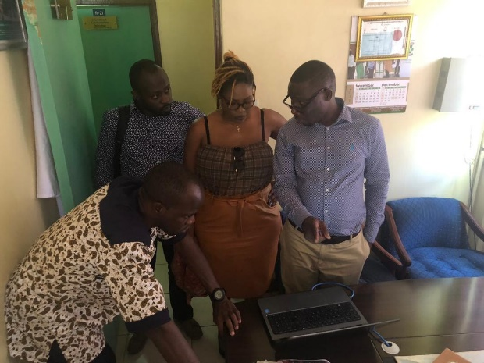
Branch Manager explaining how OpenLMIS is used at the Central Medical Store

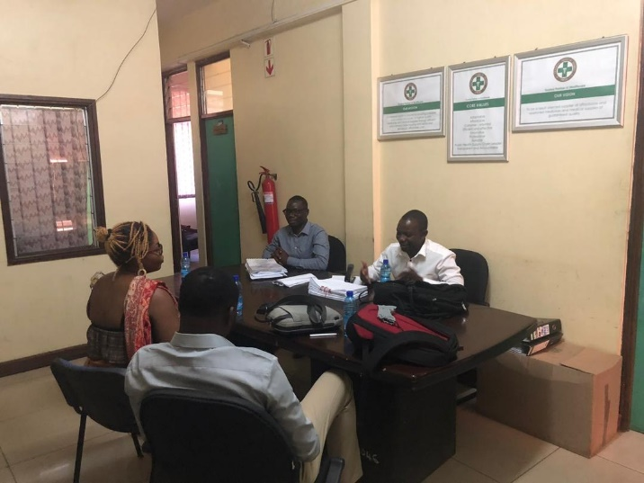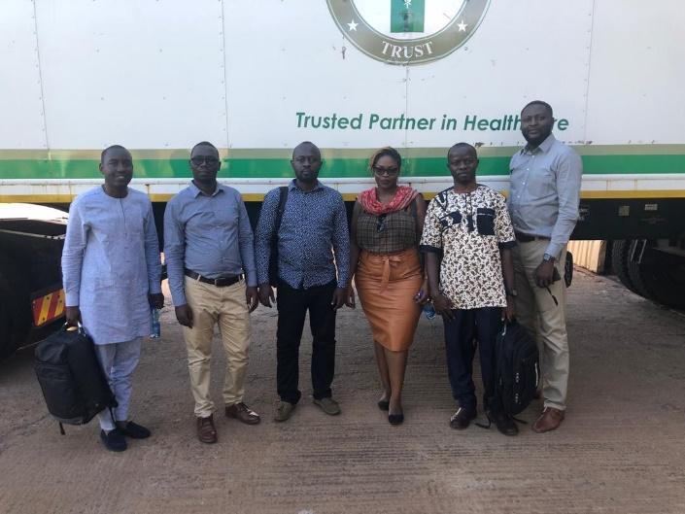
Group photo at the CMS
Discussion on OpenLMIS use at the CMS

Day 3.
Visit at Kuunika
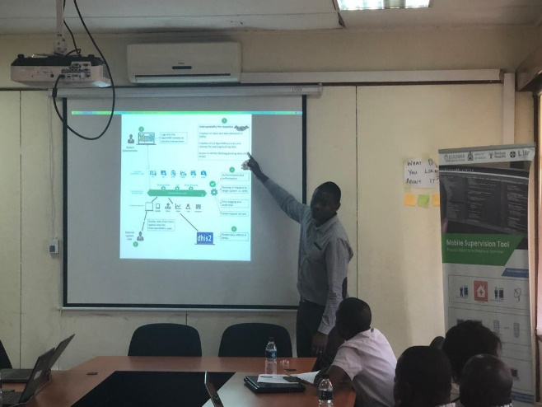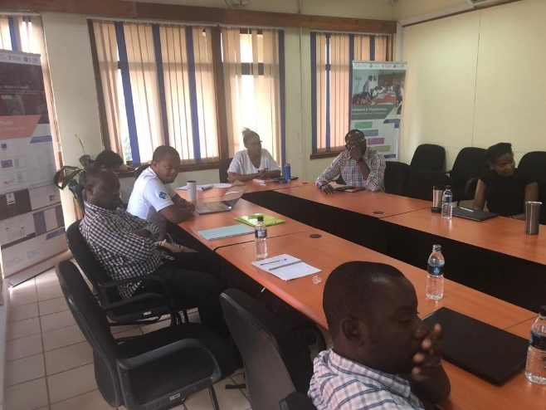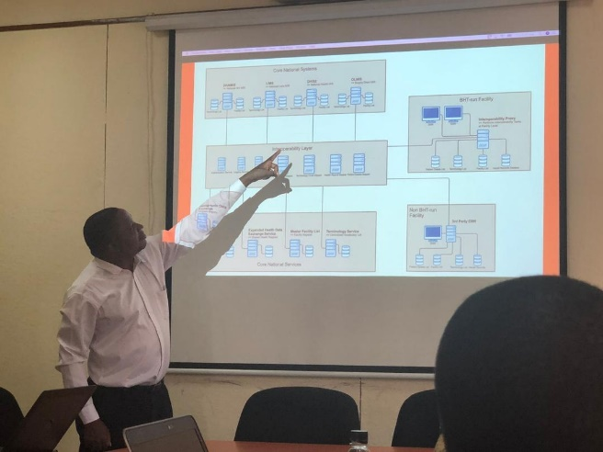
Kuunika Product Manager explaining how the interoperability layer is built

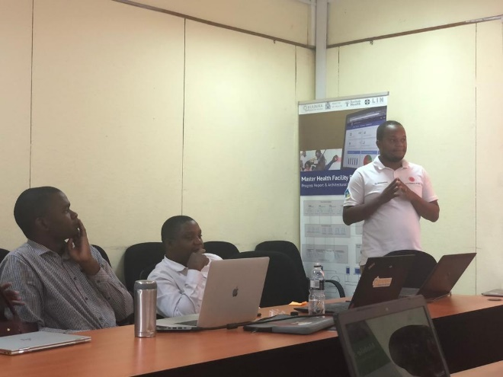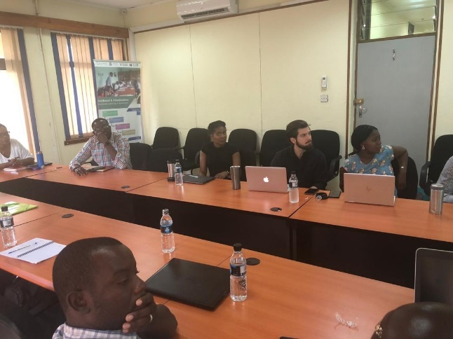
Presentations of different projects implemented by Kuunika
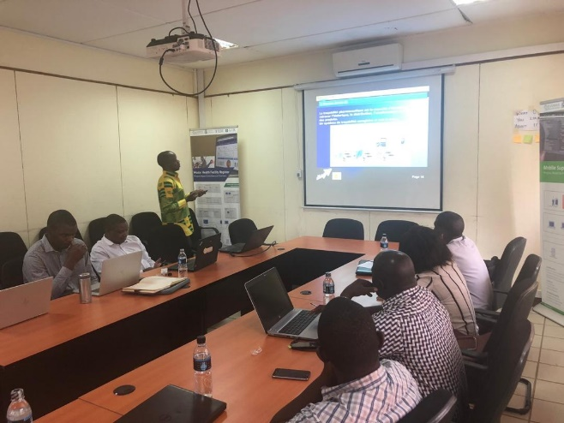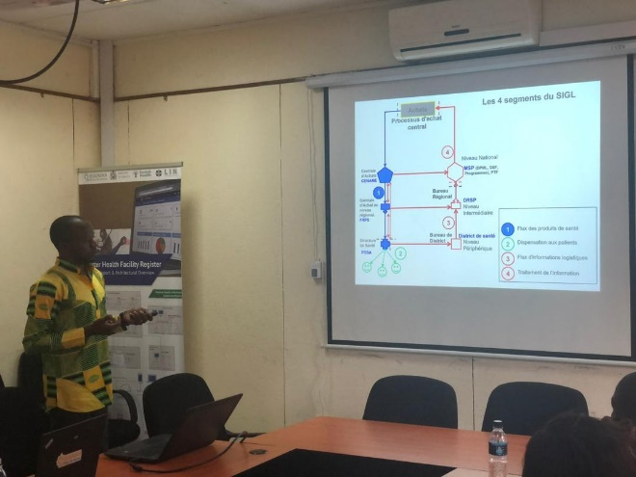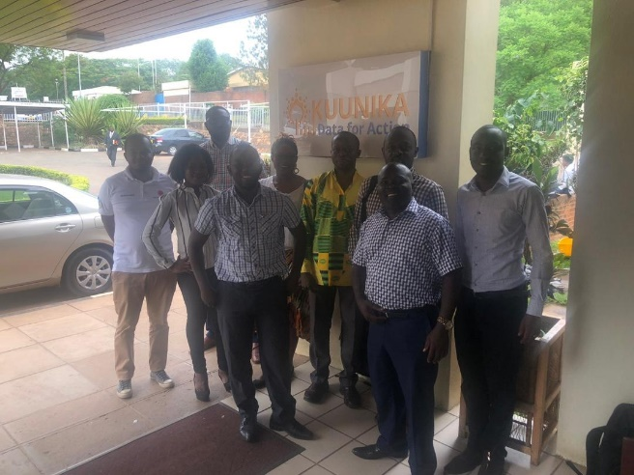
Group Photo
Cameroon eLMIS focal point presenting eLMIS vision for Cameroon

Trip Report Part II: to be completed 2-3 months following the Study Tour visit
Unanswered questions: [Please reflect back to your earlier trip report where you documented unanswered questions. Have these questions been answered or addressed somehow? Please explain below.]
xxxx

Follow-up Activities: [Please reflect back to your earlier trip report where you documented your intended follow-up activities. To what extent have these been completed? If not, why not? Please explain below.]
xxxx

