Trip Report
Philippines International Expo and Suppliers Conference
Manila, Philippines, August 19 and 20th

Background
The Department of Health (DOH) of the Philippines, with support from its technical partners, is strengthening the procurement and supply chain management (PSCM) system for health commodities. One of the key objectives of DOH for PSCM strengthening is to deploy a state-of-the-art electronic logistic management information system (eLMIS) throughout the country to manage procurement and supply information, commodity flow, warehousing, dispensing, consumption and stock reporting, and data aggregation. The eLMIS is expected to be interoperable with other information systems, including health facility-level enterprise resource planning, electronic medical records, and track and trace bar codes.
Ashraf Islam and Wendy Bomett from JSI represented the OpenLMIS community at the expo and showcased the OpenLMIS V3 and provided a country perspective on implementation.

Travelers: Ashraf Islam (JSI), Wendy Bomett (JSI)
Trip agenda: The expo was a two-day event.
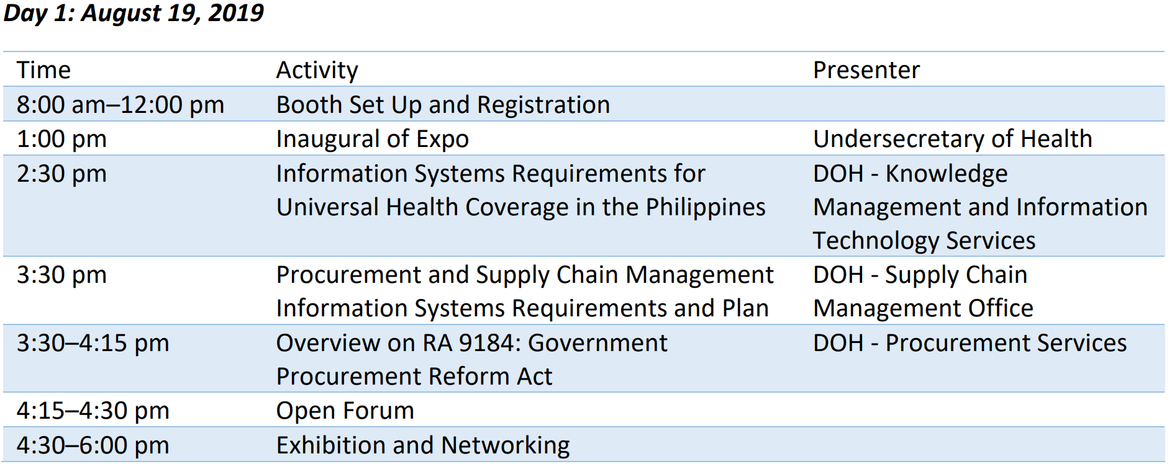
Day 1:
- Morning:
Booth setup for the suppliers
- Afternoon:
- Opening remarks from MTAPS, USAID mission, DoH
  - Govt. of Philippines vision for universal health
  - Philippines LMIS architecture and Scope
  - Overview of DOH requirements for Procurement and Supply Chain Management Information System
  - Overview of DOH Procurement Process and applicable govt rules and regulations. Next steps for the RFP/Terms of Reference (TOR)
  - Exhibition and Networking: Booth walk-in demo, Q/A, informal chats, networking

Day 2:
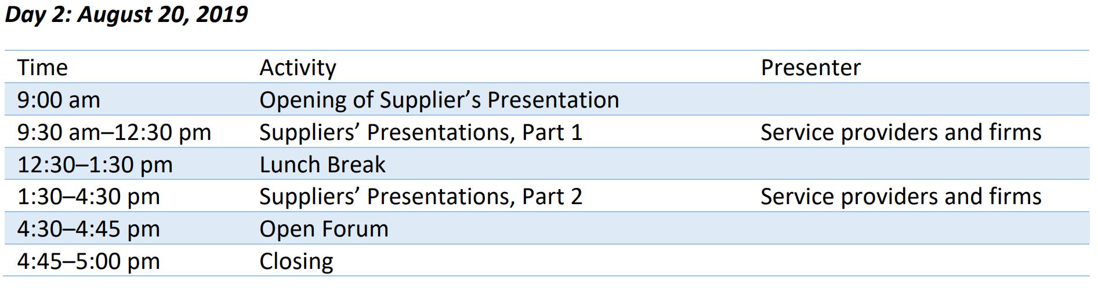
- Morning:
Opening remarks and key messages
Supplier Presentations:
- mSupply (ERP suite including procurement)
- Vitalliance (One Network. Remote presentation over webex. Realtime Value Network)
- Afternoon:
- Bileeta (Sri Lankan Company. Implemented eLMIS in Nepal and currently working on Zimbabwe eLMIS implementation)
- Logistimo (Vaccine focused presentation)
- OpenLMIS (presented OpenLMIS v3, OpenSRP, Reporting, interface with ERP applications)
- ARIS (Filipino company. Presented their locally developed ERP application. Four departments of the Govt are using ARIS)
- Exhibition and Networking: Booth walk-in demo, Q/A, informal chats, networking

Key stakeholder conversations: [fill in the table below to outline key connections made and any required follow-up via the OpenLMIS community or the travellers. Add additional lines as needed]
Name of stakeholder | Topic Discussed | Follow-up recommended?
DoH | Mostly at booth walk-in sessions, Q/A. Understanding about next step and timeline for DoH’s RFP and requirements for foreign companies | When RFP/TOR is published it will set the mechanism for proposal submission
MTAPS | Had informal chat with all MTAPS participants. Asked questions about their role, USAID’s role, next steps, etc | MTAPS is assisting DoH to draft the RFP/TOR. Expected in Sept
Suppliers participating on the Expo | Went to all supplier booths, seen their demo and chatted with them – mSupply, Logistimo, Bileeta, TIPPS, ARIS, DryIce. | Filipino based Company’s may need to be approached for joint-venture, if any foreign entity is expected to bid on the RFP, unless that foreign entity is a locally registered company

Landscape of other LMIS Products: [fill in the table below to give the community a sense of the other products that were being showcased]
Name of product & name of company/NGO managing it | Description of product/features | How does OpenLMIS compare?
mSupply | - Inventory management Order fulfilment  - Procurement  - Tendering  - Bid assessment  - Purchase order award  - Distribution  - Fleet  - Dashboard  - Offline capability  - Interoperability. Ex with Tupaia  - More APIs in work-in-progress | mSupply’s Strengths:  - Many installation bases in low resource setting  - Have modules that covers procurement/tendering process  - Tending, bid assessment and contract management seems to be well versed in South Asian practices  - Inventory transactions can be done using built-in bar code capabilities. Serialization support in the roadmap  - Have full featured distribution, route planning and fleet management capabilities  - A functioning offline capability- a background process that syncs with central server and maintains a complete database in local instance  - Have reports and dashboard within each module  - Proximity to Philippines  mSupply’s weaknesses:  - Offline feature will require high bandwidth  - No hosted cloud-based offering yet  - Some of the features seems to be desktop based (as opposed to a web-based application)  - APIs are not mature yet. Most of the integrations were through custom developed export/import routines using CSV text files  - Not Open source yet. Plans to be in 5 years
Vitalliance | - One Network ERP  - Uses a network concept for supply chain (SC) partners.  - Real time value Network/Humanitarian Aid Network  - Permission based access.  SC partners only see their part of the transactions  - Track n Trace  - Block Chain  - Machine learning  - AI  - ERP class WMS-- In-bound, outbound logistics, Pick, putaway, warehouse layout management  - Distribution- Route planning, shipment milestones & tracking events  - Analytics and Reporting  - Machine learning and Autonomous alerts | Vitalliance Strengths:  - Partnership with South Africa based Imperial Logistics  - Have a full suite of EPR modules in the supply chain area  - Have cloud based offering  - Have implementations in Rwanda, Ghana, & Nigeria at scale.  Vitalliance weaknesses:  - No apparent feature related to patient management, client registry, and dispensing to clients  - VAN/Network concept may not be that relevant to DoH requirements  - No South Asian implementation or presence
Bileeta, Entuition ERP | - Forecasting, Pipeline projection  - Tending and Procurement process  - Vendor contract management  - QC on procurement  - Warehousing and inventory management  - Delivery planning and distribution  - Dispensing  - Vaccine management features including VVM status, RTM  - Cold chain Equipment Maintenance  - Workflow for authorization, approval  - Sending delivery note to mobile device  - Bar coding through mobile app  - Dashboard with good drill down  - Online, offline, mobile | Bileeta’s Strengths:  - WMS + eLMIS + Distribution type of ERP suites  - Robust offline capabilities using Microsoft SQL Server features  - Have good forecasting, pipeline projection functionalities  - Good features to manage a Family planning program (Nepal experience)  - Bar coding through Bileeta’s own mobile app  - Good vaccine management features (Had access to Pakistan vLMIS features)  - Being a recently developed application, it has an attractive interface with nice looking dashboards and reports  - Proximity to Philippines and South Asian experience  - Cost advantage due to access to local/regional IT skills  - Quite adept in business development (already partnering with a Filipino company)  Bileeta’s Weaknesses:  - Proprietary application  - No cloud hosted offering  - Country-wide roll-out could be expensive due to per site/per user licensing (Case in point, Nepal implementation)  - Relatively new in the international public health supply chain logistics
Logistimo | - Vaccine/EPI focused  - Mobile application  - Patient level vaccination data  - Facility level inventory management  - Sync with central system  - Cloud hosted  - OCR capability to read from LMIS/EPI forms | Logistimo’s Strengths:  - Very mature vaccine management features including patient tracking  - Very practical online/offline capabilities for South Asian context  - Implementations in India, Uganda, DRC, Zambia, Angola, Somaliland and Indonesia  - Implementation experience in Indonesia (lot of similarity to Philippines)  - OCR capability  Logistimo’s Weaknesses:  - Primarily Vaccine focused (Philippines plan to start with FP/TB program in early stages)  - To meet DoH requirements will have to find other applications to meet WMS features DoH wants
ARIS | - Procurement management suits.  - Tending  - Procurement process per Filipino Govt regulations  - Vendor sourcing  - Contract management  - Warehousing and inventory management (Have gaps. Will requires more enhancement)  - Used by 4 Departments/Directorates  - Complies with Philippines procurement regulations | ARIS’s Strengths:  - Very mature procurement management suites that was custom developed originally to meet Filipino Govt regulations  - Local company (SSCGI Inc.) with established network with DoH  - Would be capable to setup a locally hosted application for DoH  - Capability to provide day-to-day support to DoH  ARIS’s Weaknesses:  - Procurement heavy suite. Seems to be lacking in WMS, distribution, and client level dispensing  - May have to partner with others to meet overall DOH requirements
TIPP | - Hospital Management system  - Patient management  - Inventory management  - (They didn’t present) | TIPP Strengths:  - Local company  - Hospital management and patient management systems  TIPP Weakness:  - DoH is not exactly looking for a Hospital management system. Apparently, most of the hospitals already use their own systems  - Barely few months in Philippines, funded by some Turkish company to explore Filipino market on hospital management

Comparatives
Organization / Software |  | Warehouse Management | Transportation Management | Inventory Management | Dispensing | Barcoding | Offline  Capability | Scaled to over 6000+ Facilities | Mobile App | Reports | Cold Chain Management | Procurement
mSupply | mSupply | X | X | X | X | X | X | X | X | X | X | X
One Network | One Network Enterprise | X |  | X |  | X |  |  | X | X
Bileeta | Entuition Vesta | X | X | X | X | X | X | X | X | X | X | X
Logistimo |  |  | X | X | X | X | X | X | X | X | X
System & Software Consulting Group Inc. | ARIS |  |  | X |  | X |  |  |  | X |  | X

Key learnings/takeaways from this trip: [high level observations about the Philippines opportunity overall, next steps, and what we can learn from the other products being showcased]
Department of Health (DOH) Requirements:
An information system that can enable the vision of universal health care (UHC) in Philippines. Requirements were in following area:
- Inventory Management
- Warehouse Management
- Transportation
- Need Assessment, Product Selection, Forecasting, quantification, Procurement plan
- Reporting/Dashboard
- KPI presented with GIS, with drill down
- Requisitions
- Order Fulfilment
- Dispensing
- Inter-operability
- GS1 bar coding
- Procurement (possibly)

Time horizon:
- Philippines would like to have universal healthcare by 2025 (in 6 years). They would like to do this in phases. They recognize the need to have digital health embedded in this road map
- After the Expo, realizes that this eLMIS implementation process will take more than one year
- Realizes that a country wide implementation of a system that will provide end-to-end visibility will require 5-10 years.

Product groups:
- Pharmaceutical
- Medical Supplies
- Lab Supplies
- Medical Equipment
- Vaccines
- Reagents

Program priority areas:
- Family Planning
- TB
- Malaria
- Essential Health

Hardware/Networking/Hosting:
- Cloud hosting initially
- During production stage, DoH hosting likely
- Doesn’t have any bias against cloud hosting or hosting on foreign cloud providers as long as they can maintain full control on data ownership
- Data ownership and security will require compliance to DoH regulations

MTAPS role
- Hosting the Expo
- Assisting DOH in finalizing the TOR/RFP
- Organizing and cleaning up the master data at warehouse level in preparation of the warehouse management system
- Assisting with change management
- Project management for the Year 1. However, a governance committee will be the super body.

Country Profile
- Population 108.12 million
- Over 7,107 islands
- Three main island groups – Luzon, Visayas, Mindanao

Distribution Network
- Central warehouse
- Regional warehouse – 17
- Rural Health Units, Service Delivery Points- 2,600

Challenges
- Very broad vision. The DOH wants to setup an information system covering the entire country with so many isolated islands. DoH expects it to be multi year project. But each year will perhaps be separately contracted with funding available in that FY
- Administratively, regions are devolved/decentralized with a lot of autonomy
- There is no LMIS reporting system and there are no LMIS forms. No standardized SOPs. DoH wants a fully connected system where all warehouses, regions and provinces are interconnected where there should not be any need for monthly or periodic reporting, since they are on the system and are visible.
- They would like a fully connected system but the ability of maintaining a central system that will host the central database would be a data centre/network challenge
- Compliance to Philippines Government Procurement Reform Act (Republic Act 9184)
- DoH expects that consulting services sections of the procurement rules will apply but they are not very sure, If so, it will allow a rating of “technical” + cost, as opposed to cost alone.
- DoH will pay in Peso
- Joint venture with local companies is expected. 60-40 rule may apply or can be relaxed

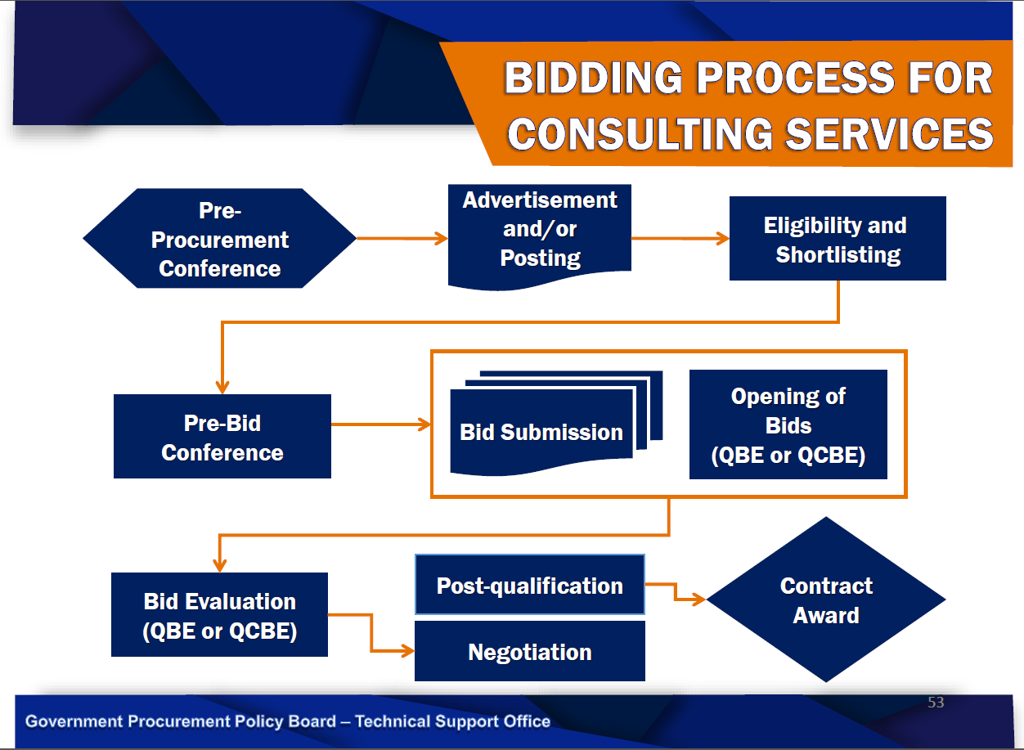

Timeline for RFP
- TOR/RFP to publish in Sept 2019
- Award in Jan 2019
- Central and Regional level eLMIS by Jun 2020
- Family planning by September 2020
- TB by Dec 2020
- Year 2 planning in July-Dec 2020
Photos- [insert any photos below taken during the trip with captions describing what is taking place and names of any stakeholders present. These will only be shared internally with donors at this stage]
Group Photo
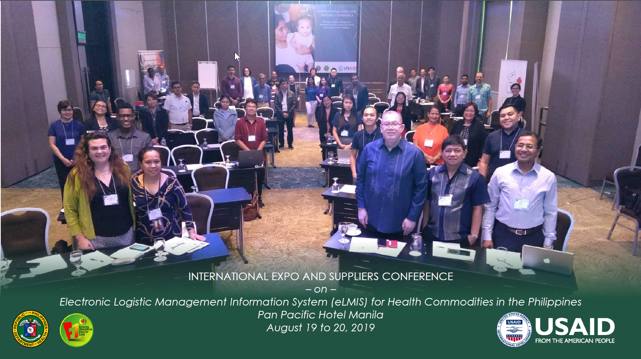

Welcome messages
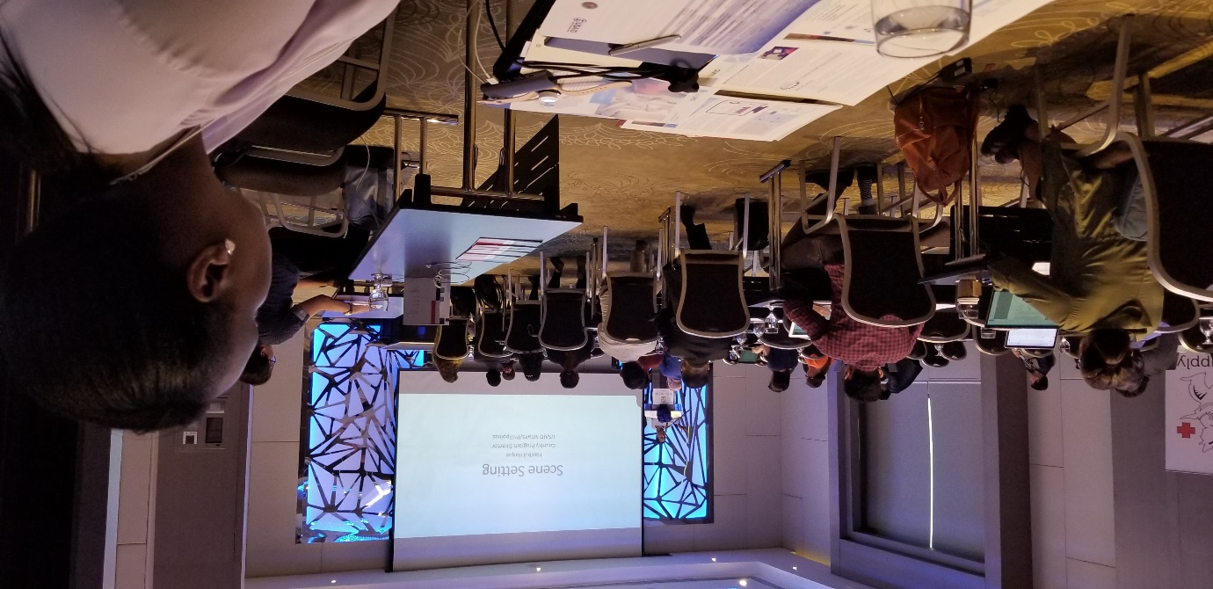

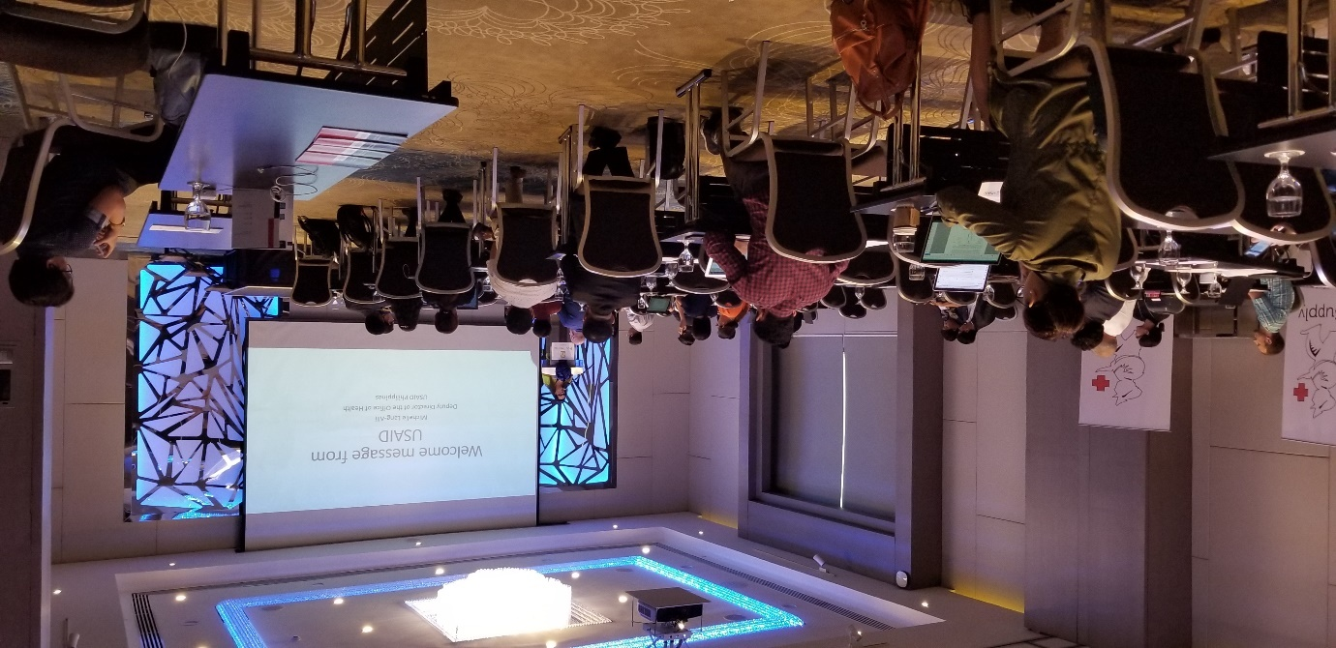

OpenLMIS Booth
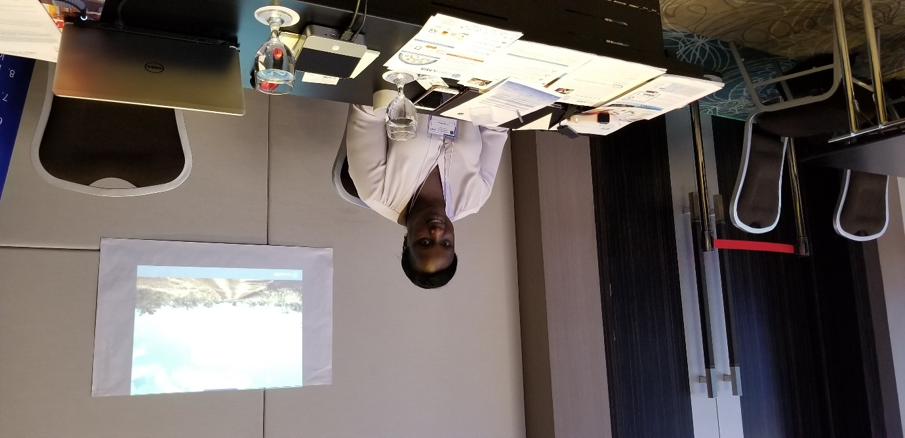

eLMIS scope
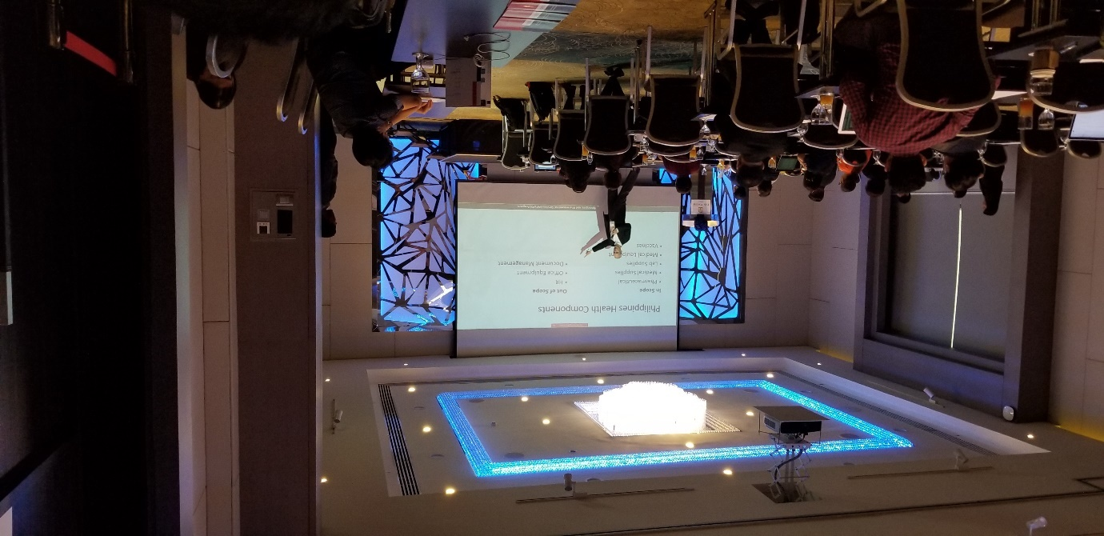

RFP/TOR Timeline
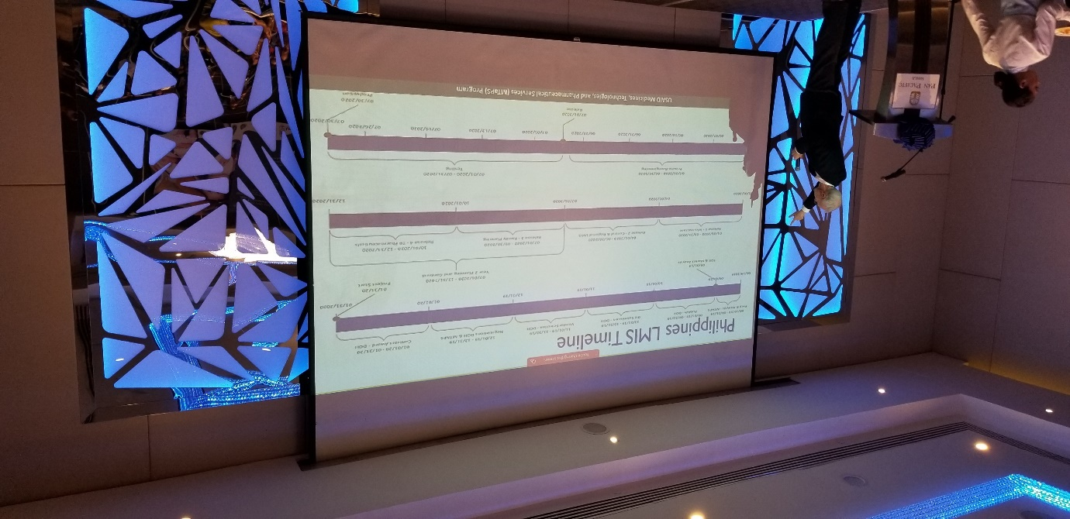

Procurement and Supply Chain Process
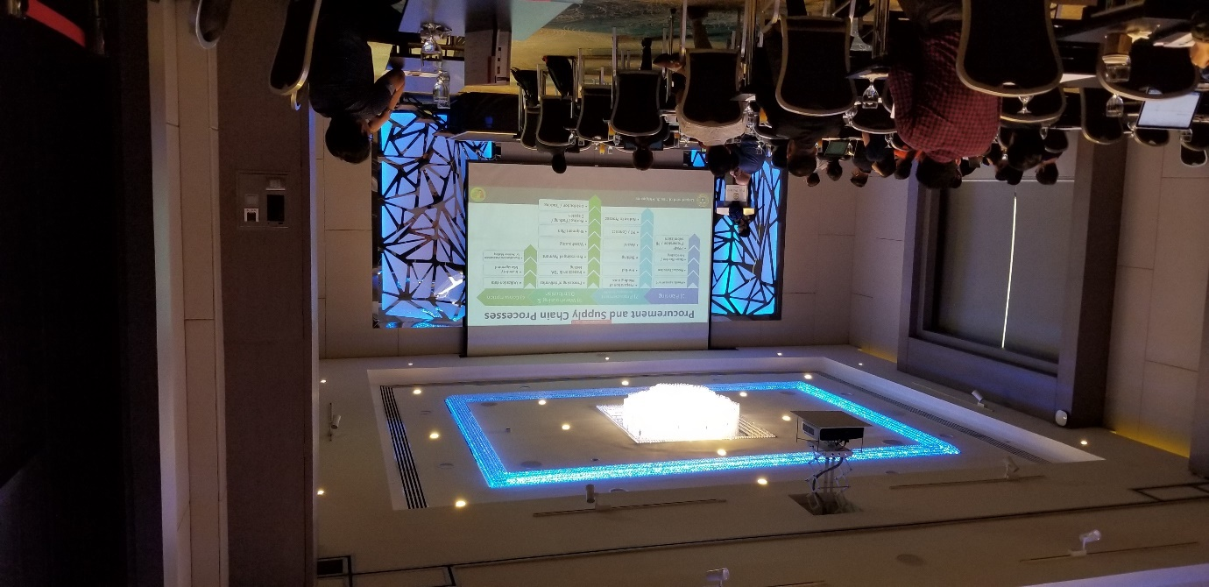

Applicable regulations/process for this RFP
