SECTION [X]: Superset Reports

X.1 SuperSet Reports
Superset is a third party software by Apache which OpenLMIS Malawi has implemented as the front-end visualization layer in the reporting platform used for dashboard creation – it pulls data from the live OpenLMIS database, to a database used by superset reports and presents it in dashboards, This data is transferred twice a day, at midday and at end of day. The configuration and administration of Superset happens on the back end and/or directly in Superset. This section provides an overview of key administrative functions that can be done through the UI (Superset).
For additional information and technical detail, please refer to the OpenLMIS Configuration Guide wiki page on Atlassian and Superset’s documentation on Apache website.

X.2 Editing a Chart
Administrative users can update the charts included on dashboards in Superset. Step-by-Step Summary X.X outlines the steps to edit a chart.
TIP: Rather than directly editing a chart, it is useful to have a test version of the chart that you use specifically for testing the updates, to avoid deploying something that is not ready and/or causing issues with the current version of the chart.

Step-by-Step Summary x.x: Edit a Chart
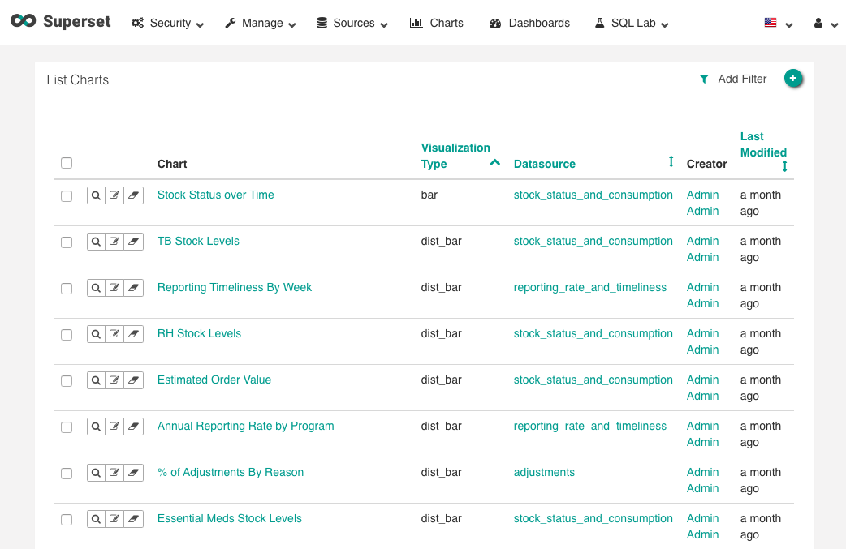
- Go to the Superset site for OpenLMIS-MW (see the Credentials page on the wiki for details) and click on the Charts button on the top navigation bar

- Click the Chart Name to open the Chart Editor.

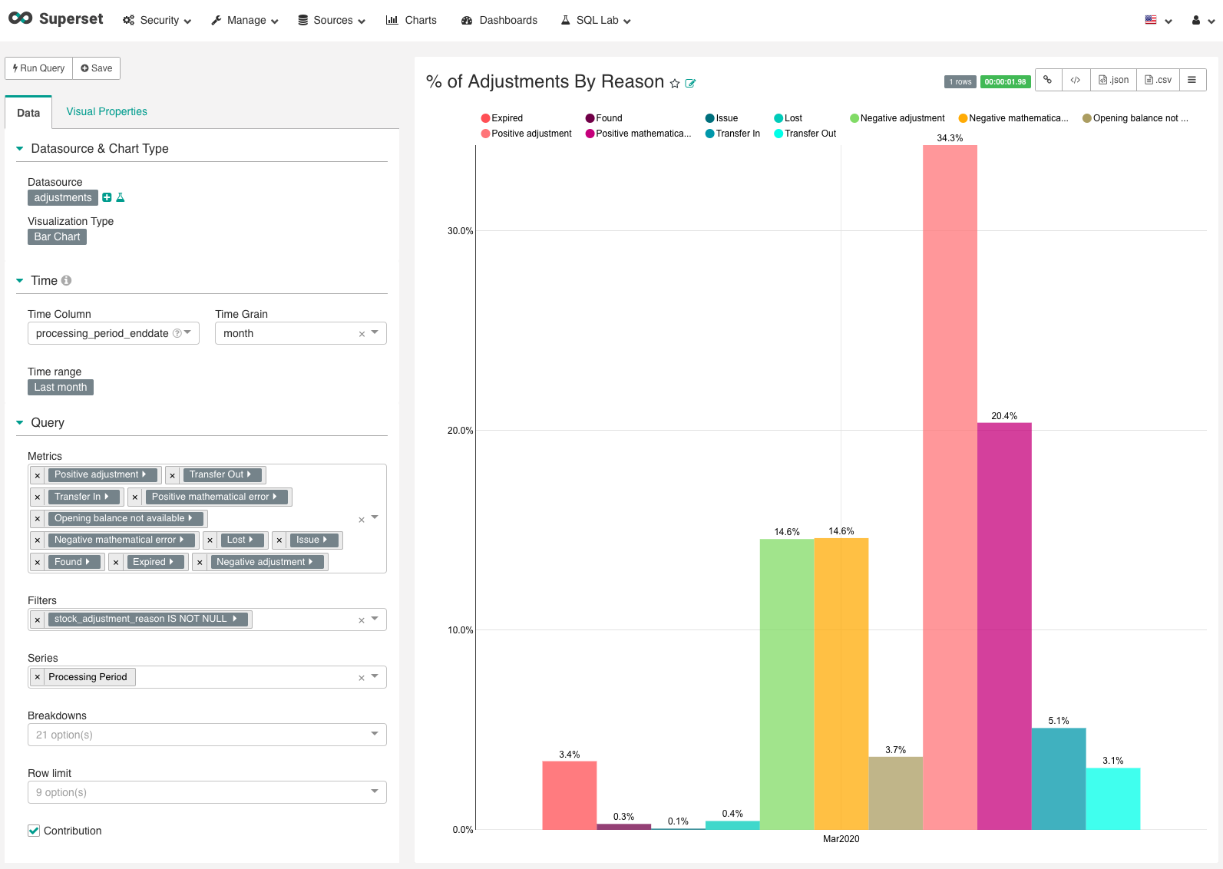
NOTE: Each visualization type has its own parameters, meaning editing options will vary for the specific chart. The section covers some of the basic parameters for charts. For more detail, see Superset’s documentation.
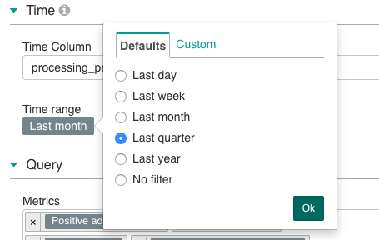
- From the Data Tab, you can make a number of changes, including:
  - Updating the time range displayed on the chart by clicking on the Time Range option and selecting a new range.

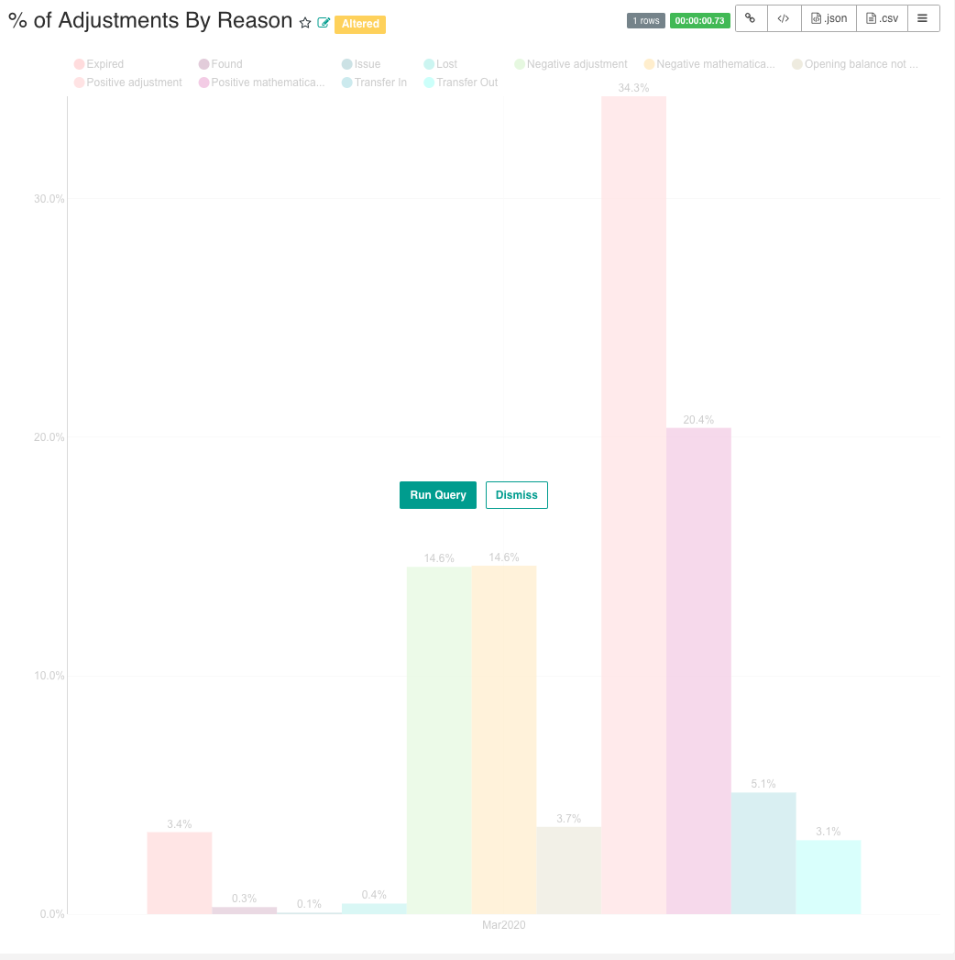
  - Click Run Query to preview the changes

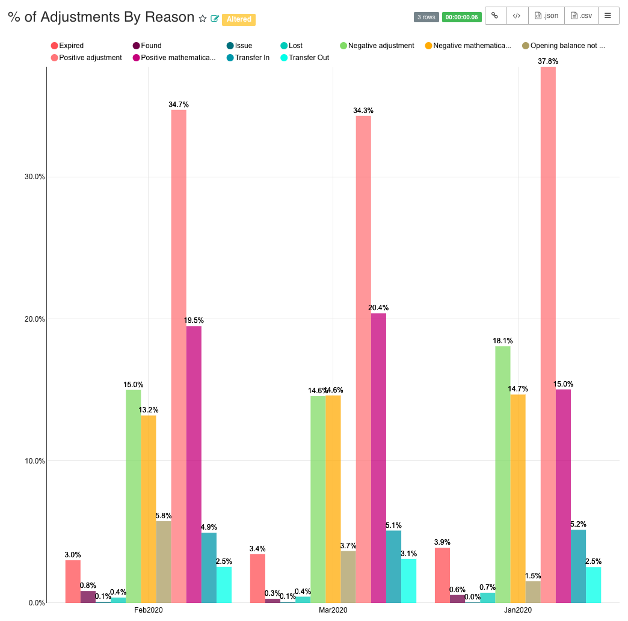

  - Update the chart type by clicking on Visualization Type and selecting a new visualization type (please note that the metrics, filters, and other parameters set up in one visualization type may not transfer well to another, and further editing may be required to achieve the desired result)

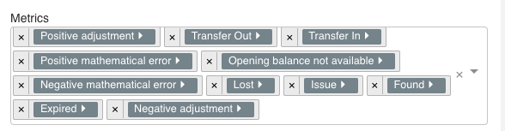
  - Update Metrics included by adding or removing them from the metrics list

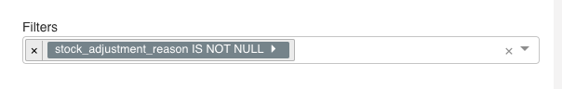
  - Update Filters included by adding or removing them from the filters list

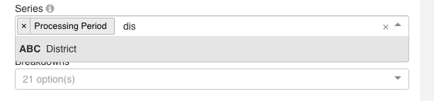
  - Update the Series included by adding or removing them from the series list
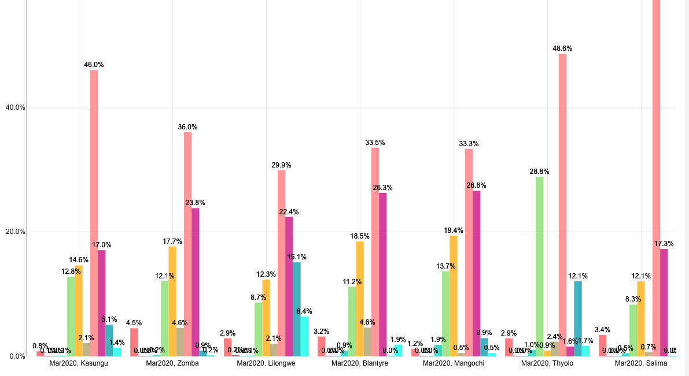

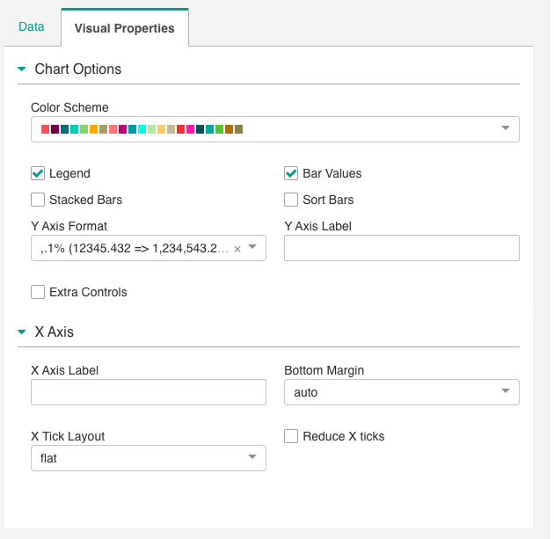
- Click on the Visual Properties tab

  - Update chart options (these will vary depending on the type of chart) such as:
    - Including the legend
    - Including value labs
    - Determining stacked or individual bars
  - Update X and Y axis formatting and labels

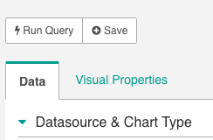
- When satisfied with the updates, click +Save to save the changes to this chart

X.3 Editing a dashboard
Administrative users can update dashboards in Superset. Step-by-Step Summary X.X outlines the steps to edit a dashboard.
Step-by-Step Summary x.x: Edit a Dashboard
- Go to the Superset site for OpenLMIS-MW (see the Credentials page on the wiki for details) and click on the Dashboards button on the top navigation bar
- Click on the Dashboard Name to open it

- Click Edit Dashboard
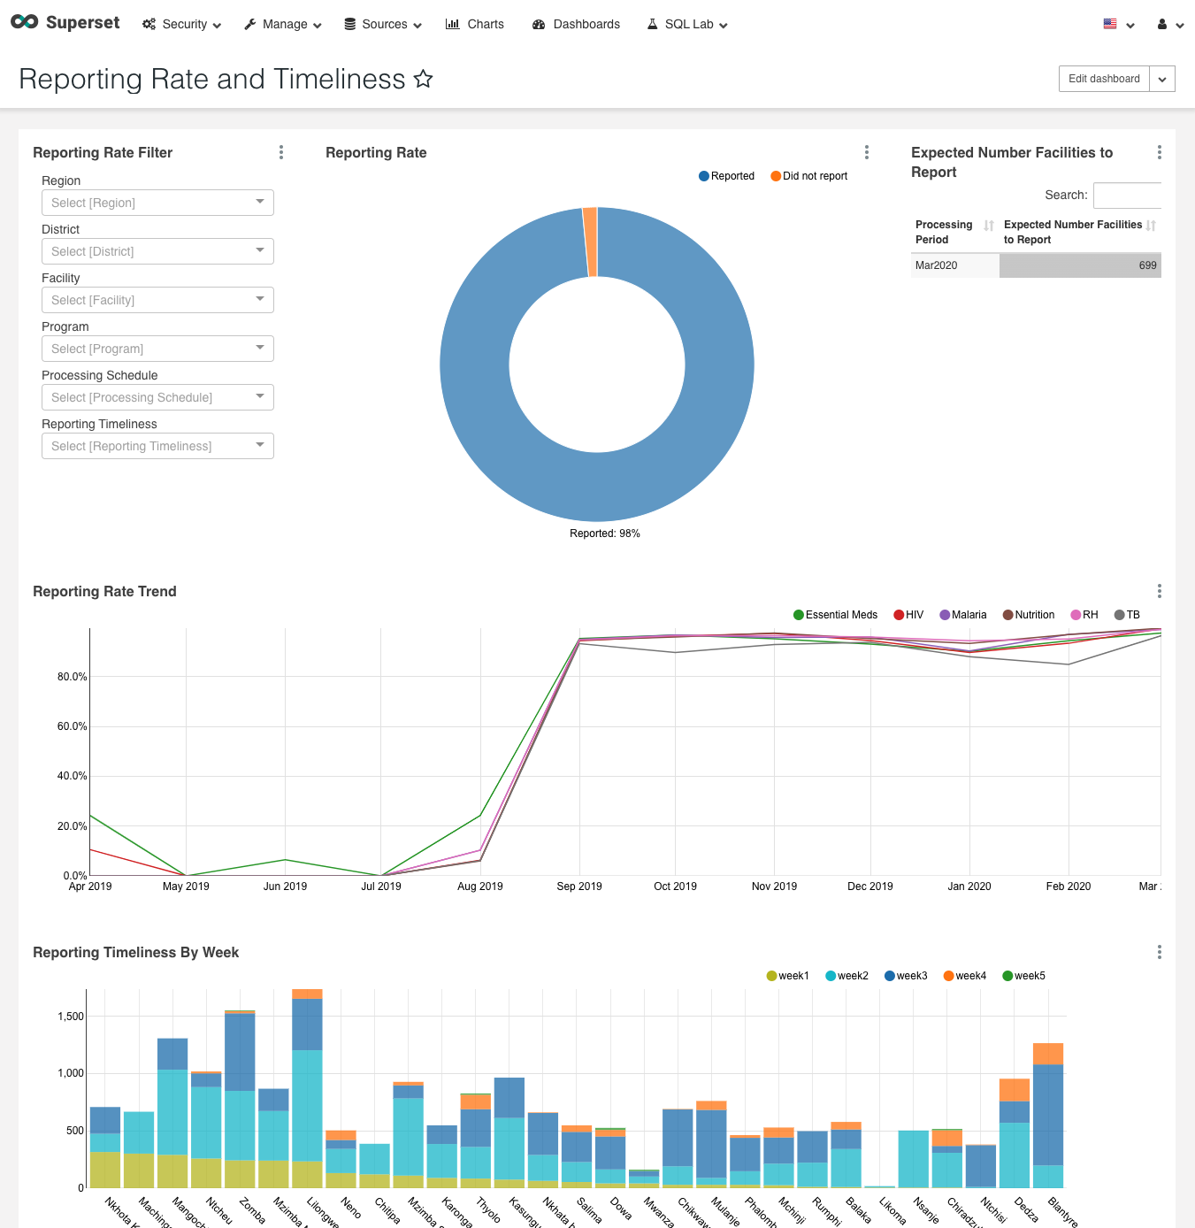

- Hover over any of the charts or tables to display the options menu.
  - Click and drag on the Dot Icon move or change the position of the graph

  - Click on the Trash Can to delete the chart from the dashboard (this will not delete the chart completely, just remove it from the dashboard)

  - Click the Gear to update the chart settings

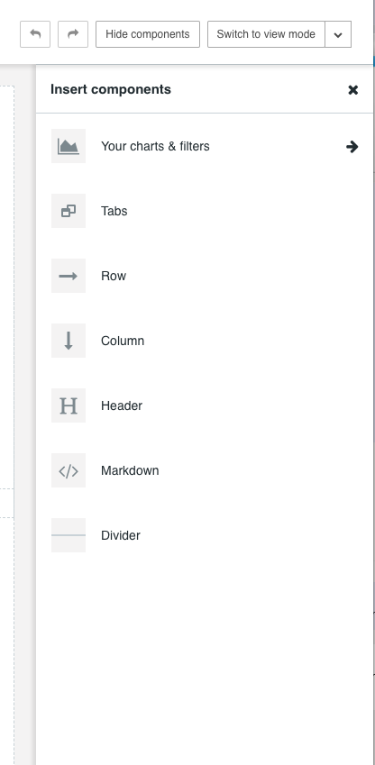
- Items can be added to the dashboard using the options in the Insert Components sidebar
  - Click Row (or other option) and drag to the desired position on the dashboard

  - Click on Your Charts & Filters to see a list of charts you’ve created in Superset

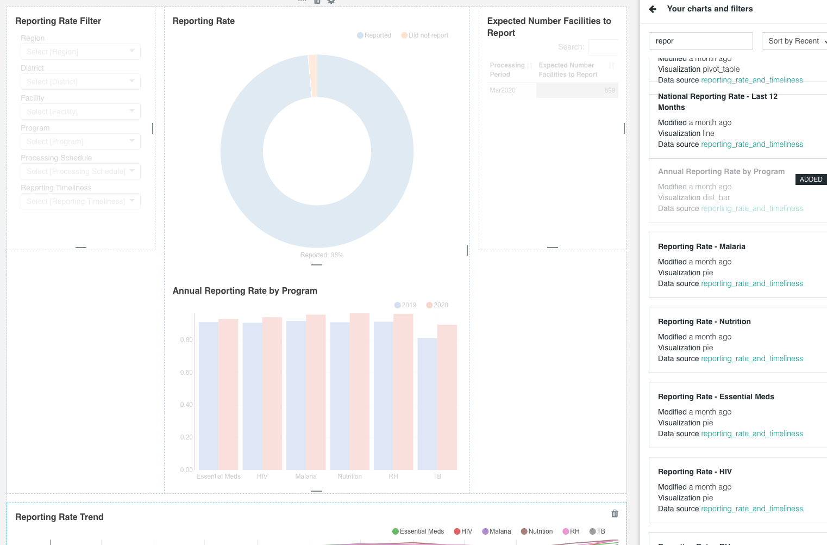
  - To add a chart, click and drag the Chart Name to the desired position on the dashboard
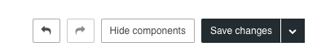
  - Click Save Changes to save the updates you’ve made

