How-To-Guide: Accessing OpenLMIS

Introduction
To access OpenLMIS, you will need to have a user account and sign in. This guide provides a brief overview of how to sign in to OPENLMIS and reset your password in case you forget or want to update it.

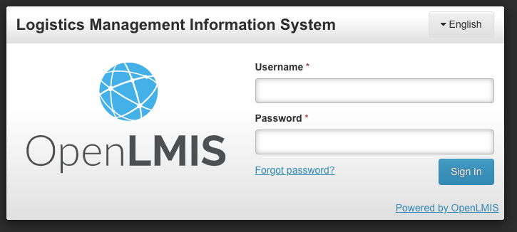
I. Sign In to OpenLMIS
- Go to [address] in an internet browser (Chrome or Firefox) to see the OpenLMIS Sign In page
- Enter your username in the Username field
- Enter your password in the Password field
- Click the Sign In button

Sign In Errors
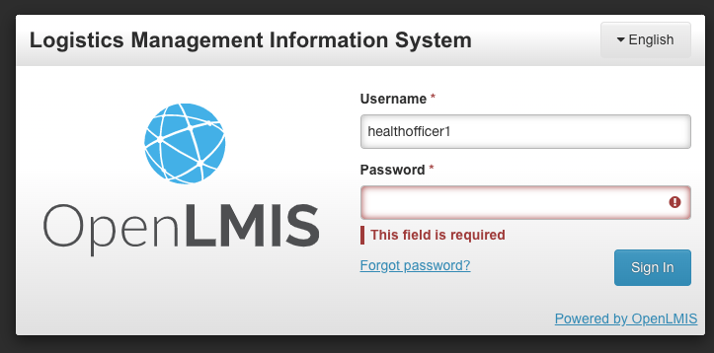
- If there are any issues with signing in, the system will display an error message indicating the problem

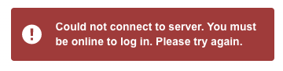
- If you are not connected to the internet, you will receive an error message like this.

- If the sign-in error persists, you can reset your password using the Forgot password link (see Section II). If the error does not resolve, you should contact OPENLMIS support XXX

II. Reset Your Password
If you would like to change your password for any reason, a password reset can be completed at any time using the Forgot Password link on the OPENLMIS log-in screen.

- From the Sign In screen, click the Forgot Password link.

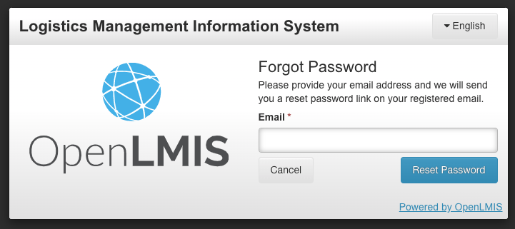
- Enter your OpenLMIS-registered email address in the pop-up. If you use a different e-mail than the one associated to your OPENLMIS user, you will receive an error message. Enter the registered e-mail to continue.

- Click Reset Password button.

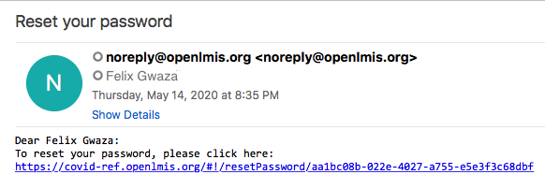
- In your e-mail, open the mail and click on the link to go to the OpenLMIS Password Reset page.

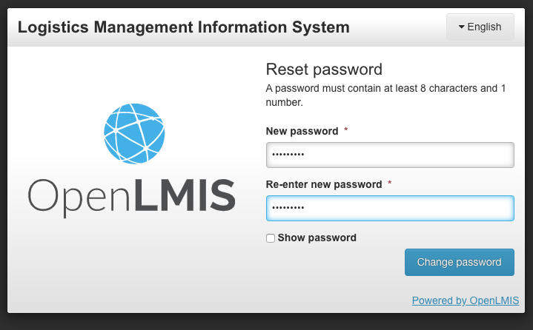
- Enter your desired password in the New Password field (it must contain at least 8 characters and a number).

- Re-enter your desired password in the Re-enter new password field. Ensure that the passwords entered match.

- Click Change password.

- You will see a confirmation message that the password was reset. You can then go to the Sign In screen and sign in with your new password. If you are having trouble resetting your password, contact OpenLMIS support XXX for assistance.

