How-To-Guide: Approving Requisitions

Introduction
To finalize the report data and prepare submitted requisitions to become orders, the submitted requisitions must be approved.

Approving Requisitions
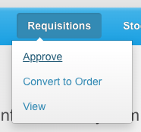
- From the OpenLMIS home screen click on Requisitions on the navigation bar and select Approve on the drop down menu
çç

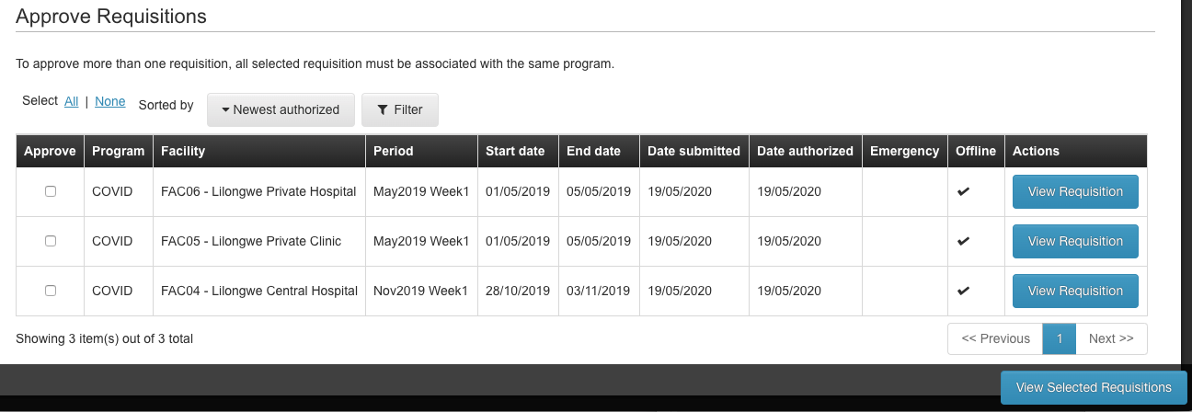
- You will see the list of requisitions waiting for approval (the list will depend on what approval roles you have in the system).

Approving a Single Requisition
çç
- Click View Requisition for the requisition you want to review and approve.

  - If you’re looking for a specific requisition and don’t see it, you can check other Pages, Filter to a specific program, or change the way the list is Sorted (from newest first to oldest first).
çç
çç
çç
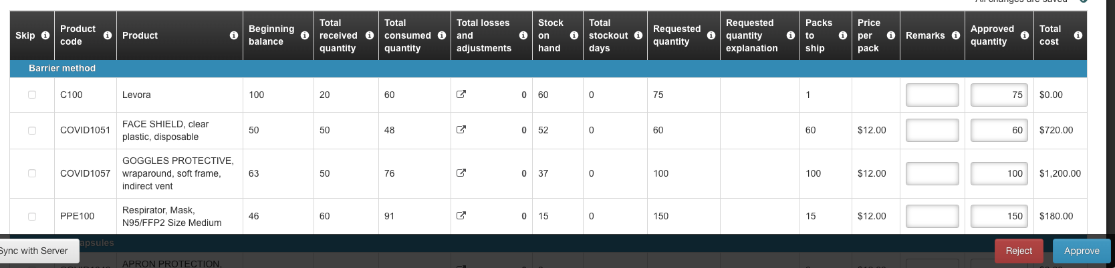
- Review the requisition. You cannot edit any of the data on the requisition at this stage, but you can update the Approved Quantity. By default, the approved quantity will be the same as the requested quantity, so you only have to make changes to those you wish to update.
çç

- Once you complete the review:
  - Click Approve to approve the requisition if everything looks good and no further changes are needed.
çç

çç
  - Click Reject if there are issues with the requisition that need to be updated before you approve. This will send the requisition back to Initiated status to be updated and re-submitted.

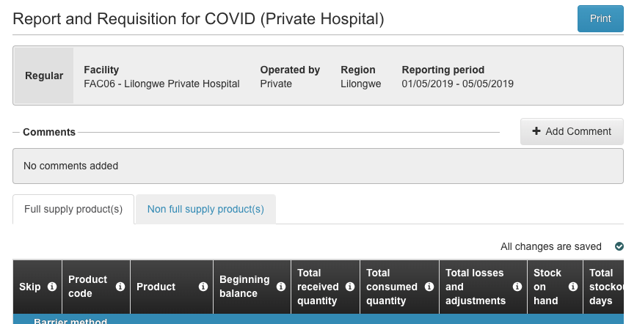
    - If you are going to reject the requisition, it is helpful to provide an explanation so the other user knows what needs to be changed. Click +Add Comment and add a note to the requisition. The other user will see this when they review.
çç

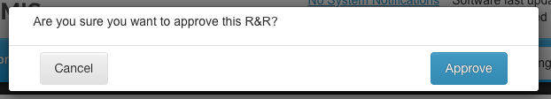
- Confirm your action:
çç
  - Click Approve to confirm the approval

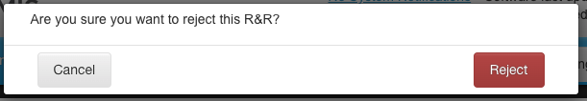
çç
  - Click Reject to confirm the rejection

Approving Multiple Requisitions (Batch Approval)
- Click the Approve Selection Box for 2 or more requisitions that you want to approve.

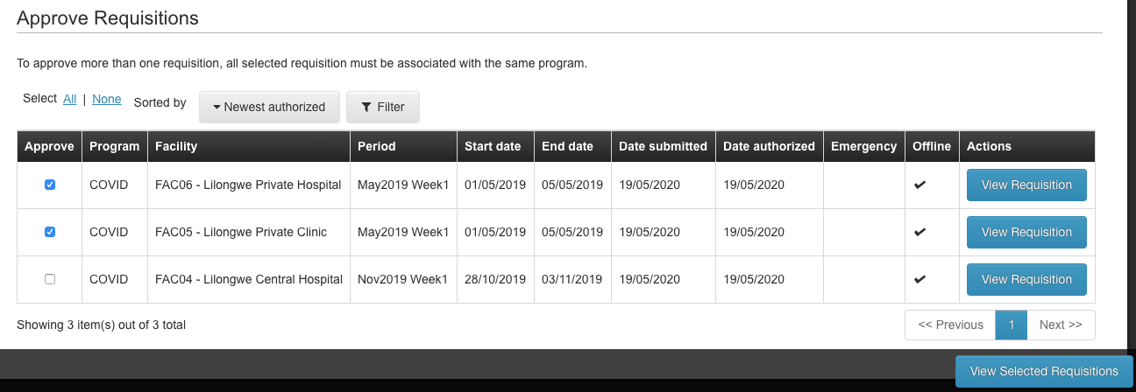
- Click View Selected Requisitions
çç
çç
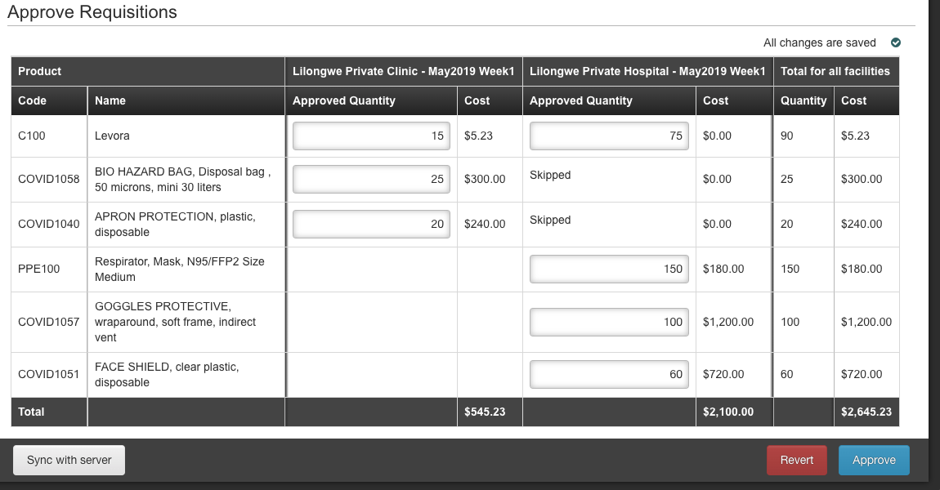
- Review and update (if necessary) the Approved Quantity for each product at each facility.
çç
çç
çç
- To remove all changes and revert back to the original numbers, click Revert

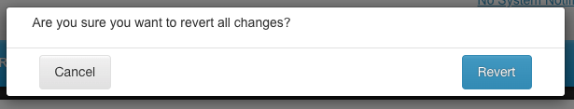
- Click Revert to confirm that you want to revert
çç

- Click Approve to approve all requisitions (if you want to reject a requisition, you must do so individually)
çç

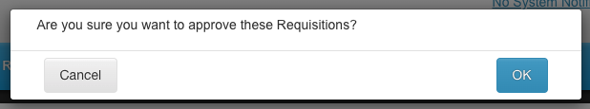
çç
- Click Approve to confirm the approval

Confirmations & Errors
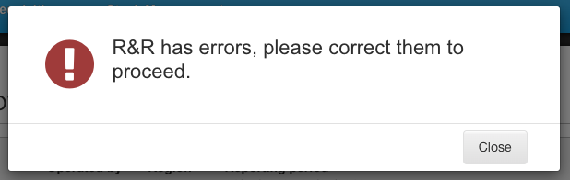
- If there are any errors (incomplete fields) you will see an alert that there are errors on the requisition. Click Close to return to the requisition form to correct the errors.
çç

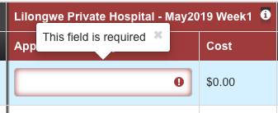
- There errors on the form will be outlined in red with an Error Icon next to them. Additionally, the page(s) where errors are located will be highlighted in red on the page navigation tool.

- Once errors are corrected, click Submit & Authorize to submit the requisition.

