How-To-Guide: Creating & Submitting Requisitions

Introduction
To report data in OpenLMIS and place orders, you will complete a Report & Requisition form (R&R). There are regular requisitions, completed at the end of a reporting period as well as emergency requisitions, that can be completed on an ad-hoc basis if you need additional stock outside of the regular delivery schedule. Requisitions can be completed using stock management data (section II) or completed manually (section III). This will depend on the system configuration and if your facility is using stock management.

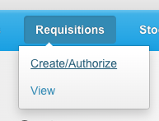
Creating a New Requisition
- From the OpenLMIS home screen click on Requisitions on the navigation bar and select Create/Authorize on the drop down menu

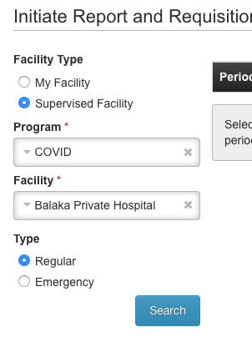

- Your facility (and the COVID program) will be selected by default. If you want to create a requisitions for your facility, move on to step 5. If you would like to create a requisition for another facility you have access to, click Supervised Facility.

- The COVID program will be selected by default.

- Select the Facility from the dropdown menu.

- Select the Requisition Type: Regular for a routine, monthly R&R or Emergency for an ad-hoc emergency request.

- Click Search

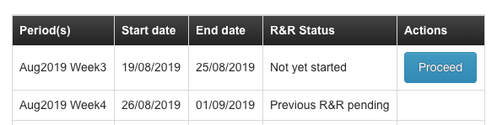
- Click Proceed in the Action column against the current period which has status “Not yet started”. If a requisition for this period has been started but not submitted, it may be at “Initiated” status.

Stock Management Enabled & Manual Requisitions
In OpenLMIS, requisitions are set up in 2 different ways. For central hospitals, requisitions are stock-enabled. These facilities will track all stock movements electronically in OpenLMIS throughout the month, and then that data is used to populate the R&R form. This process is covered in section II. Section III covers the other process: manually completing a requisition for facilities not using stock management.

Completing & Submitting a Regular Stock-Enabled Requisition
- After opening the requisition, the data entered in stock management for all products will be pulled in automatically to populate the form. Review the information.
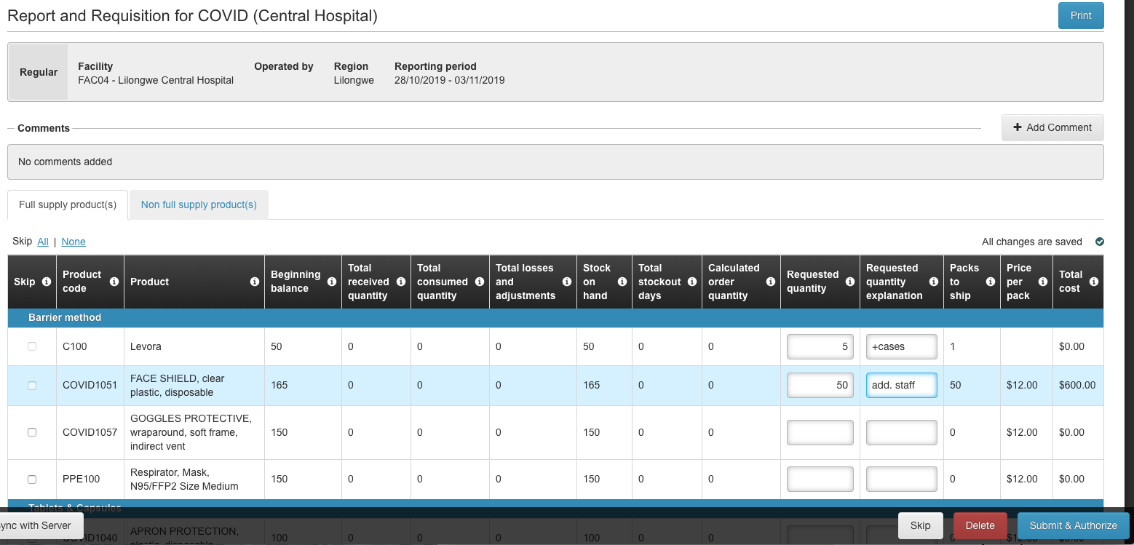
- The Calculated Order Quantity will be calculated automatically based on the current stock levels, consumption, and maximum stock levels.

- If you want to request more or less than the calculated order quantity for any product, enter the desired number in the Requested Quantity* field.
  - If you do put a different number, you will be required to enter an Explanation
*Only enter a number in this field if you want a different amount than the Calculated Requested Quantity. If you don’t need to change it, leave the Requested Quantity blank.

- Repeat step 3 for any product for which you want to change the requested quantity.
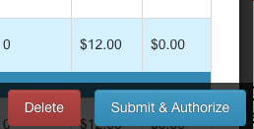
- Click Submit & Authorize

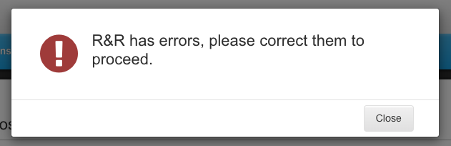
Confirmations & Errors
- If there are any errors (incomplete fields) you will see an alert that there are errors on the requisition. Click Close to return to the requisition form to correct the errors.

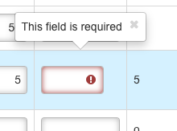

- There errors on the form will be outlined in red with an Error Icon next to them. Additionally, the page(s) where errors are located will be highlighted in red on the page navigation tool.

- Once errors are corrected, click Submit & Authorize to submit the requisition.

Correcting Data in a Stock Management-Enabled Requisition
Data pulled into a stock management-enabled requisition is view-only, and cannot be changed in the requisition form. This is why it is critical to ensure you complete and record the physical inventory for the period before you create the requisition, so the data will be accurate. If, however, you do notice any issues, you will need to restart the requisition and make updates to the products’ stock movements in the stock management module before recreating the requisition.
- Click Delete

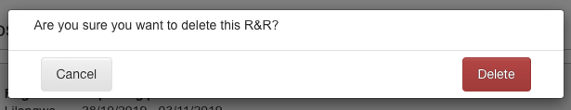
- In the confirmation box, click Delete

- Go to the Stock Management module, and make the required updates (see the stock management how-to guide for details on adding stock transactions.

- Return to the Create/Authorize Requisitions screen, and repeat the steps listed in section II

Completing & Submitting a Regular Manual Requisition

- The requisition form displays with a list of products and data to report for each. The Beginning Balance column will be automatically populated based on the previous requisition.

- For each product:
  - Skip if the facility does not manage the product (meaning they would not be expected to have it – this is different than being stocked out). You can only skip if there is no data for that product and the Opening balance is 0.
  - Enter the Received amount for the period

  - Enter the Consumed quantity for the period

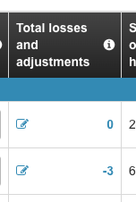
  - Click on the Losses & Adjustments Edit Icon to record any losses or adjustments

    - Select a Reason (loss or adjustment type) from the dropdown

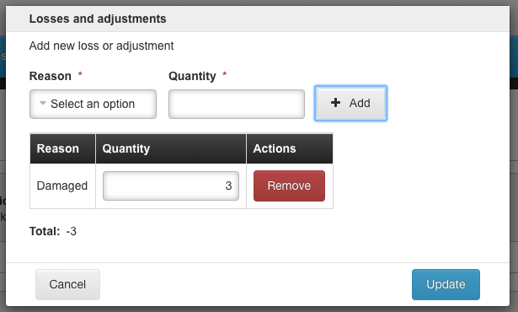
    - Enter the Quantity for that loss/adjustment

    - Click Add

    - Repeat steps to add the totals for each type of loss/adjustment for the product.

    - Click Update
  - Enter the Stock on Hand at the end of the period

  - the number of Total Stockout Days in the period

- The Calculated Order Quantity will be calculated automatically based on the current stock levels and maximum stock levels.
- If you want to request more or less than the calculated order quantity for any product, enter the desired number in the Requested Quantity* field.

  - If you do put a different number, you will be required to enter a Reason

*Only enter a number in this field if you want a different amount than the Calculated Requested Quantity. If you don’t need to change it, leave the Requested Quantity blank.
- Repeat steps 2 - 4 for all products.
- Click Submit & Authorize

Confirmations & Errors
If there are any errors on the form they will be outlined in red with an Error Icon next to them. Additionally, the page(s) where errors are located will be highlighted in red on the page navigation tool.
- Hover over the field with the error to display additional information about the error. You may see:
  - This field is required – this indicates that you must enter the data in that field to complete the requisition. Once data is entered, the error will disappear.

- OpenLMIS double checks the requisition when you try to submit it. After clicking submit you may see the following:
  - If there are errors on the form, you will see an alert asking you to correct the errors. Click Close to go back to the requisition form. Make sure you check all the pages for potential errors.

  - Once errors are corrected, click Submit & Authorize to submit the requisition.

