How-To-Guide: Manage Orders

Introduction
Once a requisition has been approved, the requisition can be turned into an order by converting the requisition to an order. The order can be fulfilled externally (by a warehouse management system or similar) or within OpenLMIS. After the order is fulfilled, the shipment can be received and confirmed with a proof of delivery.

Convert to Order
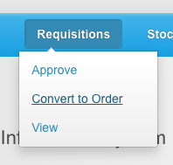
- From the OpenLMIS home screen, click on Requisitions on the navigation bar. Select Convert to Order on the dropdown menu.

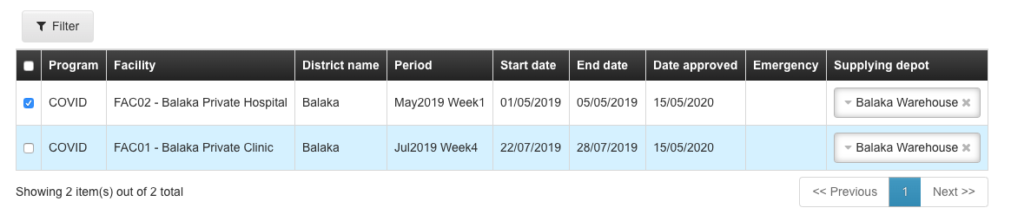
- Click the Selection Box for each requisition you want to convert to an order (or click the selection box in the top row to select all requisitions).

- The Supplying Depot will default. If there is more than one possible supply depot, select the desired depot from the dropdown list for each requisition.

- Click Convert to Order
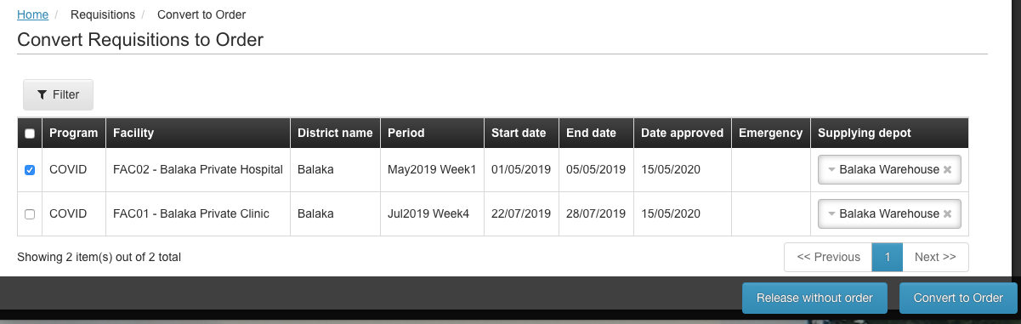
  - If the orders are for a push/distribution program, and you want to release the requisitions without actually creating an order, click Release Without Order
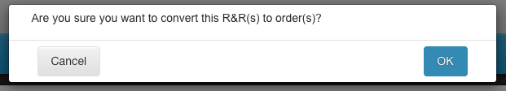
- Click OK to confirm your action

View Orders
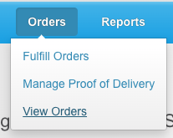
- From the OpenLMIS home screen, click on Orders on the navigation bar. Select View Orders on the dropdown menu.

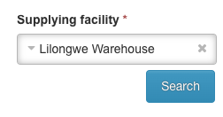
- Select the Supplying Facility (the facility the orders were sent to) from the dropdown menu.

- Click Search

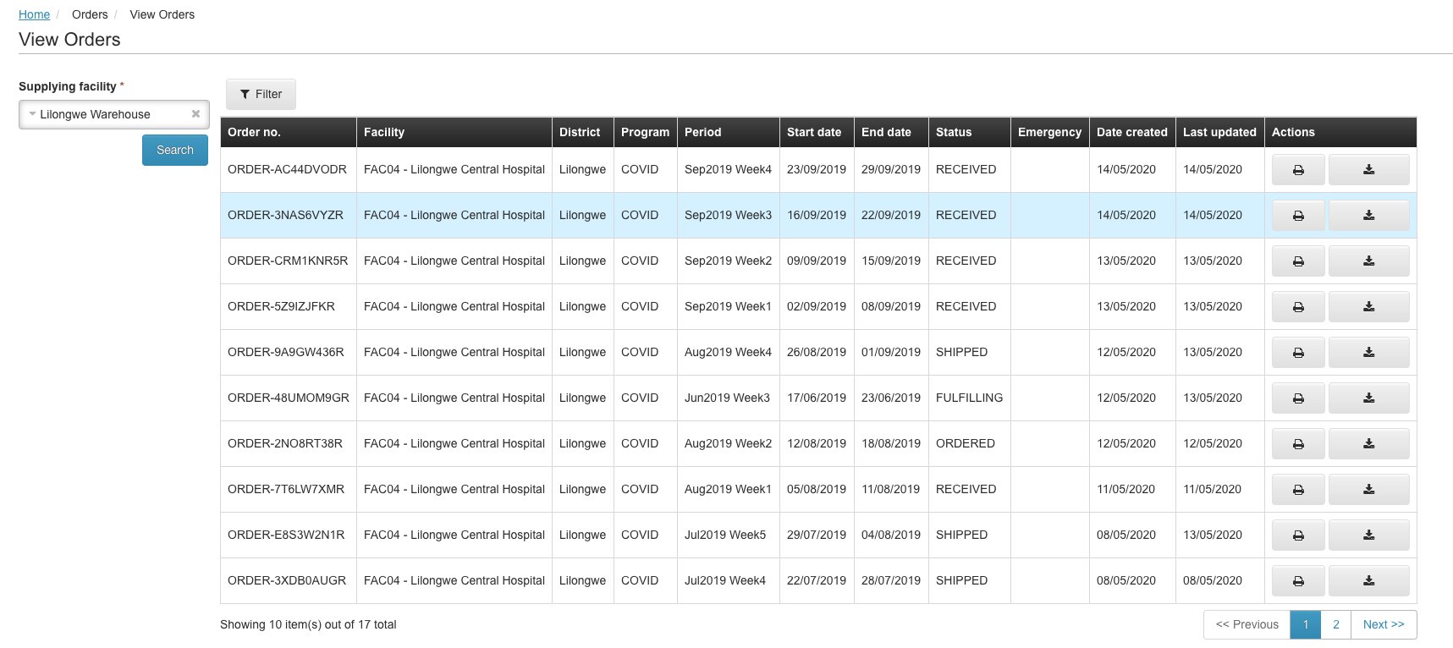
- The order list will display. If you don’t see the order you are looking for, you can navigate to the other Pages, or click Filter to narrow the list of orders you see.
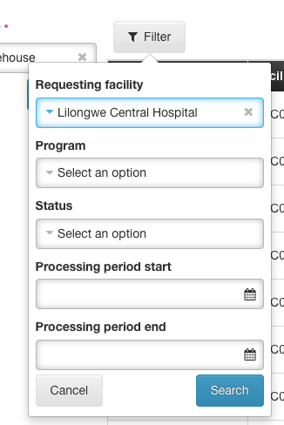

  - Select the Requesting Facility (facility that placed the order), Program, Status, or Processing Period Start/End Date to use to narrow the list.

  - Click Search

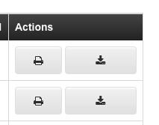
- Print or download the order to review it:
  - To print the order, click on the Print button in the Actions column for that order

  - To download the order, click on the Download button in the Actions column for that order

Fulfill Orders
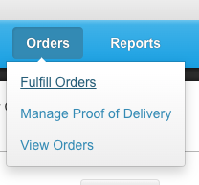
- From the OpenLMIS home screen, click on Orders on the navigation bar. Select Fulfill Orders on the dropdown menu.

- Click Start Fulfillment next to the order you want to fill (or Continue Fulfillment if it has already been started).

- For each product included in the order, enter the Fill Quantity based on the Order Quantity and Available Stock on Hand
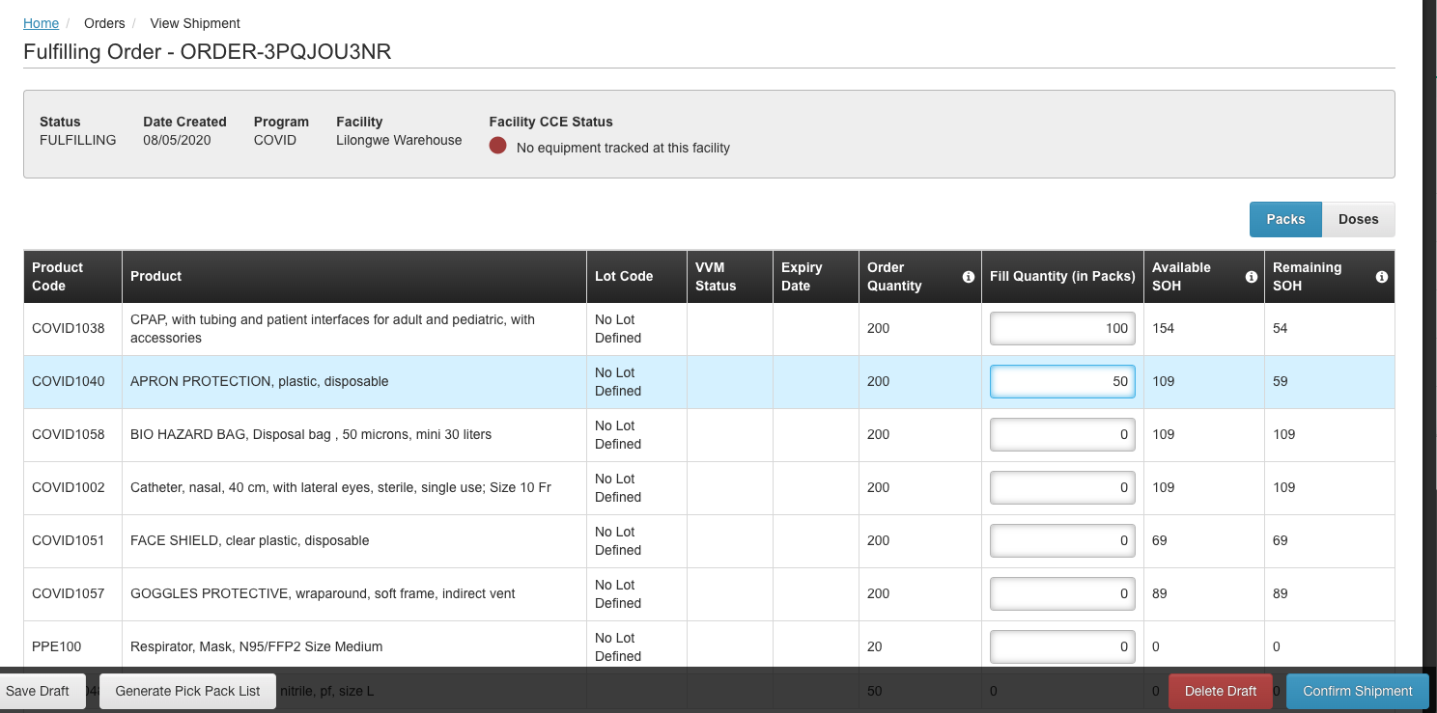
  - When you enter the fill quantity you will see the Remaining stock on hand you will have after filling the order.

- Once you’ve entered the Fill Quantity for each product, click Generate Pick Pack List to create a printable PDF list of the products that will need to be packed for shipment

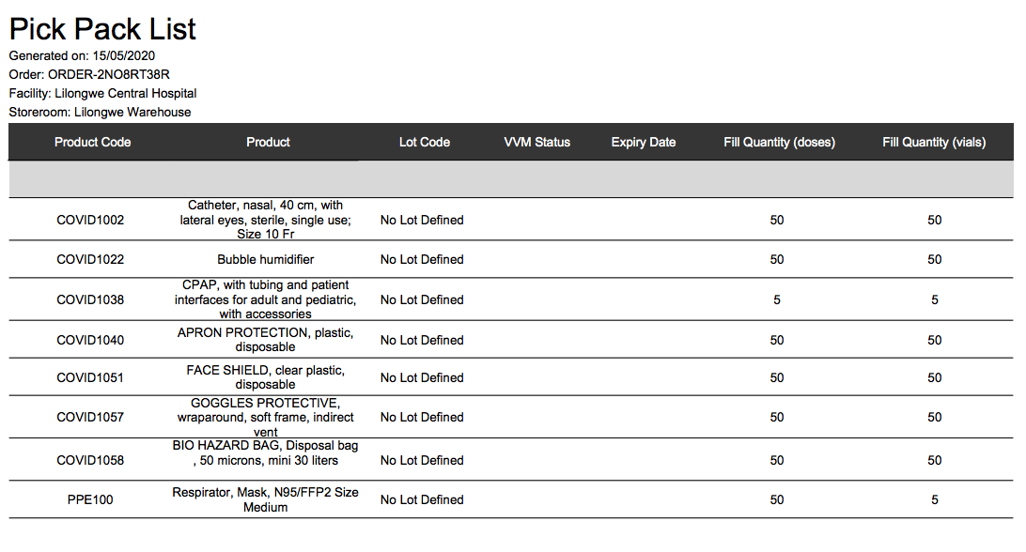
- Click Confirm Shipment

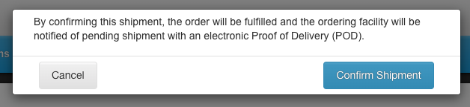
- Click Confirm Shipment on the confirmation message to complete the shipment

Manage Proof of Delivery (POD)

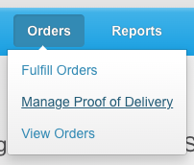
- From the OpenLMIS home screen, click on Orders on the navigation bar. Select Manage Proof Of Delivery on the dropdown menu.

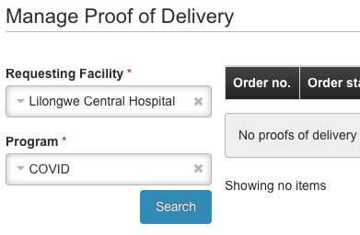
- Select the Requesting Facility and Program from the dropdown menu

- Click Search

- To print a hard copy of the POD, click Print for the order for which you want the POD.

- To complete the POD in OpenLMIS, click Manage
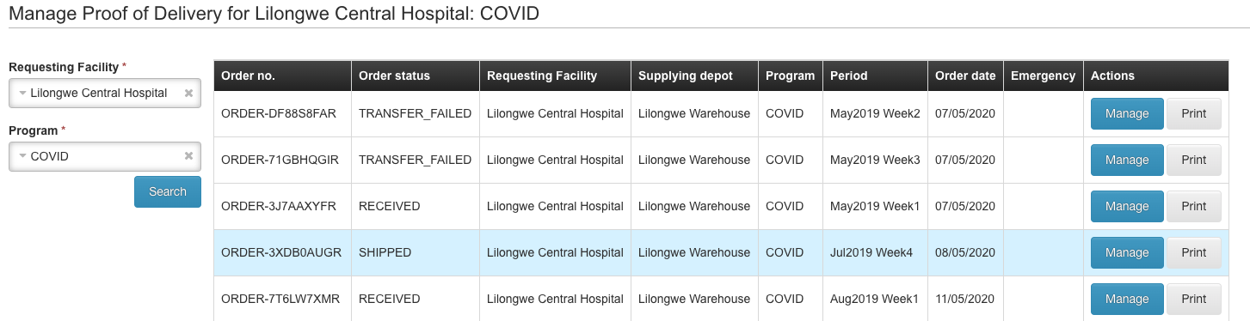
- For each product that was ordered and shipped, enter the Quantity Accepted
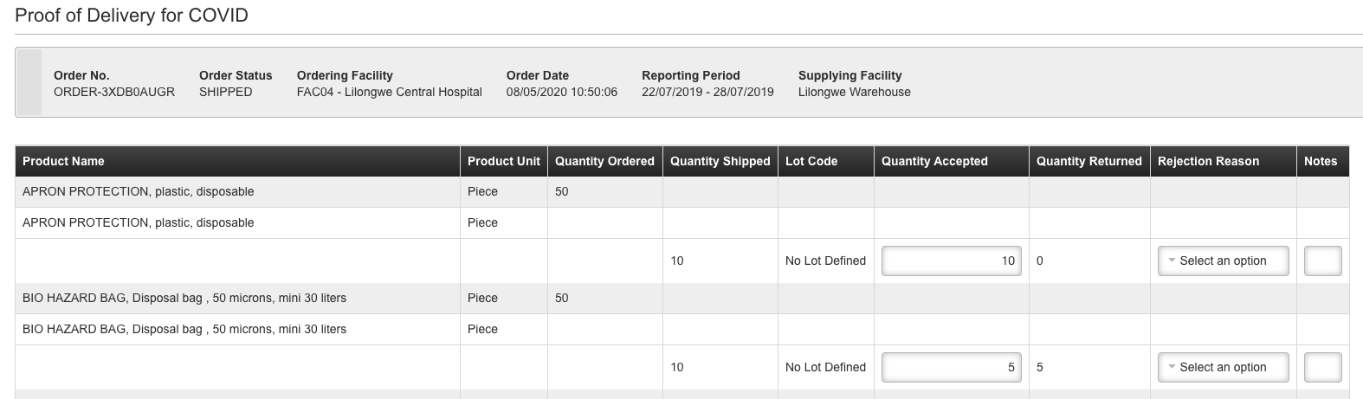

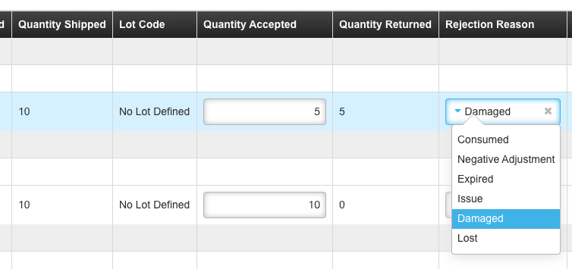
- If the quantity accepted is different than the quantity shipped, select a Rejection Reason to indicate why the products were rejected.

- Record who the shipment was Delivered By, Received By, and the Received Date.
- Click Confirm.

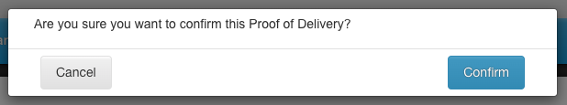

- Click Confirm on the confirmation notice.

