How-To-Guide: Manage Equipment

Introduction
You can view and manage your equipment inventory in OpenLMIS, as well as see the functional status of equipment at your and other facilities. The following sections will provide an overview of viewing the inventory, updating the functional status of the equipment, adding new equipment, or editing equipment data.

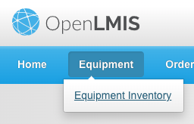
I. View Equipment Inventory
- From the home screen, click on Manage Equipment in the navigation bar and select Equipment Inventory

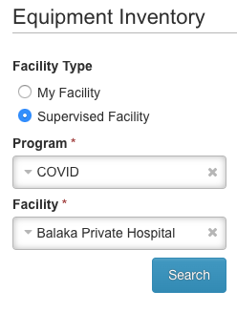

- Your facility (and the COVID program) will be selected by default. If you want to see the equipment at your facility, move on to step 5. If you would like to view the inventory and status of equipment at another facility you have access to, click Supervised Facility.

- The COVID program will be selected by default

- Select the Facility from the dropdown menu.

- Click Search

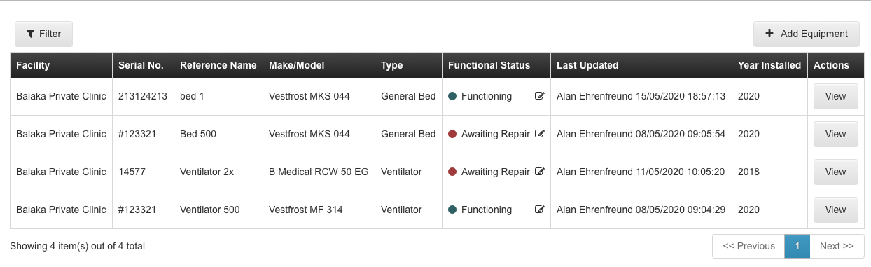
- View the Equipment Inventory registered to the facility including serial number, reference number, make/model, type, functional status, last updated and year of installation.

- To view the details of any individual piece of equipment, click View
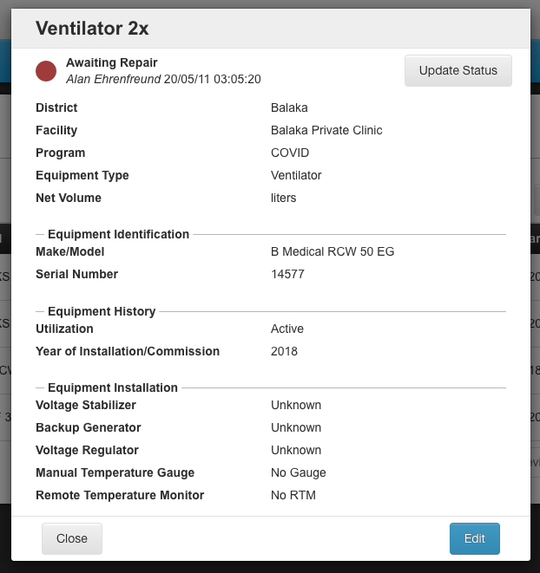
- Review the equipment details screen.

  - To return to the inventory, click Close

  - To update the functional status click Functional Status (see section II)
  - To update the equipment details click Edit (see section III)

II. Update Functional Status
- From the Equipment inventory screen click the Functional Status Edit Icon (or click the functional status button from the equipment details window, as noted in section I step 8)
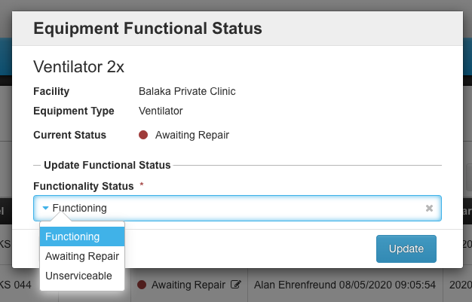

- Select the Functional Status from the dropdown menu

  - If you select Awaiting Repair, you will be asked to add the Reason

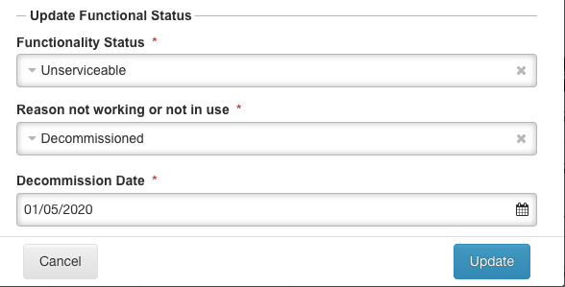

  - If you select Unserviceable, you will be asked to specify the Reason and the Decommissioned Date.

- Click Save.

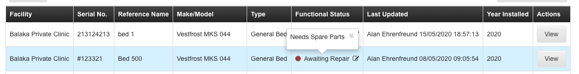
- The updated functional status will display on the inventory screen. Hover over the Functional Status to see the details.

III. Add New Equipment
If the facility receives new equipment that needs to be added to the inventory in OpenLMIS, this can be done directly from the Equipment inventory page.
- Click +Add Equipment

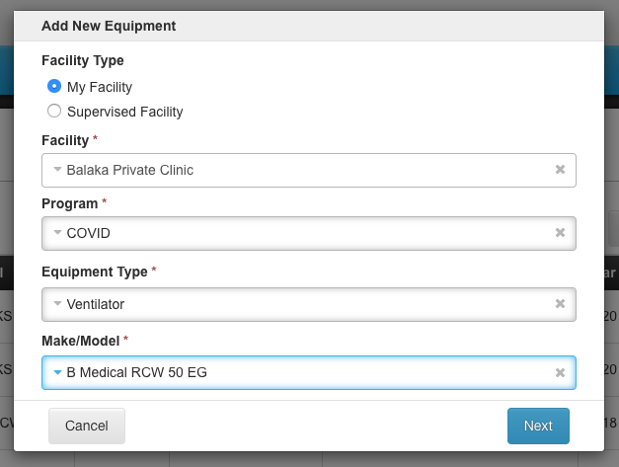
- Select the Facility
- The COVID program will be selected by default

- Select the Equipment Type
- Select the Make/Model
- Click Next

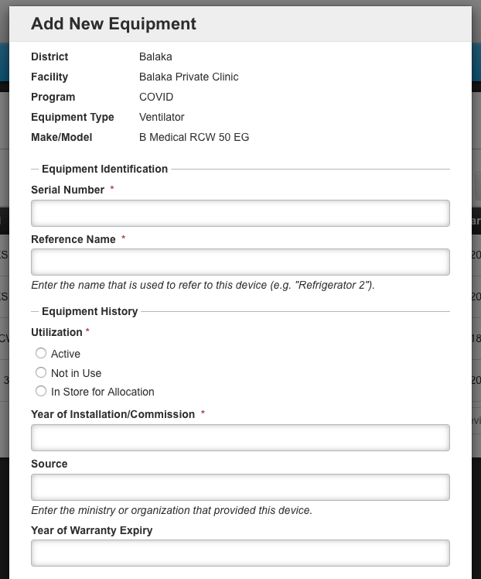
- Enter the rest of the equipment details including:
  - Serial Number
  - Reference Number
  - Utilization Status
  - Year of Installation
  - Source
  - Year of Warranty Expiry

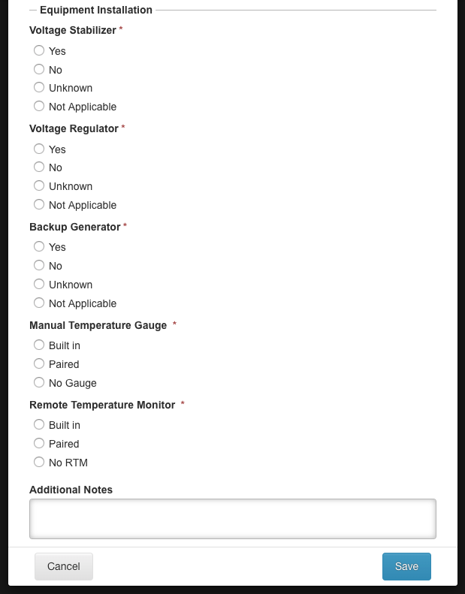
- Answer additional questions to provide further detail on if there is a:
  - Voltage Stabilizer
  - Voltage Regulator
  - Backup Generator
  - Manual Temperature Gauge
  - Remote Temperature Monitor

- Add any Additional Notes

- Click Save

Editing Equipment
If any of the data about the equipment is incorrect in OpenLMIS you can edit the information from the inventory screen.
- From the Equipment Inventory screen click View for the equipment to be edited
- Click Edit

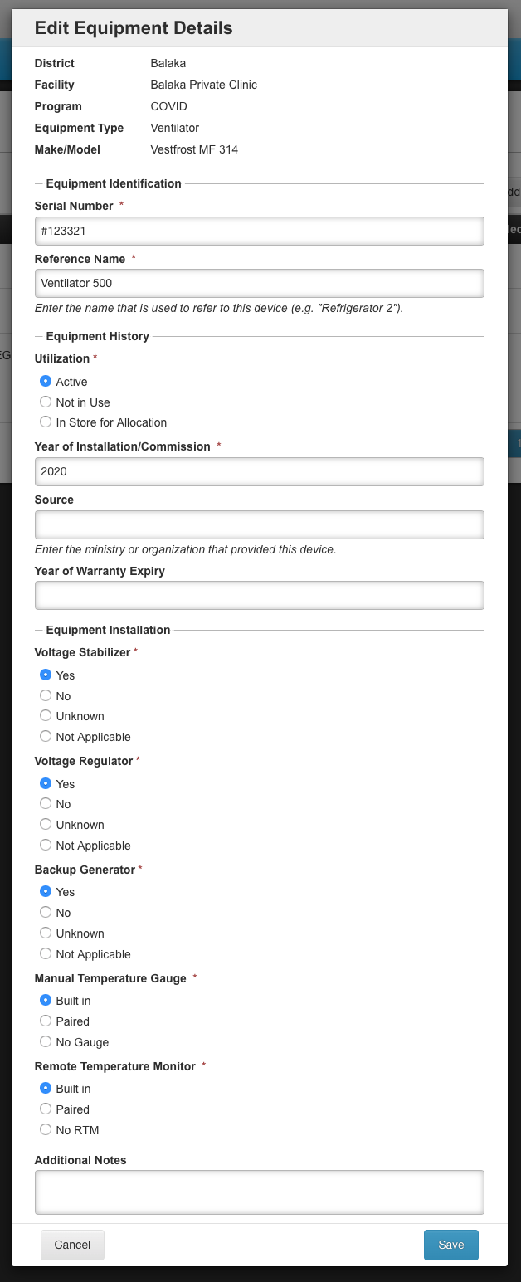

- In the Edit Equipment Details window, update the information that is inaccurate or has changed.

- Click Save.

