OPenLMIS TRoubleshooting
USAID GLOBAL HEALTH SUPPLY CHAIN PROGRAM
Procurement and Supply Management

System Specifications
OpenLMIS is web-based software and should be used in Firefox version 49 and higher or Chrome Version 52 and higher. Before using OpenLMIS check your browser version:

FirefoX:
Open the Firefox browser. Click the menu button , click help , and select “About Firefox”. The About Firefox window will appear. The version number is listed underneath the Firefox name.
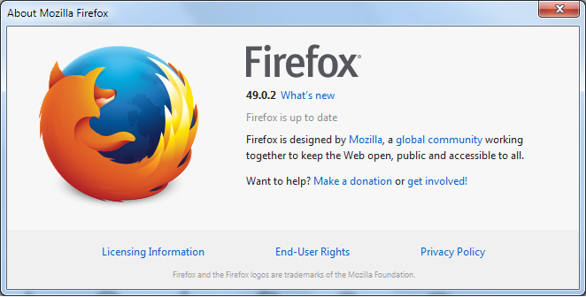

Opening the About Firefox window will, by default, start an update check. If an updated version of Firefox is available, it will be automatically downloaded.
Alternatively, click the menu button , click help and select Troubleshooting Information. A page with the address about:support will appear in a new tab. Your Firefox version is listed underneath the Application Basics section of the page.

Chrome:
Open the Chrome browser. Click the menu button, select help, and select “About Google Chrome”. The settings window or tab will appear. The version number is listed underneath the Google Chrome title.
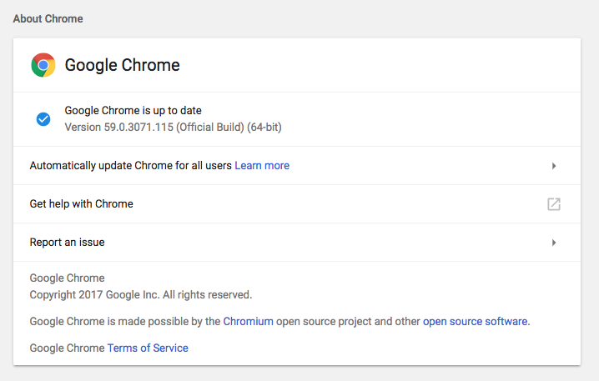
If updates are available, an “Update Google Chrome” button will be available.

Hardware and Operating System
The recommended specifications to run OpenLMIS are:
- Operating system: Windows 7-10 (other OS work as well)
- Screen resolution: 1000x600 / 1300x975 or higher
To update or change screen resolution, navigate to My Computer and select display or screen settings*. Ensure the screen resolution is set to the recommended level or higher. If the recommended resolution is not available, choose the closest possible option.

*The exact path and available settings will vary based on the computer, operating system, and OS version.

Clearing the Browser Cache
Clearing the browser cached can help troubleshoot a number of issues. An outdated old copy of the webpage or LMIS forms saved in your browser can cause a number of issues such as failing to sign in to OpenLMIS, inability to submit or authorize a form, or missing system changes or updates that need to be applied. If any such issues occur, clearing the cache for your chosen browser may resolve the issue.
NOTE: Clearing the cache will clear any offline work, such as partially completed LMIS forms that have not been synced to the server. If the cache is cleared before the forms are synced or submitted (or authorized, approved etc.) any changes will be lost.

Firefox:
- From the browser, click the menu button
- Go to History>Clear Recent History
- In “Time range to clear” select Everything.
- In "Details” select:
  - Browsing and download history
  - Cache
  - Offline website data
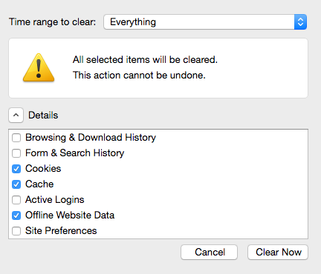
- Click “Clear Now”

Chrome:
- From the browser click on the Chrome menu icon or OR use keyboard shortcut Ctrl + Shift + Delete (slip step 2 and 3).
- Go to History
- Click on “Clear browsing data”
- In “Clear the following items from” select The beginning of time”
- Ensure the following checkboxes are selected:
  - Browsing and download history
  - Cached images and files
  - Cookies and other site data
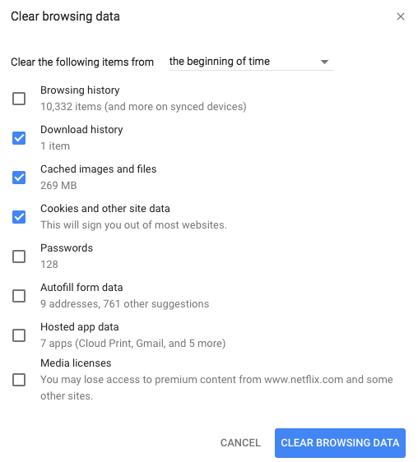
- Click on “Clear browsing data”

Disabling automatic cache clearing

In some cases, some browsers will have automatic cache clearing set-up. This setting will clear the cache automatically and if the user is working on the browser it will result in loss of data. To minimize this scenario, users should follow the steps outlined below:

Firefox:
- From the browser, click the menu button
- Click on Options> Advanced> Network

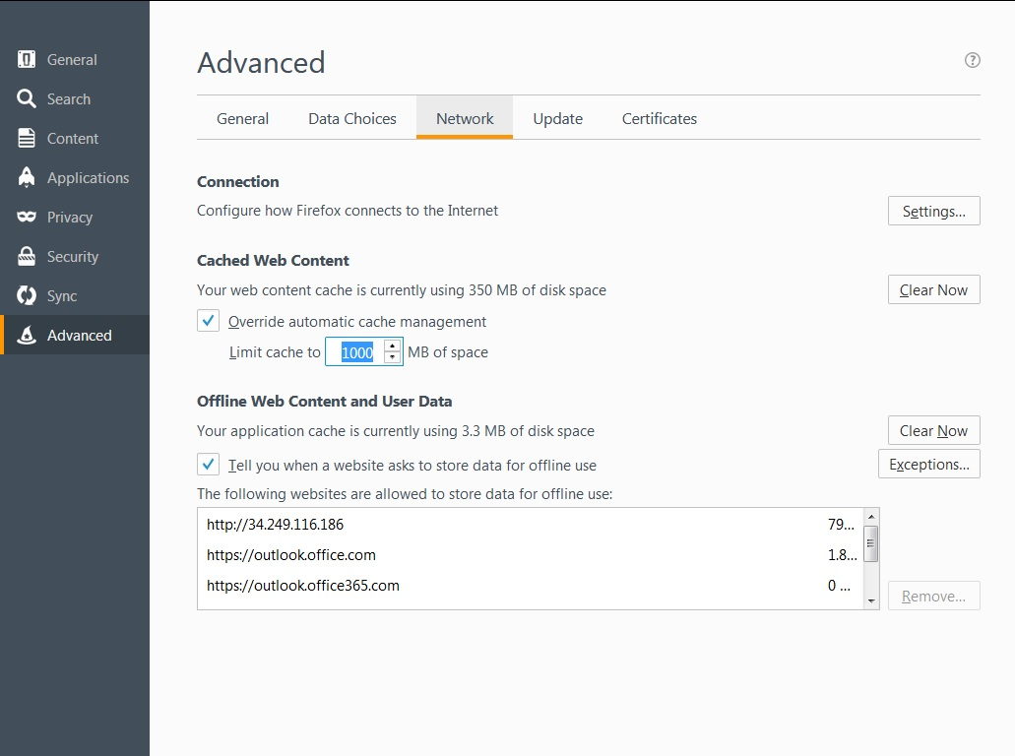

- On Cache Web Content
  - Check/Tick the Override Cache Content Management
  - Enter 1000 in the box for “Limit Cache to”
  - Close the browser
Note: Users are encouraged to sync with server regularly when they are working on the system.

Connectivity issues
- Ensure you are connected to Wi-Fi/a data network
  - If using a data network, ensure credit is available
- Disconnect from the network, turn off connectivity, turn back on, reconnect to network
- If Wi-Fi network is not working, attempt resetting router
- Contact Wi-Fi/network system admin/support (different than OpenLMIS support)

Signing in
- Ensure correct username is being used (remember that usernames are case-sensitive: User ≠ user).
- If password is failing ensure that the password entering is correct and meets the requirements:
- Minimum 8 characters
- At least 1 number
- Passwords are case-sensitive (i.e. “Password1” ≠ “password1”)
- If the password is failing or forgotten, use the “forgot password” link to reset it via e-mailed link (see section 3.2.1 in the OpenLMIS user guide for more information).
- If the forgot password link and/or the password reset is not working, contact a superuser and or system support for assistance.

