Section [X]. superset reports & dashboards
OpenLMIS now includes updated reports and dashboards using new data analysis and visualization tools. These reports are more interactive and allow the user to more specifically drill into the data using filters and visualizations. Data in the superset reports is updated daily.

x.1 Accessing Superset Reports
The Superset reports are accessed in a very similar manner as other reports. Step-by-Step Summary x.x provides an overview of how to access Superset Reports.
Step-by-Step Summary x.x: Access Superset Reports
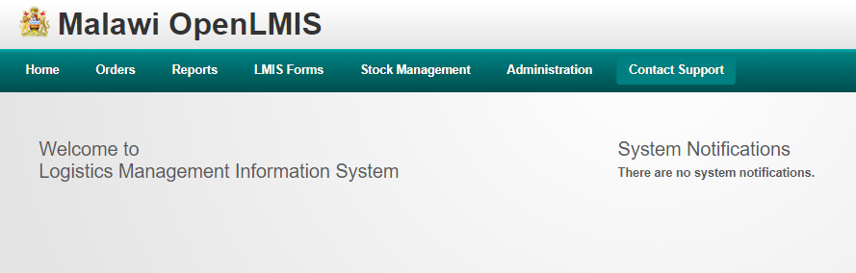
- From the OpenLMIS home screen, click on Reports on the navigation bar

- Select View Reports on the drop down menu

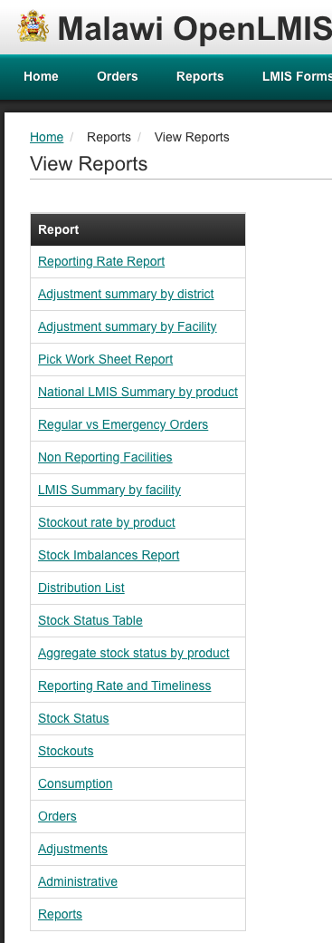

- On the View Reports screen, click on one of the Superset reports to view (see section X.x for descriptions of each report):
  - LMIS Report
  - Reporting Rate & Timeliness
  - Stock Status
  - Stockouts
  - Consumption
  - Orders
  - Adjustments
  - Administrative

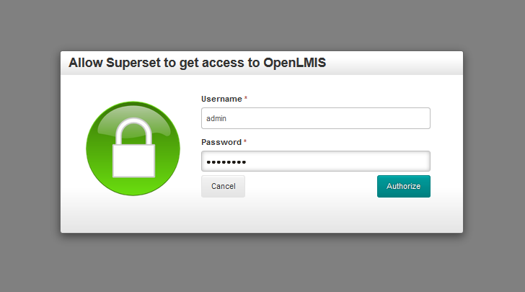
- If you have not accessed a Superset report before, click Authorize in the log in box that appears. Your username and password will already be there. Once you have done this the first time, it will happen automatically.

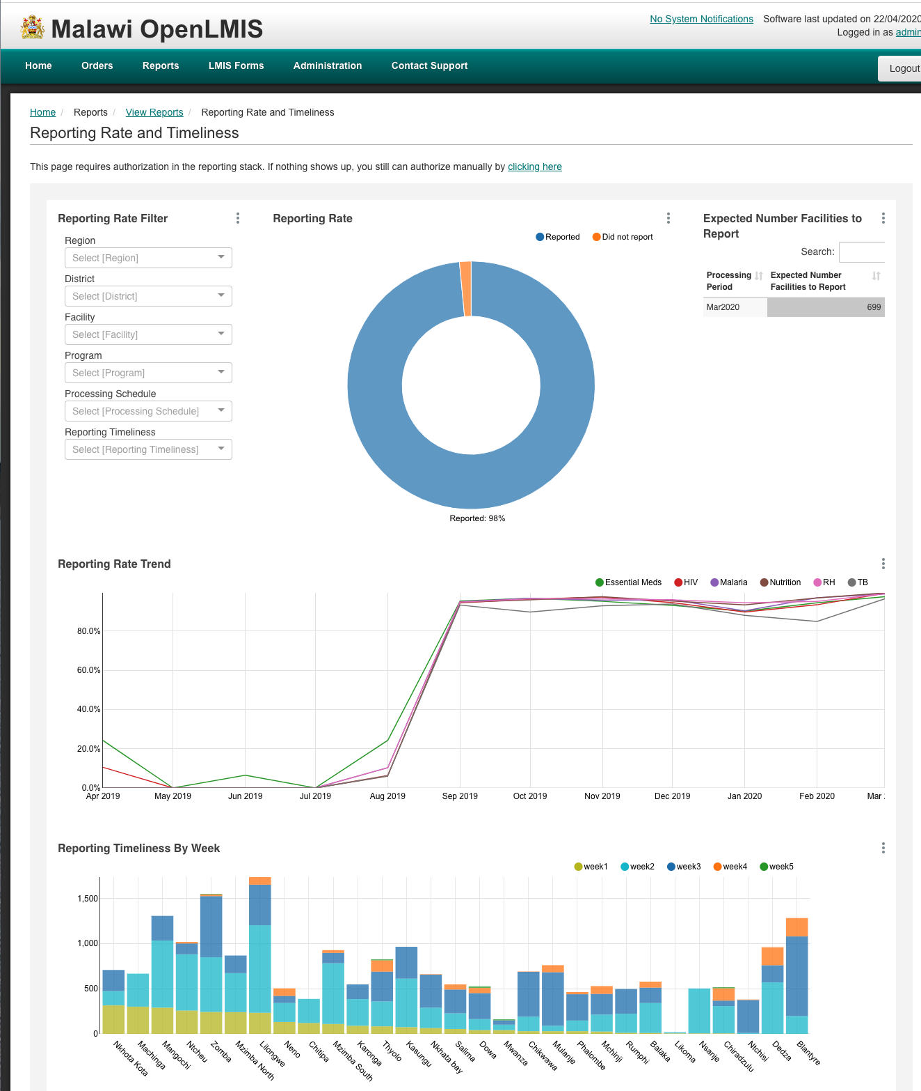
- View the Superset report in OpenLMIS

X.2 Navigating Superset Reports
Once you have a report open to view, there are a number of ways you can update and interact with the report to see more specific data or limit the information to only that which is relevant to you. The following sections will outline the various ways to interact with the Superset reports.

X.2.1 Filtering Superset Reports
One of the most important ways a user can control what data is presented in the Superset reports is through filtering. Setting filters allows users to specify what information they want to see in the report. Please note that reports default to the most recent reporting period, and some may have additional default filters set. These will be seen in the filter section and can be updated by the user. Step-by-Step Summary x.x provides an overview of how to filter Superset Reports.
Step-by-Step Summary x.x: Filtering Superset Reports
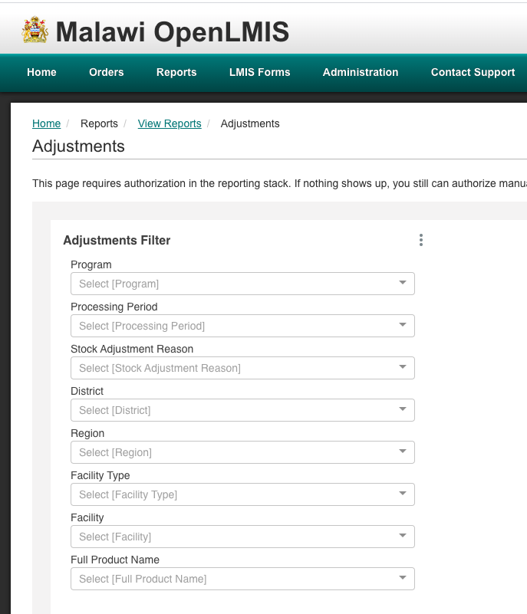
- On an open Superset report, go to the Filter section (typically on the top left of the dashboard)

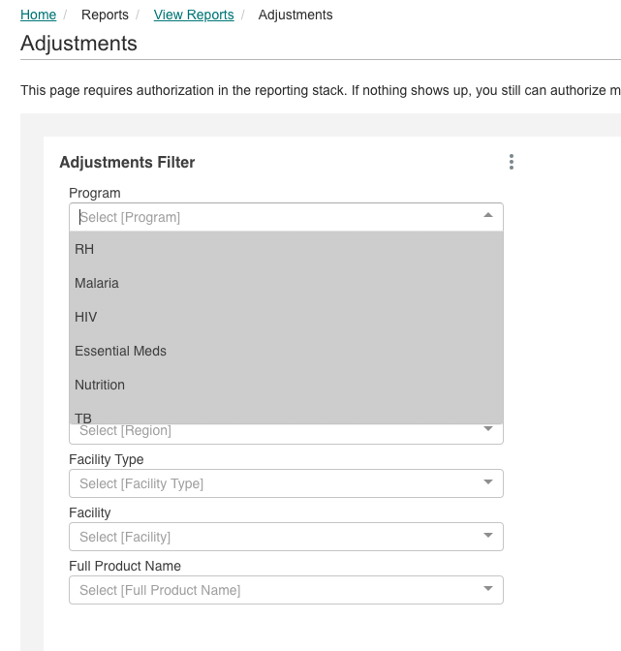
- Select an option from the dropdown menu of a filter. For example, to make the report show only data for essential medicines, click on Essential Meds in the Program filter.

- Select other options to further limit the data shown in the report. For example, select a district from the District dropdown menu to make the report show only data for Essential meds in that specific district.

  - Note that you can select multiple options from the dropdown menus.

X.2.2 Interacting with Charts & Graphs
In addition to filtering, users can interact with the charts and graphs to see more specific data. Step-by-Step Summary x.x provides an overview of how to interact with charts and graphs in Superset reports
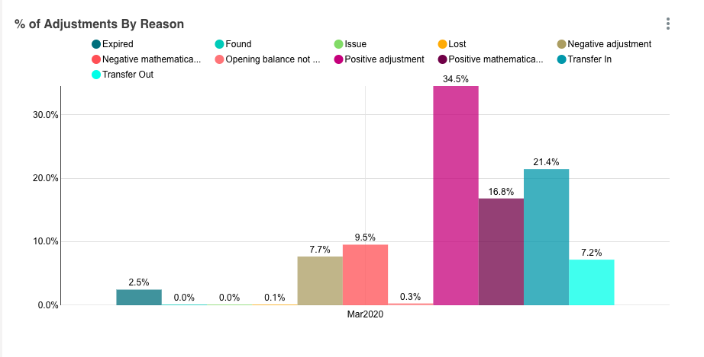
Step-by-Step Summary x.x: Interacting with Charts & Graphs
- To remove an item from a chart or graph, click on the option to remove in the legend.

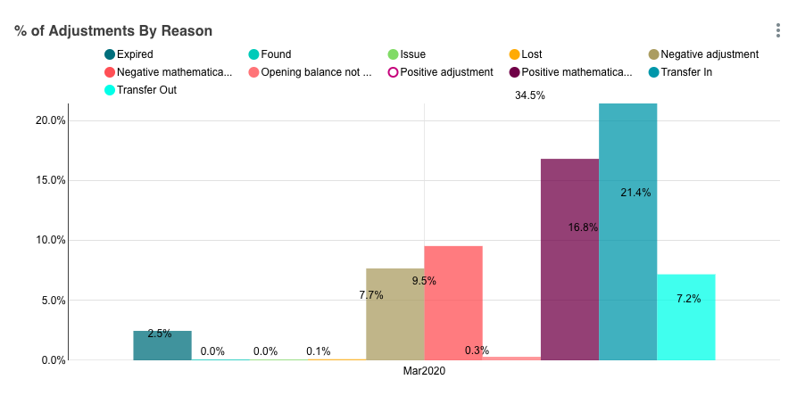
- You can remove multiple options if you like. To bring it back, click on the option again.

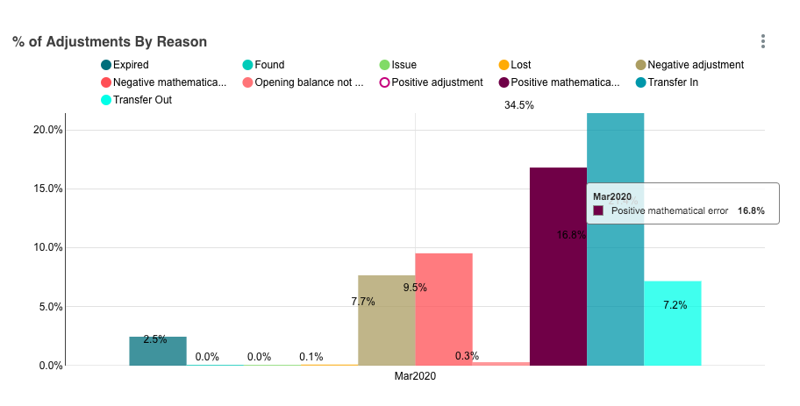
- To see details about any of the items on the chart, hover over the section to display the detailed information

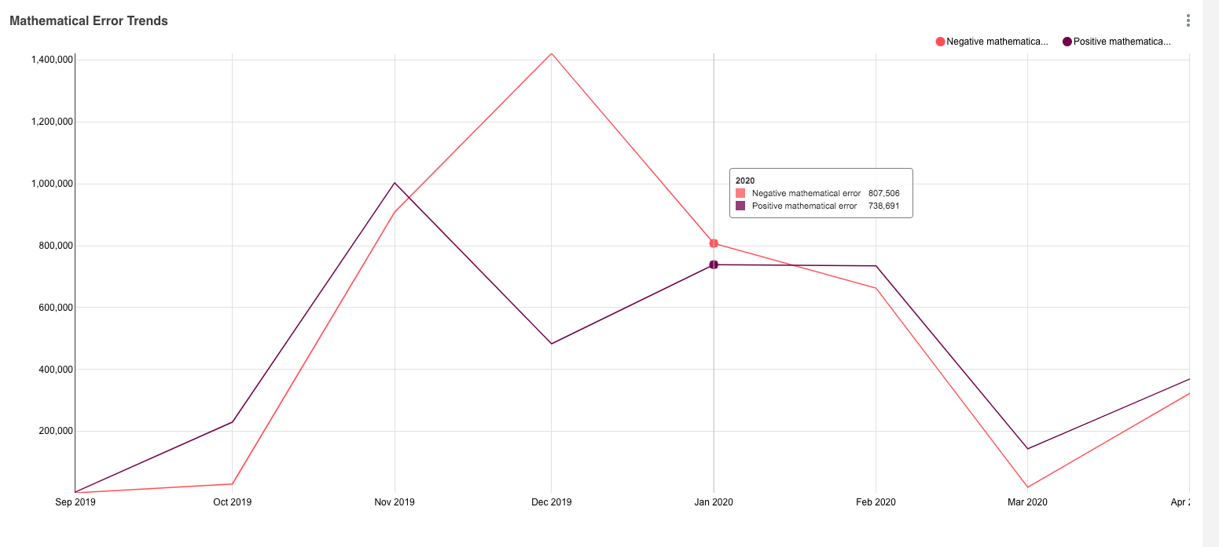
  - On a line graph, hover over any area to display points on the lines and the details of that point

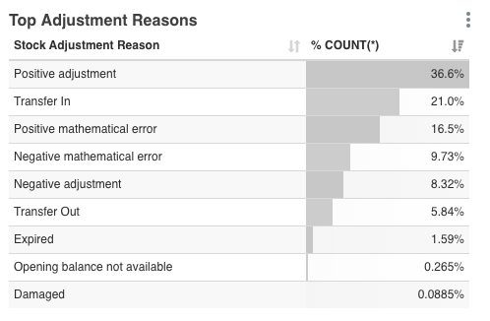
- To change the sort order on a table click on the double arrow icon to the right of any column header.
  - The icon will change to a single arrow for the element that is being sorted on, with bars to the right indicating the sort order (descending or ascending for numbers, alphabetically or reverse alphabetically for text)

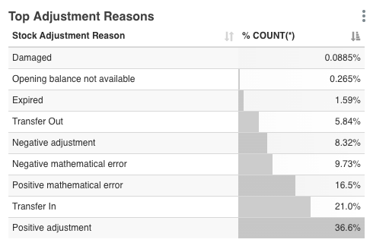
- Click on the arrow again to reverse the sort order

X.2.3 Exporting Data
In addition to viewing data and visualizations online in the Superset reports, users may want to export the data in order to review or further manipulate it. Step-by-Step Summary x.x provides an overview of how to export data from charts, graphs, and tables in Superset Reports.
Step-by-Step Summary x.x: Exporting Data from Superset Reports
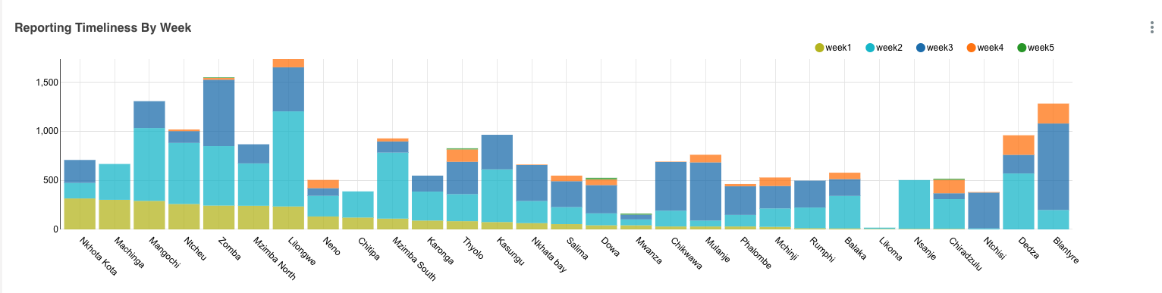
- Click on the 3-dot menu icon in the top right corner of any chart, table, or graph.

- From the menu that displays, click Export CSV

- View the CSV that opened or downloaded (depending on your computer’s settings) to see the data represented in the chart, graph, or table you exported the data from.

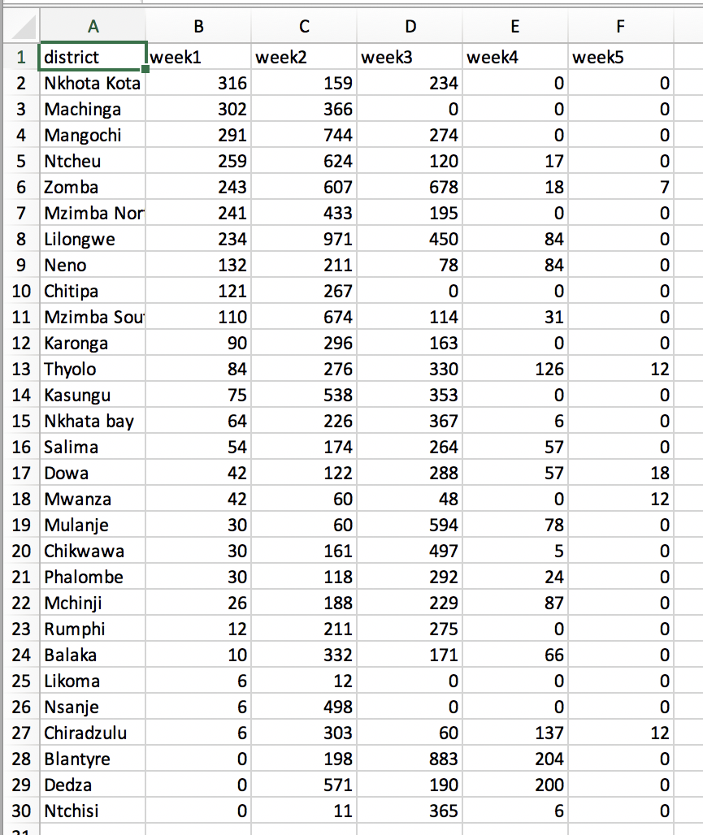

X.3 Available Reports
There are currently 8 Superset dashboards available in OpenLMIS-Malawi. Table x includes a list of the reports and a description of each.
Table X: Superset Reports & Dashboards
Report | Description
Reporting Rate & Timeliness | The Reporting Rate & Timeliness dashboard provides statistics to track reporting performance, including:  - Reporting Rate  - Expected Number of Facilities to Report  - Reporting Rate Trend (per program)  - Reporting Timeliness by Week  - Non Reporting Facilities list
Stock Status | The Stock Status dashboard presents a picture of stock availability in OpenLMIS facilities throughout the country. It includes:  - Stockout Trends by Program  - Stock Status over Time  - Stockout Rate Over Time  - Months of Stock  - Stock Levels by Program  - Non Reporting Facilities
Stockouts | The Stockouts dashboard provides details on stockouts for review and decision-making, including:  - Non Reporting Facilities  - Most Stocked out Facilities  - Most Stocked out Products  - Most Stocked out Districts  - District Stockout Rates over Time by Program
Consumption | The Consumption dashboard provides statistics about commodity consumption, including:  - Total Adjusted Consumption per District  - Most Consumed Products  - Consumption Trend  - Consumption in current year  - Consumption in Last year  - Logistics Summary Report
Orders | The Orders dashboard provides data related to ordering, including:  - Reporting Rate  - Emergency v. Regular Orders  - Order Timeliness  - Estimated Order Value  - Non Reporting Facilities  - Total Cost of Orders
Adjustments | The Adjustments dashboard provides data on stock adjustments including:  - % of Adjustments by Reason  - Reporting Rate  - Mathematical Error Trends  - Top Adjustments Reasons  - Top Districts with Adjustments  - Most Adjusted Reason  - Adjustment Summary
Administrative | The Administrative report provides a list of facilities configured in OpenLMIS including:  - Facility code  - Facility name  - Facility type  - District  - Facility operator
LMIS Report | This is a replication of the prior Excel-based monthly LMIS report. The LMIS report includes:  - The Reporting Summary  - National Reporting Rates per Program  - Timeliness of Reports  - Reporting Rate Trend  - Stockout Trends by program  - LMIS Summary Analysis Table

